

**ENTERPRISE WEB SOFTWARE DEVELOPMENT**

**COURSEWORK**

**Personal Report**

|  |  |
| --- | --- |
| Group Number | **4** |
| Student Name | **Vo Minh Nhut** |
| Leader Name | **Vo Minh Nhut** |
| Members Name | **Tran Nguyen Cong Nguyen** |
| **Nguyen Ngoc Kieu Trinh** |
| **Do Ngoc Quy** |
| ID Number (FPT CMS) | **Nhutvmgc60222** |
| **Nguyentncgc60263** |
| **Trinhnnkgc60229** |
| **Quydcgc60257** |
| Student Registration # (Greenwich CMS) | vn6073s |
|  |
|  |
|  |
| Banner ID (Greenwich CMS) |  |
| Student# | GC60222 |
| Class | GC0763 |

Table of Contents

I. Report 3

II. Logbook (Personal) 5

1. Week 1 5

2. Week 2 5

3. Week 3 5

4. Week 4 5

5. Week 5 6

6. Developing Progress 6

i. Mailing System 6

ii. Database design 10

iii. Coding Modal & Technic 12

iv. Uploading/Downloading Module 12

v. Meeting Logging Module 12

7. Bugs Log 13

Bug #1: 13

Bug #2: 14

Bug #3: 15

Bug #6: 16

Bug #7: 16

III. Appendix (Full Website Documentation- Group Work) 17

# Report

At first words, I would like to introduce myself. My name is Nhut Vo Minh, currently I am group 4 – team leader. This project (eSupervisor) has been completed as our group effort. Since my main position in the project is a main coder so here by is my report on what I have done and what I have gone through in the progress of making this project.

-This is the submission log which is created by tortoise SVN:



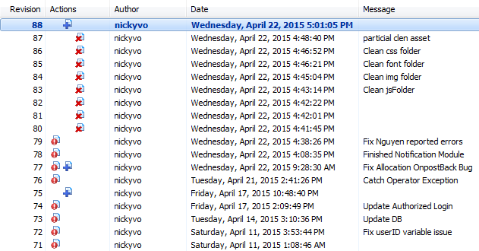

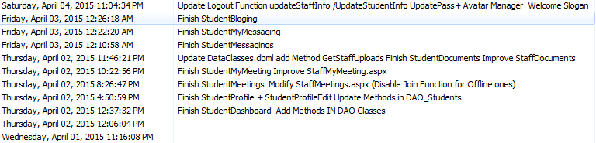

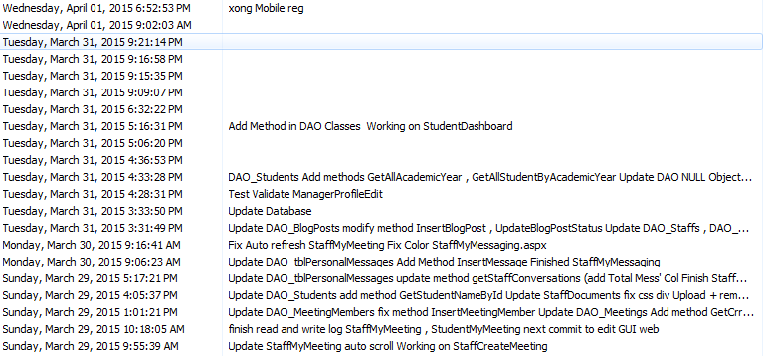

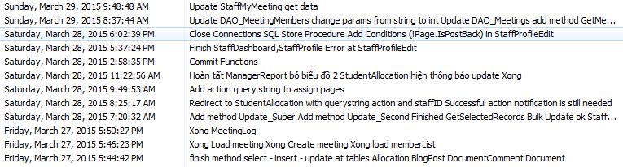

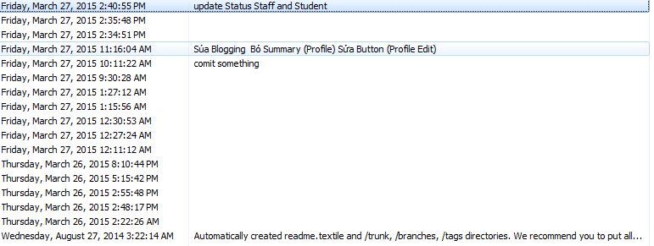

To be honest, coding this project is no easy work to me. However, I managed to finish it in the best of my effort. In the very beginning, I was confused because I did not have any experiences making a cross-device website before. Then we decided to use bootstrap as Mr. Quy had advised us to. Along with that, we managed to implement some functional code of JQuery and JavaScript too.

# Logbook (Personal)

## Week 1

|  |  |
| --- | --- |
| **Job Title** | **Status** |
| Analyzing system and requirements | Finished |
| Drafting Main System function | Finished |
| Making Project Plans, Assumption | Finished |
| Drafting UI of functional system | Finished |
| Analyzing Database | Finished |
| Creating Database Tables’ Properties Lists | Finished |
| Creating Definitions of Properties Lists | Finished |
| Creating Demo Database | Finished |

## Week 2

|  |  |
| --- | --- |
| **Job Title** | **Status** |
| Making Coding Modal | Finished |
| Researching for implementing core functions | Finished |
| Fixing and Testing Database | Finished |

## Week 3

|  |  |
| --- | --- |
| **Job Title** | **Status** |
| Modifying html codes to C# | Finished |
| Implementing mailing function | Finished |
| Implementing authorized log in | Finished |
| Implementing uploading function | Finished |

## Week 4

|  |  |
| --- | --- |
| **Job Title** | **Status** |
| Changing coding modal(3 ties 🡪 3 layers) | Finished |
| Implementing downloading function | Finished |
| Implementing delete file (server-tie) | Finished |
| Implementing recording meeting log to file | Finished |
| Implementing getting meeting log from file | Finished |

## Week 5

|  |  |
| --- | --- |
| **Job Title** | **Status** |
| Fixing some coding issues | Finished |
| Modifying Path in file-related method to adapt with IIS Config | Finished |
| Implementing On Event(Allocation/Reallocation) Mail Notification | Finished |
| Implementing authorized access to child pages | Finished |
| Writing System’s Evaluation | Finished |
| Writing Personal Report | Finished |
| Writing Report Conclusion | Finished |
| Adding References | Finished |
| Correcting demo data for database | Finished |
| Cleaning up Project Folder | Finished |

## Developing Progress

### Mailing System

This is the mail-based notification system which will send an email to each user that involved with each event.

#### Allocation/Reallocation

**Staffs’ Notification**

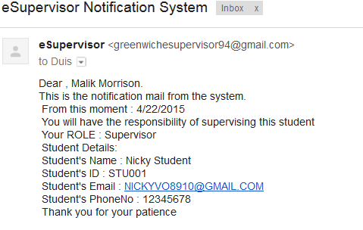

**Students’ Notification**

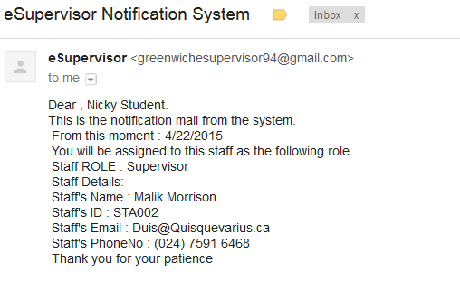

* + - 1. 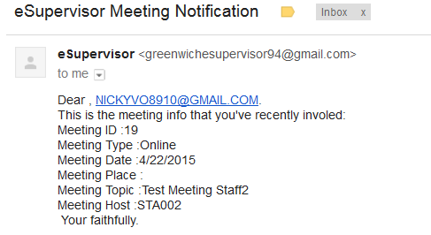Meeting Notification

#### Account Creation Notification

#### C:\Users\Nicky\Pictures\a.PNGC:\Users\Nicky\Pictures\b.PNG

#### Password Recovery System

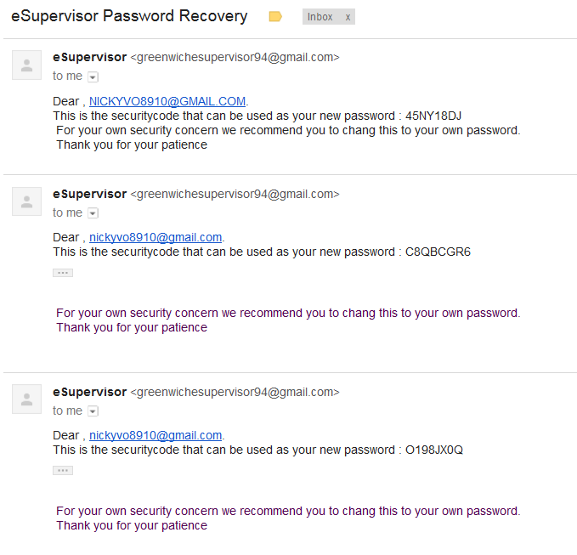

### Database design

Rev 1.0:

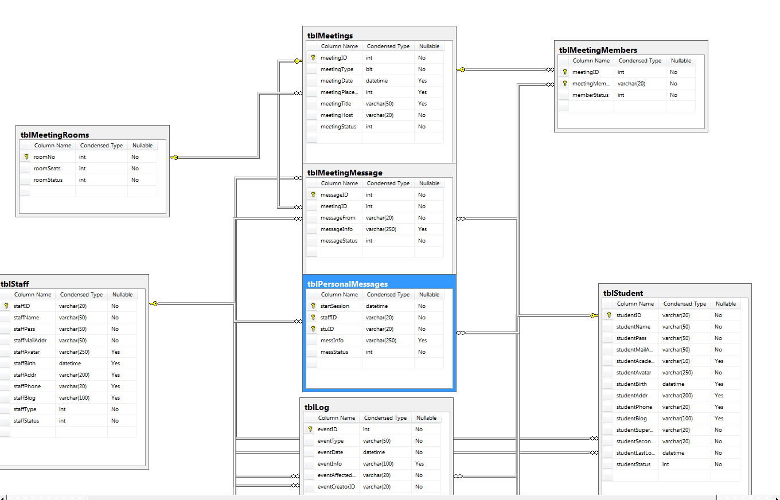

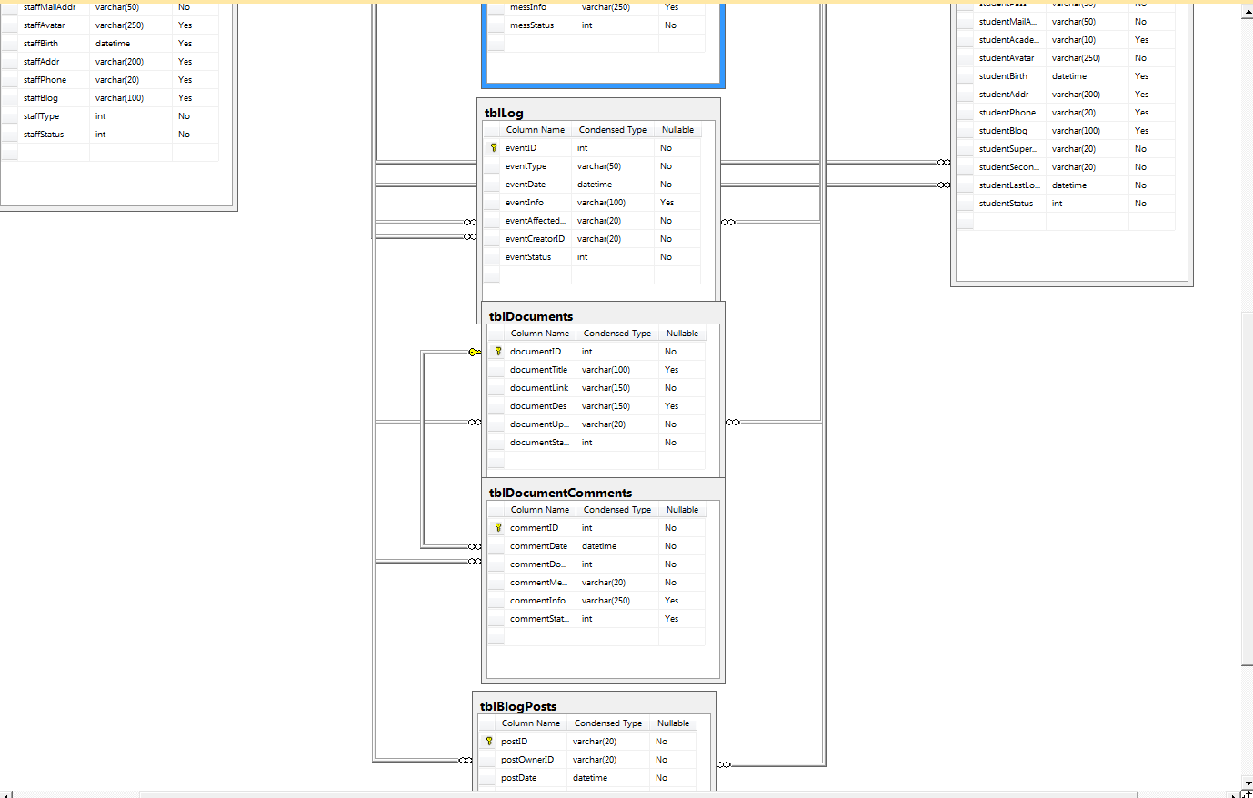

Final Rev:

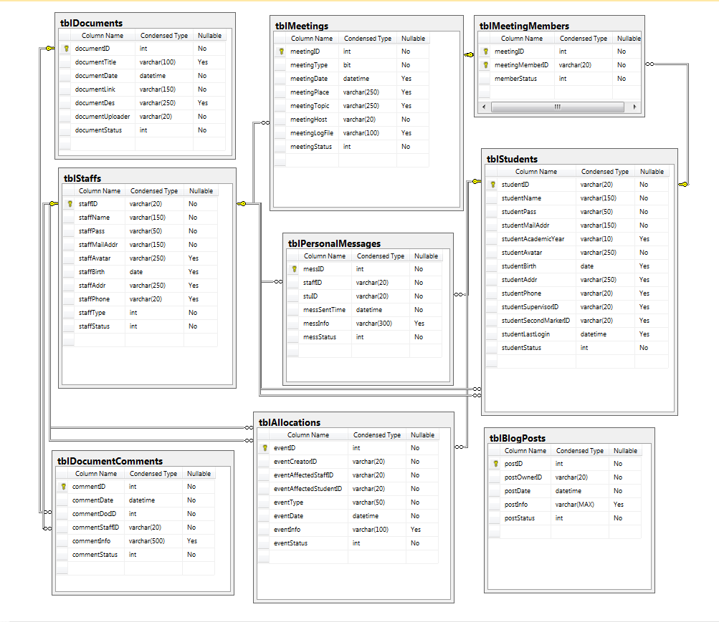

### Coding Modal & Technic

In the progress of making this web, I’ve been using a lot of coding modal. First of all, I used LINQtoSQL to get data in the database as it is the fastest way to get data from DB as I know. But then the problems came that is it is too hard to modify so I used Stored Procedure instead. Stored Procedure, despite of its flexibility in modification, is more likely for me to make mistakes.

Finally, after researching, I come up with 3-Layered Programming technic instead of implementing 3-tiered one. As the DTO, DAO classes help me a lot in programming this site.

### Uploading/Downloading Module

Uploading and downloading files is one of the smoothest part of this site because in the progress developing this module, I went through a lot of troubles and solved it appropriately.

### Meeting Logging Module

As meeting log is a long log of many people who involved so it is not good for the system as the database will grows and becomes heavy if we store this log in database. So that I decided to store the log in a file then link file path to the database.

## Bugs Log

In the progress coding this project, I’ve gone through many bugs and it do help me to improve my coding skill a lot also my problem analyzing skill. Here by is a list of some problems that I have faced and get over:

### Bug #1:

Name: Maximum request length exceeded

Reason: The size of file which is currently being uploaded to server through httpRequest makes the request length go oversized.

Solution:

I modified “maxRequestLength” and “maxAllowedContentLength”

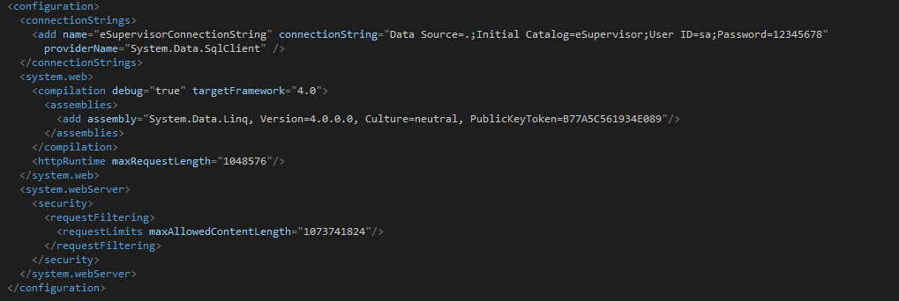

Reference: http://stackoverflow.com/questions/3853767/maximum-request-length-exceeded

### C:\Users\Nicky\Pictures\2303.PNGBug #2:

Name: Failed to map the path

Reason: IIS server has failed to map the path of current running folder

Solution: Change it into relative path

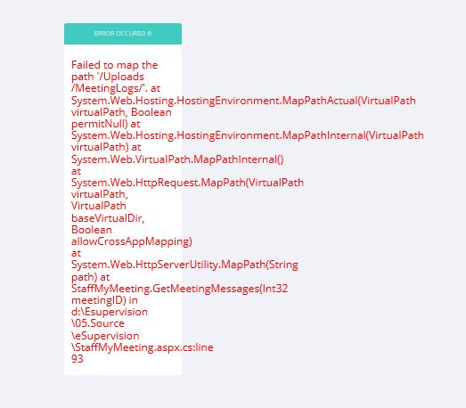Reference: <http://stackoverflow.com/questions/10951599/getting-current-directory-in-net-web-application>

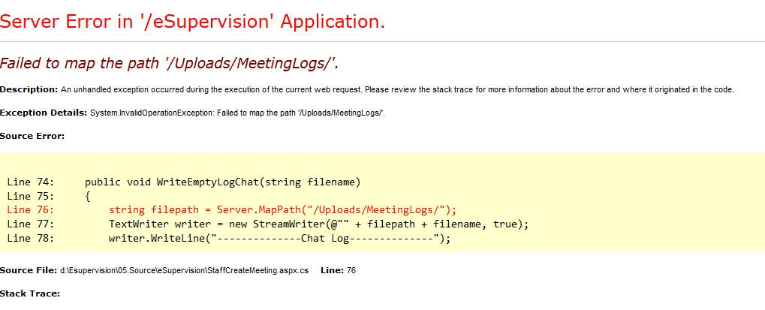 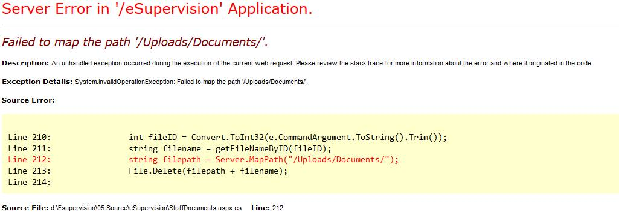

### Bug #3:

Name: Compilation Error

Reason: Main: IIS Server cannot find the DAO Object

Further: IIS Server did not recognize the site as an application but a static site

Solution: Add website as an application one

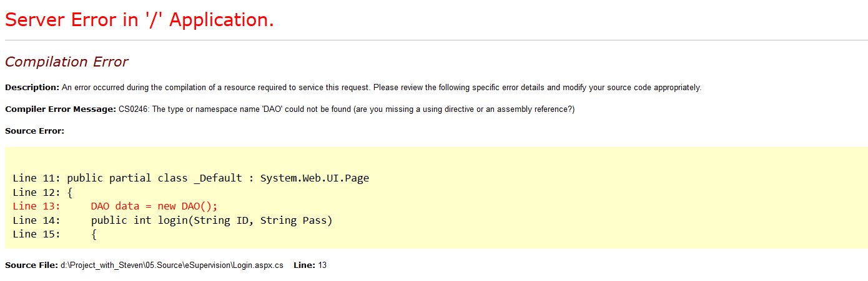Reference: No

### Bug #6:

Name: Thread has been aborted

Reason: Load Data to control event on Page post back

Solution: Only load data to control on the first page load.

Reference: No

### Bug #7:

Name: Data table/data row has no column

Reason: Adding data to data Table/data Row object without the required columns.

Solution: Add the required columns before adding data into it

Reference: No

# Appendix (Full Website Documentation- Group Work)



**ENTERPRISE WEB SOFTWARE DEVELOPMENT**

**COURSEWORK**

|  |  |  |  |
| --- | --- | --- | --- |
| **Group number** | **4** | | |
| **Members** | **Student Name** | **Student ID (FPT CMS)** | **Student ID Greenwich** |
| **Vo Minh Nhut** | **Nhutvmgc60222** | **000901562** |
| **Tran Nguyen Cong Nguyen** | **Nguyentncgc60263** |  |
| **Nguyen Ngoc Kieu Trinh** | **Trinhnnkgc60229** | **000901564** |
| **Do Ngoc Quy** | **Quydcgc60257** |  |
| **Class** | **GC0763** | | |
| **Instructor** | **Nguyen Van Sinh** | | |
| **Submission date** | **April 14 th  2015th** | | |

# Introduce

# Acknowledgment

I want to thank you Dr. Nguyen Van Sinh who supported my group complete coursework. Also, I’m thankful to his advised and realistic answers to this report.

# Abstract

This coursework is about to providing us an overview of enterprise management in large scale business.

Table of Contents

Acknowledgment 18

Abstract 19

1 Introduction 22

1.1 Motivation to build the system 22

1.2Proposed solution 23

a. eSupervisor Management System 23

b. Students' Dashboard 23

c. Online Meeting 24

d. Supervisors’ Dashboard/Second marker’s Dashboard 24

e. Managers’ Dashboards 24

1.3 Scope of the system 24

2 SystemOverview 24

2.1 Client requirement 24

a. Students 24

b. Staffs: 24

2.2 Requirement Analysis 25

2.3 System requirement 25

a. Hardware 25

*b.* Software 26

3 Assumption 26

3.1 Project Scope 26

4 Project plan 28

4.1 Individual Project schedule 28

4.2 Allocation of task 29

4.3 Logbook 30

4.4 NamingConvention 32

5 Design 33

5.1 Data flow diagram 33

5.1.1 Managers 33

5.1.2 Supervisor/Secondmarker 35

5.1.3 Students 36

5.2 Use case and sequence diagram 38

5.2.1 Managers 39

5.2.2 Supervisors/Secondmarker 73

5.2.3 Students 98

5.3 Entity Relationship Diagram 122

5.3.1 Conceptual 123

5.3.2 Logical 124

5.3.3 Physical 125

5.4 Table Properties 125

5.4.1 Properties of tblAllocations 125

5.4.2 Properties of tblMeetingMembers 126

5.4.3 Properties of tblDocuments 126

5.4.4 Properties of tblDocumentComments 127

5.4.5 Properties of tblMeetings 127

5.4.6 Properties of tblPersonalMessages 128

5.4.7 Properties of tblBlogPosts 128

5.4.8 Properties of tblStaffs 128

5.4.9 Properties of tblStudents 129

5.5 Database relationship diagram 130

5.6 Table Definition 131

5.6.1 Table Allocations 131

5.6.2 Table MeetingMembers 131

5.6.3 Table Documents 132

5.6.4 Table DocumentComments 132

5.6.5 Table Meetings 133

5.6.6 Table Personal Message 133

5.6.7 Table BlogPost 133

5.6.8 Table Staffs 134

5.6.9 Table Students 134

5.7 Class diagram 135

5.7.1 DTO 135

5.7.2 DAO 136

5.7.3 Connection 137

6 Human computer interaction discussion 137

6.1 Graphic User interface (Drafting) 137

6.1.1 Manager report 137

6.1.2 Personal profile 138

6.1.3 Blogging 139

6.1.4 Manage Staff 140

6.1.5 Allocate students 141

6.1.6 Manager dashboard 142

6.1.7 Create Meeting 142

6.1.8 Meeting 143

6.1.9 Upload document 144

6.2 Design interface by Quy 145

6.3 Full Design 162

6.3.1 “Login” page use for all actor. 163

6.3.2 Student 163

6.3.3 Manager 166

6.3.4 Supervisor/Secondmarker 168

6.4 Site map 171

6.4.1 Manager’s Site map 171

6.4.2 Staff’s site map 172

6.4.3 Student’s site map 172

7 Implementation 172

8 Installation guide 173

9 Testing 181

9.1 Test plan 181

9.1.1 Features to be tested 181

9.2 Test Log 190

10 Evaluation 200

10.1 Advantages 200

10.2 Disadvantages 200

11 References 200

# Introduction

## Motivation to build the system

* As science and technology have rapidly developed with many achievements, the education has too appeared with a new look in term of the wide application of new technologies in learning supporting and education management. Educational administration services are appeared to be more and more complete but students and staffs still have to face many difficulties in learning such as:
  + About students:

•Students are inactive in order to check the progresses of their assignments.  
• There are no dedicated place for individuals to express their ideas about the subject.  
•The receipt of study material is limited by physical methods.  
•Cannot be noticed on time about the changes in faculty or school announcements.

* + About staffs:

• Cannot know exactly who they have to guide and take responsibility of.  
• Difficulties in arranging rooms for meetings,

• Cannot communicate quickly with other staffs and students.  
• Cannot be noticed on time about the changes in faculty or school announcements.

## Proposed solution

* To solve those difficulties below, we have decided to create a new breakthrough in term of education managing and communicating by creating a specialized website of the school to help resolve the difficulties of teachers and improve the management for students. The system will help both parties have a professional working environment for students to achieve greater efficiency in communicating with some typical benefits such as:

### eSupervisor Management System

* eSupervisor is a user-friendly web-based communication and educational management system that supports a flexible communicating environment. Through it, we can easily arrange rooms for meeting, discussion, management supervisors for students, online collaboration and communication. It also supports online delivery of documents.

* Supervisors and students can contact with each other, conduct online discussions and enhance supervisors-students interaction. Students are strongly encouraged to access eSupervisor regularly in order to receive the latest announcements from the university.

### Students' Dashboard

* The Students' Dashboard contains a brief information of student such as personal information, latest notifications and important announcements from Supervisor and second marker. Students are advised to log in regularly for information updates and announcements.

### Online Meeting

* eSupervisor provides the virtual environment to conduct online meetings for academic talks, seminars and social activities to enrich students' experiences for their project.

### Supervisors’ Dashboard/Second marker’s Dashboard

* The Supervisors’ Dashboard contains useful information such as personal profile. Beside, Supervisor and second marker can also know who are under their guiding by this.

### Managers’ Dashboards

* Authorized staff can access to the dashboards of other staff and students.

## Scope of the system

-The system has been developed is unofficial system and it is not sufficient functionality. However, the system contains core functions:

* Login.
* Changing password/avatar or personal information.
* Personal blog.
* Messaging between students and supervisors.
* Organizing online/ offline meeting.
* Uploading/downloading/commenting documents.
* Assign instructors to students.

# SystemOverview

## Client requirement

### Students

* **Question 1: How does student can contact with staff?**
* **Answer**: A week, staffs will create meeting so exchanged views on student’s coursework. Also, students can send message for them by eSupervisor’s messaging.
* **Question 2:If students want to share comment about course what will they do?**
* **Answer:** Students can write or post every things in their blog of eSupervisor.

### Staffs:

* **Question 1: How does staff can guiding for students?**
* **Answer:** Staff easily create meeting online or offline for students by ‘Create New Meeting’ function on the system. In addition, they can send message or upload document for students if they want.
* **Question 2: How does assign students for supervisor/secondmarker?**
  + **Answer:** Staff will set supervisor/second marker for students**.**

## Requirement Analysis

* After further reading coursework specification , my group build system with functions:
* System has two actors :student and staff who is two type supervisor/ second marker and manager. Manager is person set supervisor/second marker for students and they do not send message or create meeting for students. But they can view statitics message between supervisor/second marker and students plus with some functions.
* The interface can be fitting for all devices (eg mobile phones, tablets, laptop, computers).
* ***Students***
* Instructed by supervisors and secondmarker.
* Receiving email from system about allocated/reallocated instructors.
* Messaging to supervisor/sencondmarker by eSupervision system.
* Receiving email from system about instructors’s meeting.
* Uploading/downloading/commenting documents and blogging.
* Having dashboard to interact with their supervisor/secondmarker.
* ***Staffs*** 
  + Allocating/reallocating supervisors and second markers for students.
  + Bulk allocation of students to their supervisor and second marker needs to be implemented.
  + Messaging to students by eSupervision system.
  + Arranging/Recording online/offline meetings.
  + Uploading/downloading/commenting documents and blogging.
  + Supervisor/secondmarker have dashboard to their project students.
  + Manager can access other staff’s dashboard and student’s dashboard.

## System requirement

1. Hardware

|  |  |
| --- | --- |
| Processor | Core i3 gen3 or higher is recomended |
| Memory | 4GB RAM or greater. |
| Monitor | 1024x768 or higher resolution with true color |
| Pointing Device | Microsoft Mouse, Microsoft IntelliMouse®, or compatible pointing device. |
| Modem/ADSL | Connecting to internet |

1. Software

|  |  |
| --- | --- |
| Operation System | Windows 7 |
| Browser | Mozilla Firefox 28 or higher |
| Database | Microsoft SQL Server 2012 |
| Software | Notepad/HTML editor/Java editor |
|  | j2sdk1.4.1_02 (or later) / .Net 4.5 / J2EE |

# Assumption

## Project Scope

This application is optimized to be used is a department of a university. As it would be a little bit confused for this website to be used in a whole university because the major categorizing is not mentioned in the scope of work. When assigning a faculty to student(s), the manager will be needed to make a decision on which academic that the student(s) is/are currently in to assign an appropriated faculty.

# Project plan

## Individual Project schedule

|  |  |  |  |  |  |  |
| --- | --- | --- | --- | --- | --- | --- |
| **No** | **Activity description** | **Planned date of Completion** | **Actual Date** | **Responsibility** | **Level of Completion** | **Remark** |
|  | Requirement Analysis | March 10th,2015 | March 10th,2015 | Nhut | 90% |  |
|  | Design database | March 12th,2015 | March 12th,2015 | Nhut | 70% |  |
|  | Deciding naming conventions | March 13th,2015 | March 13th,2015 | Nhut | 100% |  |
|  | Filling the project document formats(Introduction, System Overview, Project Plan, Design) | April 7th,2015 | April 7th,2015 | Trinh | 100% |  |
|  | Creating the database | March 15th ,2015 | March 20th,2015 | Nhut | 90% | He had problems with requirement analysis. |
|  | Designing the Login page | March 16th,2015 | March 16th,2015 | Quy | 100% |  |
|  | Designing all relating page of manager (Dashboard, manager Profile, Report, Managing Students, Managing Staff, Blogging, Add new Account) | March 20th,2015 | March 24th,2015 | Quy | 80% | He had problems with designing structures page for appropriate functions of system and high interacting. |
|  | Design all relating page of Staff (Dashboard, Staff Profile ,Meeting, Documents, Messaging, Blogging) | March 26th,2015 | March 26th,2015 | Quy | 90% |  |
|  | Design all relating page of Students(Dashboard, Student Profile, Edit Profile, Meeting, Messaging, Documents, Blogging) | March 27th,2015 | March 27th,2015 | Quy | 80% |  |
|  | Design Class diagram | April 13th ,2015 | April 13nd,2015 | Nguyen | 80% |  |
|  | Design Use case and sequence diagram off all user(manager , staff, students) | April 3th,2015 | April 3th,2015 | Trinh | 90% |  |
|  | Design data flow diagram, Entity relationship diagram  (Conceptual,Logical,Physiscal) | April 4th,2015 | April 4th,2015 | Nguyen | 100% |  |
|  | Writing introduction | April 9th,2015 | April 9th,2015 | Nhut | 100% |  |
|  | Filling up project documentation(Human computer interaction, Site map, Testing, Evaluation, Design ) | April 10th,2015 | April 10th,2015 | Trinh | 80% |  |
|  | Filling up project documentation about test plan and test log | April 12th,2015 | April 12th,2015 | Nguyen | 75% |  |
|  | Check validation of input | April 10th,2015 | April 10th,2015 | Nguyen | 80% |  |
|  | Solving Coding Problems and improving codes | April 15th,2015 | April 15th,2015 | Nhut | 100% |  |
|  | Solving some of the design problems | April 15th,2015 | April 15th,2015 | Nhut | 100% |  |
|  | Review Final Document | April 17th,2015 | April 17th,2015 | Nhut | 80% |  |

## Allocation of task

|  |  |  |
| --- | --- | --- |
| No | Task | Reponsibility |
|  | Designing and creating database | Nhut |
|  | Creating demo data for database | Nhut |
|  | Table properties | Nhut |
|  | UI designing for manager | Quy |
|  | UI designing for supervisor/ secondmarker | Quy |
|  | UI designing for student | Quy |
|  | Validating of input | Nguyen |
|  | Designing DFD | Nguyen |
|  | Designing ERD | Nguyen |
|  | Designing test plan | Nguyen |
|  | Testing Application and Logging | Nguyen |
|  | Designing format report | Trinh |
|  | Completing report | Trinh |
|  | Drafting UI | Trinh |
|  | Designing use case for manager, supervisor/sencondmarker. | Trinh |
|  | Drafting site map | Trinh |
|  | Designing sequence for manager, supervisor/sencondmarker. | Trinh |
|  | Writing project plan and individual project | Trinh |
|  | Screen shooting | Trinh |
|  | Writing installation guide | Trinh |

## Logbook

|  |  |  |  |  |  |  |  |  |  |
| --- | --- | --- | --- | --- | --- | --- | --- | --- | --- |
| **Week No** | **Date** | **Begin** | **Finish** | **Creator** | **Absent** | **Content** | **Allocation task** | **Author** | **Result** |
| 1 | March 10th, 2015 | 8:00 am | 11:00 am | Nhut | None | -Analysis requirement.  -Create individual Project plans. | 1. Create basic form for user. 2. Design database. 3. Design list of functions 4. Create basic report format | Quy  Nhut  Nguyen  Trinh | All of member done |
| 2 | March 17th, 2015 | 7:30 am | 11:20 am | Trinh | None | -Review allocation task meeting before.  -Choose working software(Visual studio 2012, ASP.Net, Java Script, Visual Paradigm, yEd Graph Editor, SQL Manager 2012) | 1. User interface design. 2. Preparing database and develop functions. 3. Drawing conceptual ERD, physical) 4. Writing introduction, system overview, drawing use case and sequence for manager, student, supervisor/second marker. | Quy  Nhut  Nguyen  Trinh | All of member done |
| 3 | March 24th, 2015 | 2:00pm | 5:30 pm | Nguyen | Quy | -Review allocation task meeting before.  -Debug project first time.  -Check report first time. | 1. Check validation of input. 2. Complete upload/download document, assign students and view report functions. 3. Filling up the project documentation (Database relationship diagram,table definition, table properties,class diagram,human computer interaction,site map.) | Nguyen  Nhut  Trinh | All of member done  Quy (Absent-NoReason) |
| 4 | April 4st, 2015 | 8:00am | 11:30am | Nhut | Quy | -Review task of members.  -Fix interface design.  -Test log the first time.  -Collecting all the component of members.  -Debug project the second time. | 1. Finalizing full of function. 2. Writing result of test log. 3. Filling up the document about evaluation, installation guide, testing. | Nhut  Nguyen  Trinh | All of member done  Quy (Absent-NoReason) |
| 5 | April 10th,2015 | 8:10am | 10:20am | Trinh | Quy | -Review task of members.  -Test plan and test log the last.  -Debug project the last.  -Final report |  |  | All of member done  Quy (Absent-NoReason) |

## NamingConvention

|  |  |
| --- | --- |
| **Objects** | **Naming Conventions** |
| Classes | Classes’ naming rule should be based on which that the class’s name can perfectly describe the represented objects. |
| Variables | Public variables: the first letter is always an uppercased one. Everything behind follows Camel Case.  Private variables: the first letter is always a lowercased one. |
| Controls | Labels : lblName  Textbox : txtName  Checkbox : chkName  Combobox/Dropdownlist : cmbName/drpName  Radiobutton : rdBtnName  Image: imgName |
| Files | File that uploaded to server or being stored in application should be named depends on which kind of data that they contain and furthermore to optimize the application flows in order to avoids filename confliction. |

# Design

## Data flow diagram

* Data flow diagram explain the data will be transferred and processed in the system. It helps programmer clearly know data transferred among modules. Also, the diagram is useful improve features and design groups visualize data processing. And in the coursework my group has three type actors so has three view of data flow diagram.

### Managers

-Data flow of manager created by Tran Nguyen Cong Nguyen.

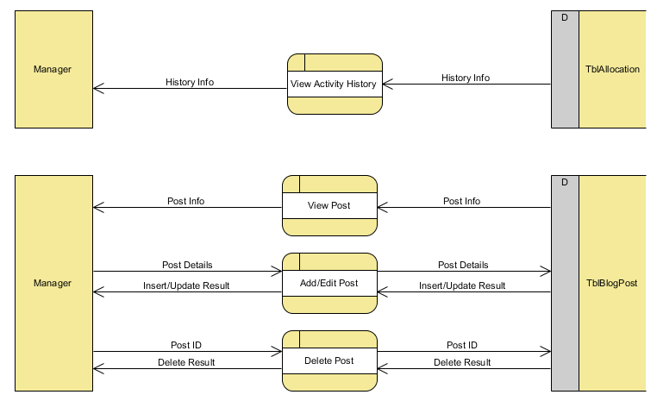

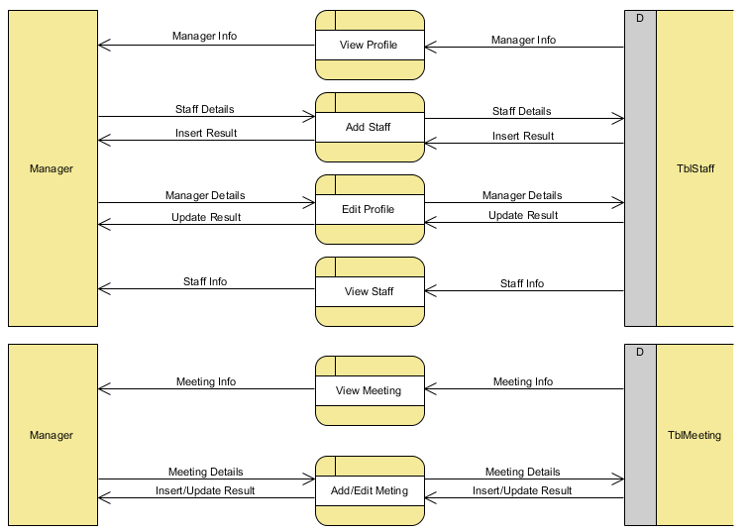

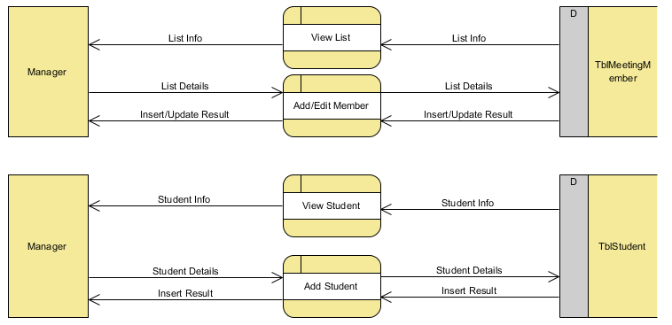

### Supervisor/Secondmarker

-Data flow of manager created by Tran Nguyen Cong Nguyen.

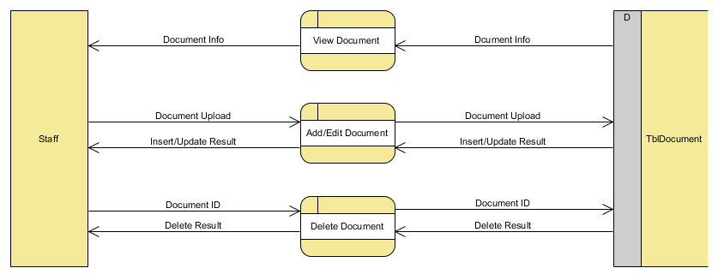

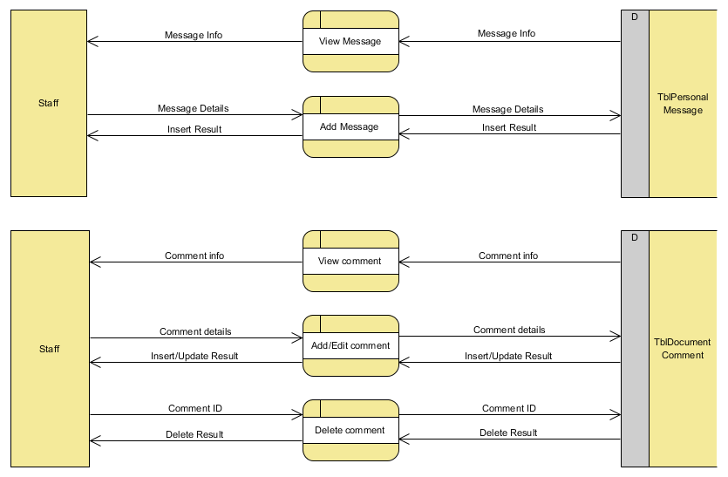

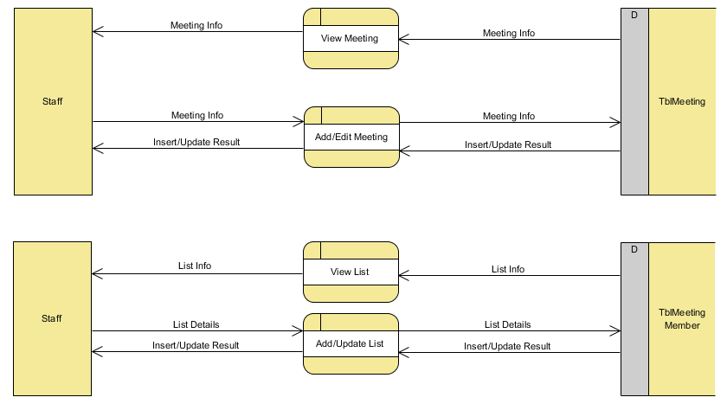

### Students

-Data flow of manager created by Tran Nguyen Cong Nguyen.

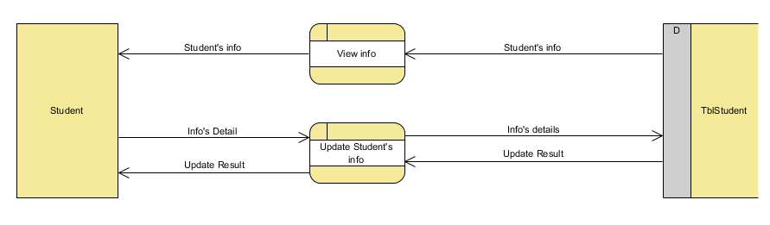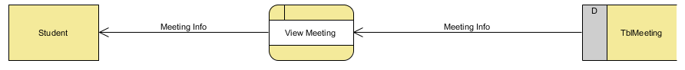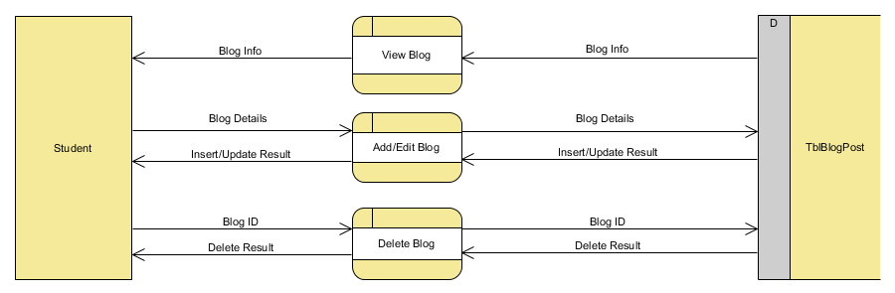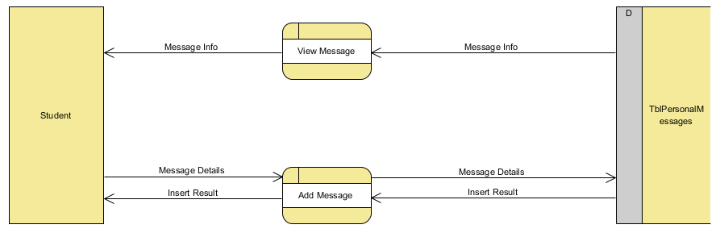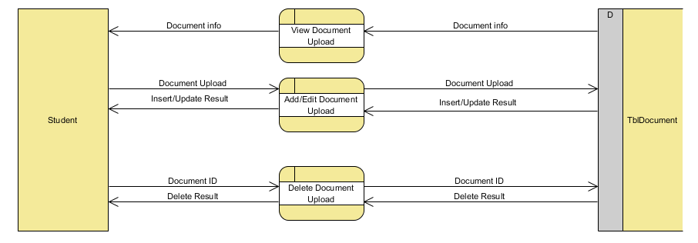

## Use case and sequence diagram

-Use case shown actually actions between users and system. It helps design teams understand activities toward difference actor and development functions.

-Sequence diagram are used to describe interact of user in the system in detail state.

### Managers

t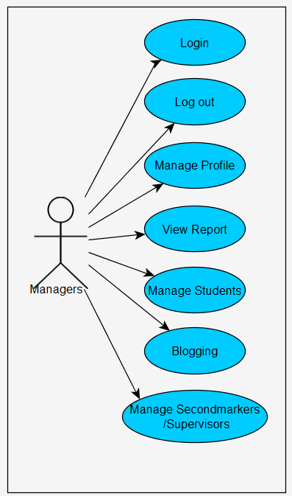

#### Login

|  |  |  |
| --- | --- | --- |
| **Author** | Nguyen Ngoc Kieu Trinh | |
| **Use Case Name** | Login | |
| **Actors** | Managers | |
| **Description** | Managers want to login to website as a manager. | |
| **Requirements** | Actor provides user ID and password | |
| **Pre-conditions** |  | |
| **Post-conditions** | Success: Manager logged in to website.  Fail: Refill information | |
| **Basic flow** | Actor Actions:  1. Actor go to Login page of website.  3. Actor inputs User ID and Password, then click the Login button. | System Responses:  2. System redirects to Login page and displays Login form on the left with the following control:  - ‘ID’ textfield  - ‘Password’ textfield  - ‘Sign In’ button  -‘Forgot Password’ link  4. System checks the information  [Exception 1]  5. System redirects to Actor’s Login page. |
| **Alternative flow** | Actor Actions:   1. Actor click ‘Sing In’ button   . | System Responses:  1. System checks the information  [Exception 1]  2. System redirects to Actor’s Login page and show message ‘Login failed. Try again’ |
| **Exception** | Actor Actions:  [Exception 1]   1. Actor input invalid id and password. 2. Actor input ID and click Sign In button 3. Actor input username and password don’t same with database. | -System show message :  -System show message:” ‘Login failed. Try again’  -System show message ‘Login failed. Try again’  --System show message ‘Login failed. Try again’ |

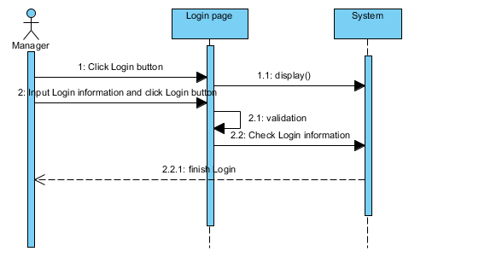

#### Logout

|  |  |  |
| --- | --- | --- |
| **Author** | Nguyen Ngoc Kieu Trinh | |
| **Use Case Name** | Log out | |
| **Actors** | Manager | |
| **Description** | Manager wants to log out of the System. | |
| **Requirements** | Actor provides log out button | |
| **Pre-conditions** | Actor has logged in. | |
| **Post-conditions** | Success: Actor Logged out. | |
| **Basic flow** | Actor Actions:  1. Actor clicks ‘Log out’ button on the Manager’s menu in the left screen.   1. Actor clicks ‘Yes’ button in the alert. | System Responses:  - System show message :”Do you want to log out?”  - System process to Log user out then redirect to Login page. |
| **Alternative flow** | Actor action:   1. Actor click ‘No’ button . | System Responses:  -System cancel Log out. |
| **Exception** |  |  |

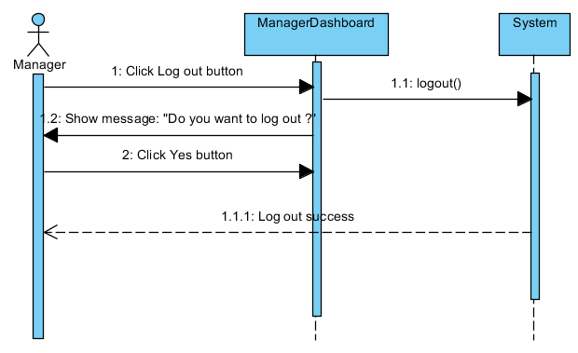

#### Manage profile

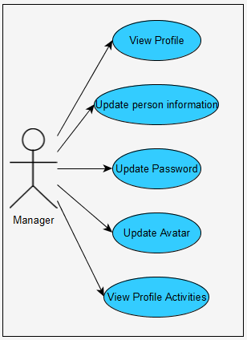

* **View Profile**

|  |  |  |
| --- | --- | --- |
| **Author** | Nguyen Ngoc Kieu Trinh | |
| **Use case name** | View Profile | |
| **Actors** | Managers | |
| **Description** | View Profile | |
| **Requirements** | Managers can view private information. | |
| **Post-conditions** | Actor login as Manager | |
| **Basic flow** | Actor actions:   1. From ‘Login’ page, actor clicks on to the ‘Profile’ on the side bar in the left screen. | System response:  2. System redirects to ‘Profile’ page and display all of personal info in the textbox :  -ID  -Name  -Email  -Address  -Academic Year  -Birthday  -Mobile |
| **Alternative flow** |  |  |
| **Exception** |  |  |

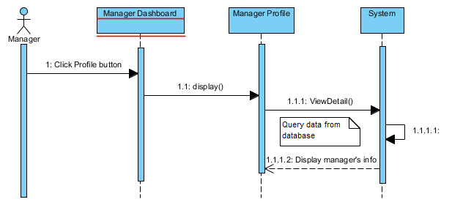

* **Update personal information**

|  |  |  |
| --- | --- | --- |
| **Author** | Nguyen Ngoc Kieu Trinh | |
| **Use Case Name** | Update Profile | |
| **Actors** | Manager | |
| **Description** | Manager wants to Update his/her profile’s information. | |
| **Requirements** | Actor provides profile information | |
| **Pre-conditions** | Actor has logged in. | |
| **Post-conditions** | Success: Profile’s information of this user has been updated.  Fail: Refill information | |
| **Basic flow** | Actor Actions:  1. Actor clicks ‘Edit Profile’ button below avatar of his/her in ‘Manager Profile’ page.  3. Actor updates information of them and click ‘Save’ button. [Alternative 1] | System Responses:   1. System redirects to ‘Manager Profile Edit ‘page and displays Update Profile form with the following control :   - ‘Name’ textfield  - ‘Birthday’ date picker  - ‘Address’ textfield  - ‘Email’ textfield  - ‘Phone’ textfield  - ‘Save’ button  - ‘Cancel’ button  4. System checks the information  [Exception 1]  5. System update the account into database and then redirects to Manager Profile page. |
| **Alternative flow** | Actor Actions:  [Alternative 1]   1. Actor click ‘Cancel’ button. | System Responses:   1. Information not change and system returns to Manager Profile page. |
| **Exception** | Actor Actions:  [Exception 1]  1. Actor lefts ‘Name’ textfield blank.  2. Actor lefts ‘Phone’ textfield blank.  3. Actor lefts ‘Address’ textfield blank.  4. Actor left ‘Email’ textfield blank.  5. Actor left ‘Mobile’ text blank | System Responses:  System displays message to Actor :  - ‘Name can’t be blank’’.  - ‘Phone can’t be blank’.  -‘Address can’t be blank’.  -‘Email can’t be blank.’  -‘Mobile can’t be blank.’ |

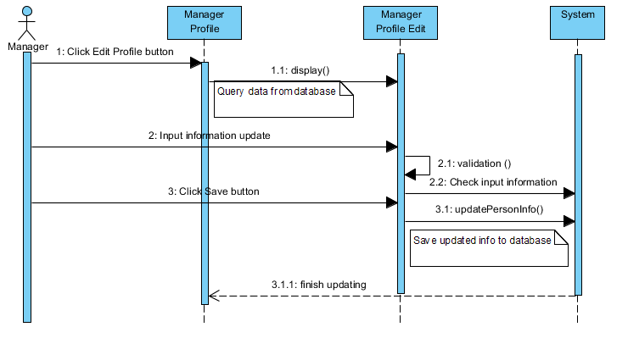

* **Update Password and Avatar**

|  |  |  |
| --- | --- | --- |
| **Author** | Nguyen Ngoc Kieu Trinh | |
| **Use case name** | Change Password and avatar | |
| **Actors** | Manager | |
| **Description** | Change Password and avatar | |
| **Requirements** | Actor provides Current Password | |
| **Pre-conditions** | Actor has logged in as Manager | |
| **Post-conditions** | Success: The password of Manager has changed. | |
| **Basic flow** | Actor actions:  1. From ‘Manager Profile’ page, actor clicks on to the ‘Edit Profile’ button.  3. Actor clicks on to ‘Save’ button to finish changing. [Alternative 1] | System response:  2. System redirects to ‘Manager Profile Edit’ page and display form with the following controls:  -‘Current Password’ textfield.  -‘New Password’ textfield.  -‘Re-type New Password’ textfield.  -‘Image’ box  -‘Select image’ button  -‘Save’ button.  ‘Cancel’ button  4. System checks input information.  [Exception 1]  5. System update new password and new avatar of manager into the database. |
| **Alternative flow** | [Alternative 1]  -Actor click ‘Cancel’ button | -System redirect to Manager Profile page. |
| **Exception** | [Exception 1]  1. Actor lefts ‘Current Password’ textfield.  2. Actor lefts ‘New Password’ textfield.  3. Actor lefts ‘Re-type New Password’ textfield.  4. ‘Re-type New Password’ textfield is not same as ‘New Password’ textfield. | System displays a message to notice actor:  -“Current Password can’t be blank.”  -“New Password can’t be blank.”  -“Re-typeNew Password can’t be blank.”  “Re-type New Password and New Password must be same.” |



* **View Profile Activities**

|  |  |  |
| --- | --- | --- |
| **Author** | Nguyen Ngoc Kieu Trinh | |
| **Use case name** | View Profile Activities | |
| **Actors** | Managers | |
| **Description** | View Profile Activities | |
| **Requirements** | Managers can view private information. | |
| **Post-conditions** | Actor login as Manager | |
| **Basic flow** | Actor actions:  1.From ‘Manager Profile’ page, actor clicks on to the ‘Recent Notification’ in the left screen below avatar.   1. Actor click ‘Load Old Activities’ button | System response:  2. System redirects to ‘Manager Profile Activities’ page and display notification of personal:  -Allocation  -‘Load Old Activities’ button.   1. System load old activities |
| **Alternative flow** |  |  |
| **Exception** |  |  |

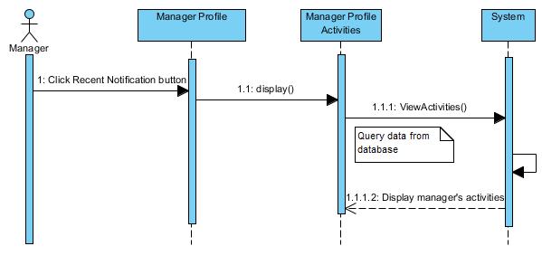

#### View Report

|  |  |  |
| --- | --- | --- |
| **Author** | Nguyen Ngoc Kieu Trinh | |
| **Use case name** | View Report | |
| **Actors** | Manager | |
| **Description** | View report | |
| **Requirements** | Manager can | |
| **Post-conditions** | Actor login as Manager | |
| **Basic flow** | Actor actions:   1. From ‘ManagerDashboard’ page, actor clicks on to the ‘Report’ in the navigation bar. 2. Actor clicks ‘Submit’ button on the Actor Home page menu. | System response:  2. System redirects to ‘Report’ page and display some report by chart :  -Chart 1: show average number of messages for each supervisor.  -Chart 2: display number of messages in last 7 days. |
| **Alternative flow** |  |  |
| **Exception** |  |  |

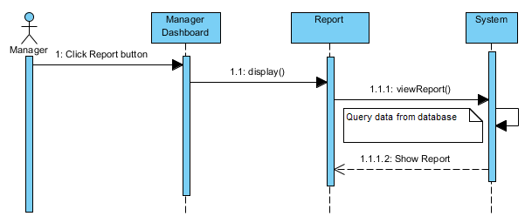

#### Manage students

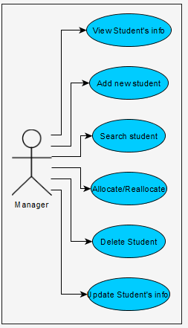

* **View Student’s information**

|  |  |  |
| --- | --- | --- |
| **Author** | Nguyen Ngoc Kieu Trinh | |
| **Use case name** | View Student’s information | |
| **Actors** | Managers | |
| **Description** | View Student’s information | |
| **Requirements** | Managers can view basic Student’s information. | |
| **Post-conditions** | Actor login as Manager | |
| **Basic flow** | Actor actions:   1. From ‘Manager Dashboard’ page, actor clicks on to the ‘Managing Students’ on the side bar in the left screen. | System response:  2. System redirects to ‘Managing students’ page and display some information of student in the table with :  -Student ID  -Student Name  -Student Email  -Student Birthday  -Supervisor  -Second marker  -Status |
| **Alternative flow** |  |  |
| **Exception** |  |  |

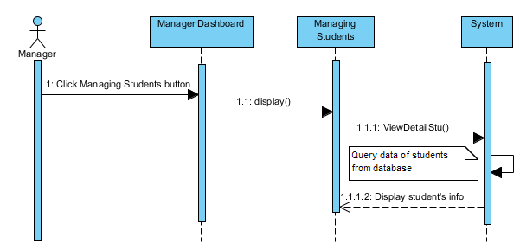

* **Add new student**

|  |  |  |  |
| --- | --- | --- | --- |
| **Author** | Nguyen Ngoc Kieu Trinh | | |
| **Use Case Name** | Add User Account for Student | | |
| **Actors** | Manager | | |
| **Description** | Manager wish to add new Student Account | | |
| **Requirements** | Manager must be provide some student’s information. | | |
| **Pre-conditions** | Actor has logged in as Manager. | | |
| **Post-conditions** | Success: Add User Account successful  Fail: Refill information | | |
| **Basic flow** | Actor Actions:  1. Actor clicks ‘Add New Student’ button on ’Managing Student’ page.  4. Actor click ‘Submit’ button.  [Alternative 1] | System Responses:  2. System redirects to ‘Add Student ’page and displays form for Actor to input information with the following control :  -‘Student ID’ text field  -‘Student Name’ text field  -‘Student Email’ text field  -‘Academic year’ text field  -‘Mobile’ text field  -‘Address’ text field  -‘DateOfBirth’ date picker  -‘Submit’ button  -‘Reset’ button  3. System checks information input [Exception 1]  6. System add student into database then display message ‘Student has been add successful’. | |
| **Alternative flow** | Actor Actions:  [Alternative 1]  -Actor click ‘Reset’ button | System Response:  -System will reset all information of in form. |
| **Exceptions** | Actor Actions:  [Exception 1]  1. Actors left ‘Student ID’ text field blank  2. Actor left ‘Student Name’’ text field blank.  3. Actor left ‘Student Email’ text field blank. | System Response:  1. System displays message to notice: ‘Student Id can’t be blank’.  2. System displays message to notice:’ Student Name’ can’t be blank.’  3. System displays message to notice  ’Student email can’t be blank.’ |

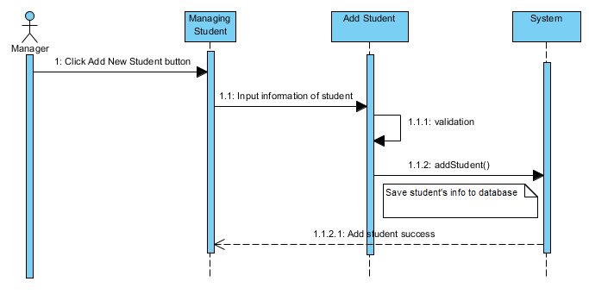

* **Search student**

|  |  |  |
| --- | --- | --- |
| **Author** | Nguyen Ngoc Kieu Trinh | |
| **Use Case Name** | Property for student | |
| **Actors** | Manager | |
| **Description** | Manager wants to perform a Property for student | |
| **Requirements** | Actor provides search information | |
| **Post-conditions** | Success: Properties match the condition show up.  Fail: Do not have any property match the condition. | |
| **Basic flow** | Actor Actions:  1. Actor clicks ‘Search’ button on the “Managing Student” page.  3.Actor inputs searching’s information and click ‘Search’ button’ | System Responses:  2. System display form with the following controls:  - Search by student’s name text field.  4. System select the properties in database that match searching condition and display the result in the Searching Result list below the table in Managing student page. |
| **Alternative flow** |  |  |
| **Exception** |  |  |

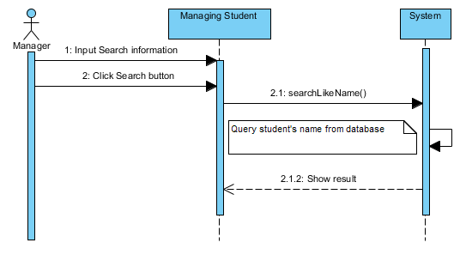

* **Allocate/Reallocate**

1. **Set Supervisor**

|  |  |  |  |
| --- | --- | --- | --- |
| **Author** | Nguyen Ngoc Kieu Trinh | | |
| **Use Case Name** | Allocate student | | |
| **Actors** | Manager | | |
| **Description** | Manager set Supervisor for Student | | |
| **Requirements** | Manager should be students need to assign Supervisor | | |
| **Pre-conditions** | Actor has logged in as Manager. | | |
| **Post-conditions** |  | | |
| **Basic flow** | Actor Actions:  1. Actor clicks ‘Assign Supervisor’ button on ’Managing Dashboard’ page.  [Alternative 1]   1. Actor click ‘Assign’ button in ‘Staff Allocation’page 2. Actor click ‘Assign Students’ button. | System Responses:  2. System redirects to ‘Staff Allocation’page and displays some Supervisor with the following control:  -Name  -Avatar  -Detail button   1. System redirects to ‘Staff Allocation’page and displays table for Actor to choose students need to assign with the column following control :   -‘Student ID’  -‘Student Name’  -‘Student Email’  -‘Birthday’  -‘Supervisor’  -‘Second marker’  -‘Status’  -‘Assign Students’ button  6.System will set Students’ Supervisor to the chosen Staff | |
| **Alternative flow** | Actor Actions:  [Alternative 1]   1. Actor click ‘Detail’ button | System Response:   1. System will show detail information of Supervisor by dialog box with some information:   -‘Staff ID’  -‘Staff Email’  -‘Staff birthday’  -‘Current students’ |
| **Exceptions** |  |  |

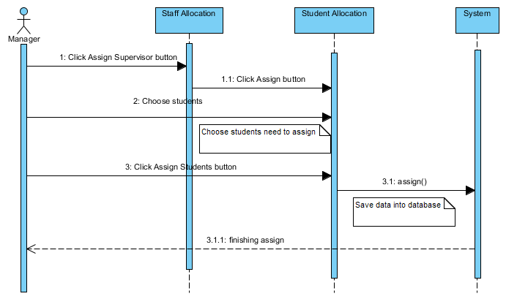

1. **Set Second marker**

|  |  |  |  |
| --- | --- | --- | --- |
| **Author** | Nguyen Ngoc Kieu Trinh | | |
| **Use Case Name** | Allocate student | | |
| **Actors** | Manager | | |
| **Description** | Manager set Second marker for Student | | |
| **Requirements** | Manager should be students need to assign Second marker | | |
| **Pre-conditions** | Actor has logged in as Manager. | | |
| **Post-conditions** |  | | |
| **Basic flow** | Actor Actions:  1. Actor clicks ‘Assign Sencondmarker’ button on ’Managing Dashboard’ page.  [Alternative 1]   1. Actor click ‘Assign’ button in ‘Staff Allocation’page 2. Actor click ‘Assign Students’ button. | System Responses:  2. System redirects to ‘Staff Allocation’page and displays some Sencondmarker with the following control:  -Name  -Avatar  -Detail button   1. System redirects to ‘Staff Allocation’page and displays table for Actor to choose students need to assign with the column following control :   -‘Student ID’  -‘Student Name’  -‘Student Email’  -‘Birthday’  -‘Supervisor’  -‘Second marker’  -‘Status’  -‘Assign Students’ button  6.System will set Students’ Sencond marker to the chosen Staff | |
| **Alternative flow** | Actor Actions:  [Alternative 1]   1. Actor click ‘Detail’ button | System Response:   1. System will show detail information of Sencondmarker by dialog box with some information:   -‘Staff ID’  -‘Staff Email’  -‘Staff birthday’  -‘Current students’ |
| **Exceptions** |  |  |

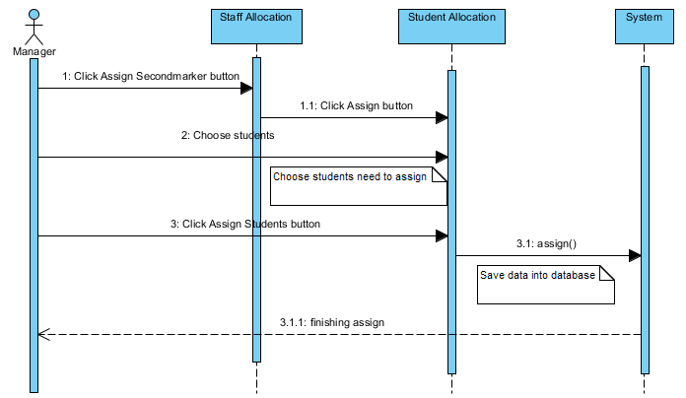

* **Delete student**

|  |  |  |  |  |
| --- | --- | --- | --- | --- |
| **Author** | Nguyen Ngoc Kieu Trinh | | | |
| **Use Case Name** | Change Status student | | | |
| **Actors** | Manager | | | |
| **Description** | Manager wish to change status student. | | | |
| **Requirements** | Manager must be choose user to delete. | | | |
| **Pre-conditions** | Actor has logged in as Manager | | | |
| **Post-conditions** | Success: Change status student successful  Fail: Error Page show | | | |
| **Basic flow** | | | Actor Actions:  1. Actor clicks Delete button on Managing Student page.  3. Actor clicks Yes button on message  [Alternative 1] | System Responses:  2. System show alert message:” Do you want to delete this student”. With Yes and No button.  4. System delete user from database then display message ‘Delete user successful’. |
| **Alternative flow** | | | Actor Actions:  [Alternative 1]  Actor clicks No button on message | System Responses:  System returns to current page. |
| **Exceptions** | | |  |  |

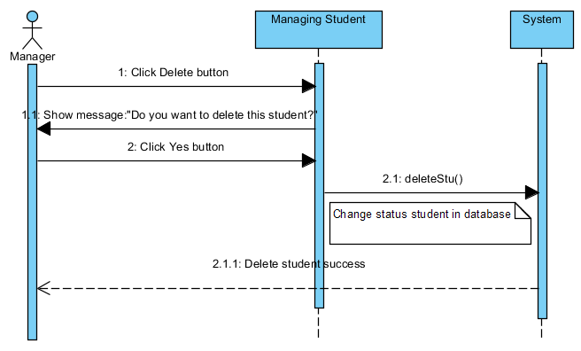

* **Update Student’s information by Managers**

|  |  |  |  |
| --- | --- | --- | --- |
| **Author** | Nguyen Ngoc Kieu Trinh | | |
| **Use Case Name** | Update student’s information. | | |
| **Actors** | Manager | | |
| **Description** | Manager wish to update Student’s info. | | |
| **Requirements** | Manager must be provide some student’s information. | | |
| **Pre-conditions** | Actor has logged in as Manager. | | |
| **Post-conditions** | Success: Add User Account successful  Fail: Refill information | | |
| **Basic flow** | Actor Actions:  1. Actor clicks ‘Update’button on ’Managing Student’ page.  4. Actor click ‘Create’ button.  [Alternative 1] | System Responses:  2. System redirects to ‘Add Student ’page and displays form for Actor to input information with the following control :  -‘Student ID’ text field  -‘Student Name’ text field  -‘Student Email’ text field  -‘Academic year’ text field  -‘Mobile’ text field  -‘Address’ text field  -‘DateOfBirth’ date picker  -‘Update’ button  -‘Cancel’ button  3. System checks information input [Exception 1]  6. System update student into database then display message ‘Student has been update successful’. | |
| **Alternative flow** | Actor Actions:  [Alternative 1]  -Actor click ‘Cancel’ button | System Response:  -System will redirect to ‘Managing Student’ page. |
| **Exceptions** | Actor Actions:  [Exception 1]   1. Actor left ‘Student Name’’ text field blank.   3. Actor left ‘Student Email’ text field blank. | System Response:  2. System displays message to notice:’ Student Name’ can’t be blank.’   1. System displays message to notice   ’Student email can’t be blank.’ |

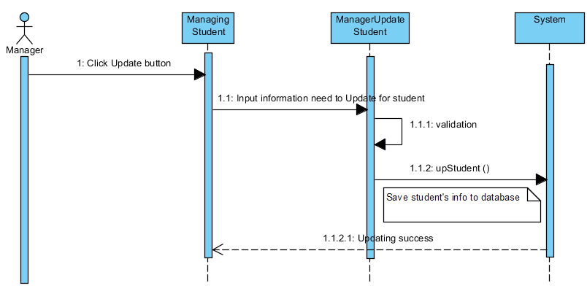

#### Blogging

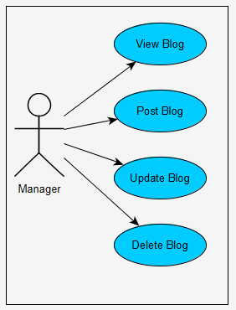

* **View Blog and Post Blog**

|  |  |  |
| --- | --- | --- |
| **Author** | Nguyen Ngoc Kieu Trinh | |
| **Use case name** | View manager’s blogging | |
| **Actors** | Managers | |
| **Description** | View or post manager’s blogging | |
| **Requirements** | Managers view, post their blogging | |
| **Post-conditions** | Actor login as Manager | |
| **Basic flow** | Actor actions:   1. From ‘Manager Dashboard’ page, actor clicks on to the ‘Blogging’ on the side bar in the left screen. 2. Actor click ‘Post ’ button. | System response:  -System redirects to ‘Manager blogging’ page and display form with the following controls:  -Manager’s emotion textfield  -Post button  -Delete button  -Update button.  -System will post manager’s emotion to Blogging page. |
| **Alternative flow** | Actor Actions:  [Alternative 1]   1. Actor click ‘Update’ button 2. Actor click ’Delete’ button | System Responses:  -System will update manager ‘s emotion.  -System will delete manager ‘s emotion. |
| **Exception** |  |  |

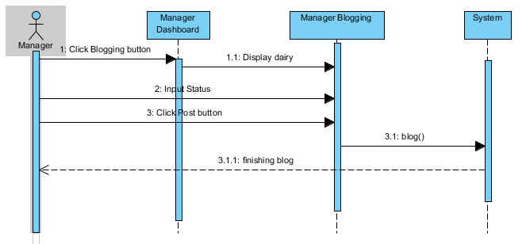

* **Update Blog**

|  |  |  |
| --- | --- | --- |
| **Author** | Nguyen Ngoc Kieu Trinh | |
| **Use case name** | Update manager’s blogging | |
| **Actors** | Managers | |
| **Description** | Update manager’s blogging | |
| **Requirements** | Managers update their blogging | |
| **Post-conditions** | Actor login as Manager | |
| **Basic flow** | Actor actions:   1. From ‘Manager Dashboard’ page, actor clicks on to the ‘Blogging’ on the side bar in the left screen. 2. Actor click ‘Update’ button. 3. Actor click ‘Close’ button. 4. Actor click ‘Save change’ button. | System response:  -System redirects to ‘Manager blogging’ page and display form with the following controls:  -Manager’s emotion textfield  -Post button  -Delete button  -Update button.  -System will show update status dialog with ‘Close’ and ‘Save changes’ button.  -Update status dialog will be close.  -System will be update manager’s status. |
| **Alternative flow** | Actor Actions:  [Alternative 1]   1. Actor click ’Delete’ button | System Responses:  -System will delete manager ‘s emotion. |
| **Exception** |  |  |

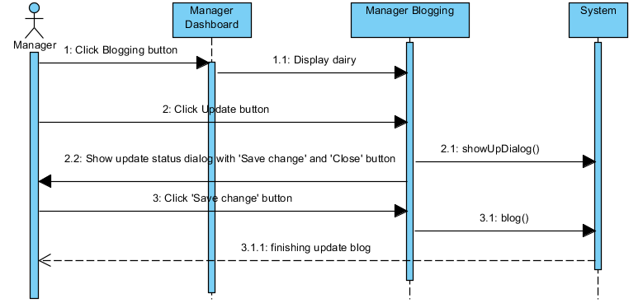

* **Delete Blog**

|  |  |  |
| --- | --- | --- |
| **Author** | Nguyen Ngoc Kieu Trinh | |
| **Use case name** | Delete manager’s blogging | |
| **Actors** | Managers | |
| **Description** | Delete manager’s blogging | |
| **Requirements** | Managers delete their blogging | |
| **Post-conditions** | Actor login as Manager | |
| **Basic flow** | Actor actions:   1. From ‘Manager Dashboard’ page, actor clicks on to the ‘Blogging’ on the side bar in the left screen. 2. Actor click ’Delete’ button 3. Actor click ‘Yes’ button | System response:  -System redirects to ‘Manager blogging’ page and display form with the following controls:  -Manager’s status textfield  -Post button  -Delete button  -Update button.  -System will show message: ’Do you want to delete status?’  -System will delete status. |
| **Alternative flow** | Actor Actions:  [Alternative 1]   1. Actor click ‘No’ button | System Responses:  -.System will redirects to ‘Manager Blogging’. |
| **Exception** |  |  |

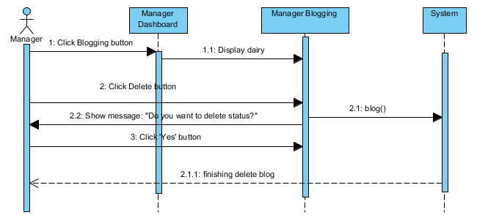

#### Manage Supervisor/Secondmarker

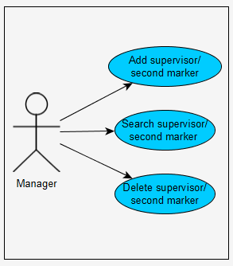

* **View Supervisor ‘s /second marker’s information**

|  |  |  |
| --- | --- | --- |
| **Author** | Nguyen Ngoc Kieu Trinh | |
| **Use case name** | View Supervisor ‘s /second marker’s information | |
| **Actors** | Managers | |
| **Description** | View Supervisor ‘s /second marker’s information | |
| **Requirements** | Managers can view basic Supervisor ‘s /second marker’s information. | |
| **Post-conditions** | Actor login as Manager | |
| **Basic flow** | Actor actions:   1. From ‘Manager Dashboard’ page, actor clicks on to the ‘Managing Staffs’ on the side bar in the left screen. | System response:  2. System redirects to ‘Managing Staff ’ page and display some information of student in the table with :  -Staff ID  -Staff Name  -Staff Email  -Staff Birthday  -Type  -Status  -Update button  -Delete button |
| **Alternative flow** |  |  |
| **Exception** |  |  |

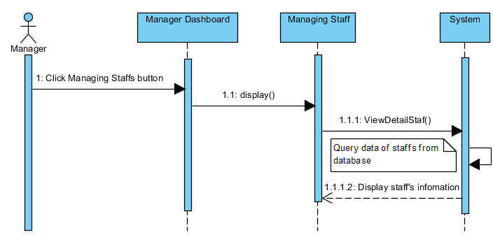

* **Add new Staff**

|  |  |  |  |
| --- | --- | --- | --- |
| **Author** | Nguyen Ngoc Kieu Trinh | | |
| **Use Case Name** | Add new Staff | | |
| **Actors** | Manager | | |
| **Description** | Manager wish to add new Staff | | |
| **Requirements** | Manager must be provide some Staff’s information. | | |
| **Pre-conditions** | Actor has logged in as Manager. | | |
| **Post-conditions** | Success: Add User Account successful  Fail: Refill information | | |
| **Basic flow** | Actor Actions:  1. Actor clicks ‘Add New Student’ button on ’Managing Student’ page.  4. Actor click ‘Submit’ button.  [Alternative 1] | System Responses:  2. System redirects to ‘Add Student ’page and displays form for Actor to input information with the following control :  -‘Account Type’ text field  -‘Staff ID’ text field  -‘Name’ text field  -‘Staff Email’ text field  -‘Academic year’ text field  -‘Mobile’ text field  -‘Address’ text field  -‘DateOfBirth’ date picker  -‘Submit’ button  -‘Reset’ button  3. System checks information input [Exception 1]  6. System add student into database then display message ‘Staff has been add successful’. | |
| **Alternative flow** | Actor Actions:  [Alternative 1]  -Actor click ‘Reset’ button | System Response:  -System will reset all information of in form. |
| **Exceptions** | Actor Actions:  [Exception 1]  1. Actors left ‘Staff ID’ text field blank  2. Actor left ‘Staff Name’’ text field blank.  3. Actor left ‘Staff Email’ text field blank. | System Response:  1. System displays message to notice: ‘Staff ID’ can’t be blank’.  2. System displays message to notice:’ Staff Name’ can’t be blank.’  3. System displays message to notice  ’ Staff email can’t be blank.’ |

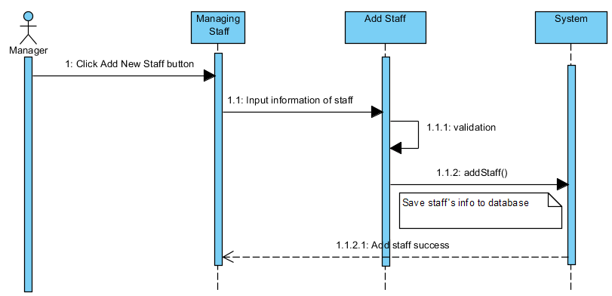

* **Search Staff**

|  |  |  |
| --- | --- | --- |
| **Author** | Nguyen Ngoc Kieu Trinh | |
| **Use Case Name** | Property for Staff | |
| **Actors** | Manager | |
| **Description** | Manager wants to perform a Property for Staff | |
| **Requirements** | Actor provides search information | |
| **Post-conditions** | Success: Properties match the condition show up.  Fail: Do not have any property match the condition. | |
| **Basic flow** | Actor Actions:  1. Actor clicks ‘Search’ button on the “Managing Staff” page.  3.Actor inputs searching’s information and click ‘Search’ button’ | System Responses:  2. System display form with the following controls:  - Search by Staff’s name text field.  4. System select the properties in database that match searching condition and display the result in the Searching Result list below the table in Managing Staff page. |
| **Alternative flow** |  |  |
| **Exception** |  |  |

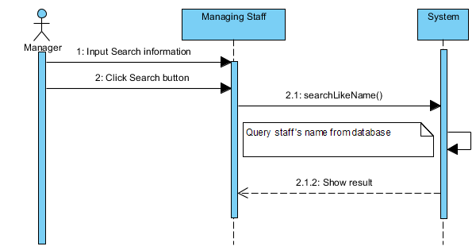

* **Delete Staff**

|  |  |  |  |  |
| --- | --- | --- | --- | --- |
| **Author** | Nguyen Ngoc Kieu Trinh | | | |
| **Use Case Name** | Change Status Staff | | | |
| **Actors** | Manager | | | |
| **Description** | Manager wish to change status Staff. | | | |
| **Requirements** | Manager must be choose user to delete. | | | |
| **Pre-conditions** | Actor has logged in as Manager | | | |
| **Post-conditions** | Success: Change status Staff successful  Fail: Error Page show | | | |
| **Basic flow** | | | Actor Actions:  1. Actor clicks Delete button on Managing Staff. page.  3. Actor clicks Yes button on message  [Alternative 1] | System Responses:  2. System show alert message:” Do you want to delete this Staff ?“ With Yes and No button.  4. System delete Staff from database then display message ‘Delete Staff successful’. |
| **Alternative flow** | | | Actor Actions:  [Alternative 1]  Actor clicks No button on message | System Responses:  System returns to current page. |
| **Exceptions** | | |  |  |

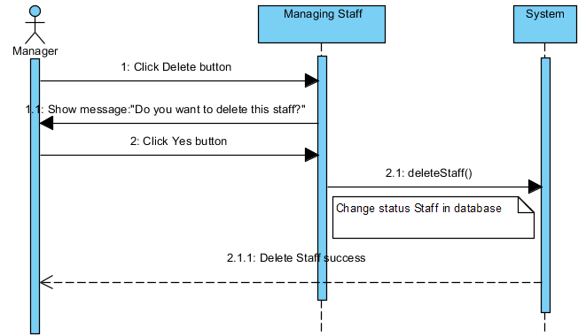

### Supervisors/Secondmarker

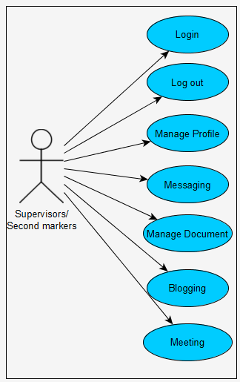

#### Login

|  |  |  |
| --- | --- | --- |
| **Author** | Nguyen Ngoc Kieu Trinh | |
| **Use Case Name** | Login | |
| **Actors** | Supervisor/Secondmarker | |
| **Description** | Supervisor/Secondmarker want to login to website as a staff. | |
| **Requirements** | Actor provides user ID and password | |
| **Pre-conditions** |  | |
| **Post-conditions** | Success: Supervisor/Second marker logged in to website.  Fail: Refill information | |
| **Basic flow** | Actor Actions:  1. Actor go to Login page of website.  3. Actor inputs ID and Password, then click the Login button. | System Responses:  2. System redirects to Login page and displays Login form on the left with the following control:  - ‘ID’ textfield  - ‘Password’ textfield  - ‘Sign In’ button  -‘Forgot Password’ link  4. System checks the information  [Exception 1]  5. System redirects to Actor’s Login page. |
| **Alternative flow** | Actor Actions:   1. Actor click ‘Sing In’ button   . | System Responses:  1. System checks the information  [Exception 1]  2. System redirects to Actor’s Login page and show message ‘Login failed. Try again’ |
| **Exception** | Actor Actions:  [Exception 1]   1. Actor input invalid id and password. 2. Actor input ID and click Sign In button 3. Actor input username and password don’t same with database. | -System show message :  -System show message:” ‘Login failed. Try again’  -System show message ‘Login failed. Try again’  --System show message ‘Login failed. Try again’ |

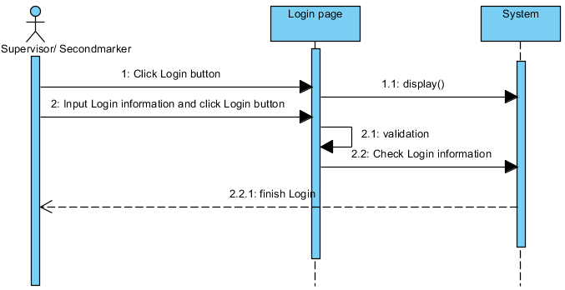

#### Logout

|  |  |  |
| --- | --- | --- |
| **Author** | Nguyen Ngoc Kieu Trinh | |
| **Use Case Name** | Log out | |
| **Actors** | Supervisor / Secondmarker | |
| **Description** | Supervisor / Secondmarker wants to log out of the System. | |
| **Requirements** | Actor click log out button | |
| **Pre-conditions** | Actor has logged in. | |
| **Post-conditions** | Success: Actor Logged out. | |
| **Basic flow** | Actor Actions:  1. Actor clicks ‘Log out’ button on themenu in the left screen.   1. Actor clicks ‘Yes’ button in the alert. | System Responses:  - System show message :”Do you want to log out?”  - System process to Log user out then redirect to Login page. |
| **Alternative flow** | Actor action:   1. Actor click ‘No’ button . | System Responses:  -System cancel Log out. |
| **Exception** |  |  |

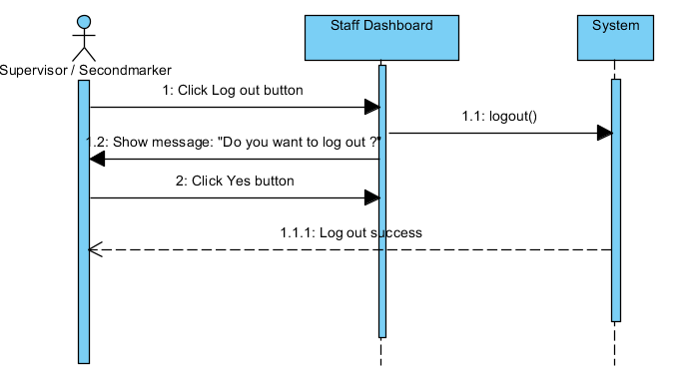

#### Manage profile

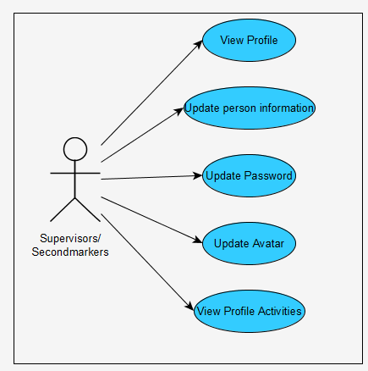

* **View Profile**

|  |  |  |
| --- | --- | --- |
| **Author** | Nguyen Ngoc Kieu Trinh | |
| **Use case name** | View Profile | |
| **Actors** | Supervisors/Secondmarkers | |
| **Description** | View Profile Supervisors/Secondmarkers | |
| **Requirements** | Supervisors/Secondmarkers can view private information. | |
| **Post-conditions** | Actor login as Staff | |
| **Basic flow** | Actor actions:   1. From ‘Login’ page, actor clicks on to the ‘Profile’ on the side bar in the left screen. | System response:  2. System redirects to ‘Profile’ page and display all of personal info in the textbox :  -ID  -Name  -Email  -Address  -Academic Year  -Birthday  -Mobile |
| **Alternative flow** |  |  |
| **Exception** |  |  |

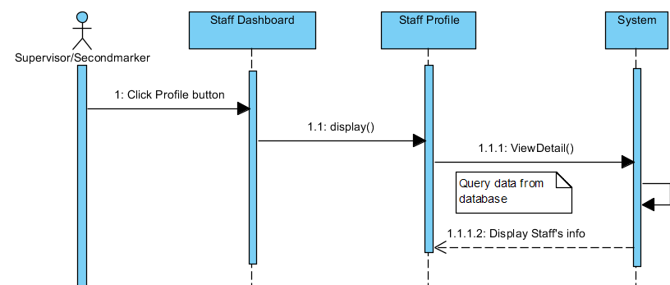

* **Update Staff’s information**

|  |  |  |
| --- | --- | --- |
| **Author** | Nguyen Ngoc Kieu Trinh | |
| **Use Case Name** | Update Profile | |
| **Actors** | Supervisor/Secondmarker | |
| **Description** | Supervisor/Secondmarker wants to Update his/her profile’s information. | |
| **Requirements** | Supervisor/Secondmarker provides profile information | |
| **Pre-conditions** | Supervisor/Secondmarker has logged in. | |
| **Post-conditions** | Success: Profile’s information of this user has been updated.  Fail: Refill information | |
| **Basic flow** | Actor Actions:  1. Actor clicks ‘Edit Profile’ button below avatar of his/her in ‘Staff Profile’ page.  3. Actor updates information of them and click ‘Save’ button. [Alternative 1] | System Responses:   1. System redirects to ‘Staff Profile Edit ‘page and displays Update Profile form with the following control :   - ‘Full Name’ textfield  - ‘Birthday’ date picker  - ‘Address’ textfield  - ‘Email’ textfield  - ‘Phone’ textfield  - ‘Save’ button  - ‘Cancel’ button  4. System checks the information  [Exception 1]  5. System update the account into database and then redirects to ‘Staff Profile’ page. |
| **Alternative flow** | Actor Actions:  [Alternative 1]   1. Actor click ‘Cancel’ button. | System Responses:   1. Information not change and system returns to ‘Staff Profile’ page. |
| **Exception** | Actor Actions:  [Exception 1]  1. Actor lefts ‘Full Name’ textfield blank.  2. Actor lefts ‘Phone’ textfield blank.  3. Actor lefts ‘Address’ textfield blank.  4. Actor left ‘Email’ textfield blank.  5. Actor left ‘Mobile’ text blank | System Responses:  System displays message to Actor :  - ‘Full Name can’t be blank’’.  - ‘Phone can’t be blank’.  -‘Address can’t be blank’.  -‘Email can’t be blank.’  -‘Mobile can’t be blank.’ |

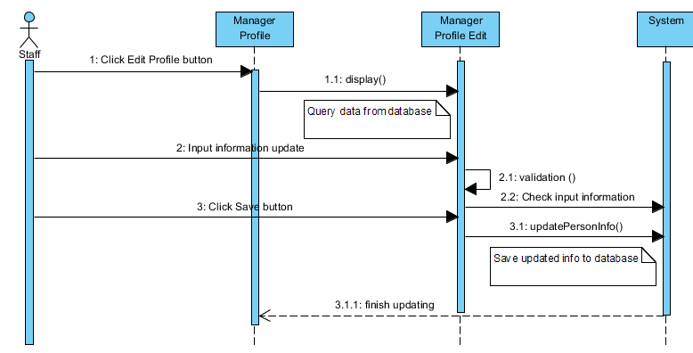

* **Update password and avatar**

|  |  |  |
| --- | --- | --- |
| **Author** | Nguyen Ngoc Kieu Trinh | |
| **Use case name** | Change Password | |
| **Actors** | Supervisor/Secondmarker | |
| **Description** | Staff Change Password and avatar | |
| **Requirements** | Actor provides Current Password | |
| **Pre-conditions** | Actor has logged in as Staff | |
| **Post-conditions** | Success: The password of Staff has changed. | |
| **Basic flow** | Actor actions:  1. From ‘Staff Profile’ page, actor clicks on to the ‘Edit Profile’ button.  3. Actor clicks on to ‘Save’ button to finish changing. [Alternative 1] | System response:  2. System redirects to ‘Staff Profile Edit’ page and display form with the following controls:  -‘Current Password’ textfield.  -‘New Password’ textfield.  -‘Re-type New Password’ textfield.  -‘Image’ box  -‘Select image’ button  -‘Save’ button.  ‘Cancel’ button  4. System checks input information.  [Exception 1]  5. System update new password and new avatar of Staff into the database. |
| **Alternative flow** | [Alternative 1]  -Actor click ‘Cancel’ button | -System redirect to Staff Profile page. |
| **Exception** | [Exception 1]  1. Actor lefts ‘Current Password’ textfield.  2. Actor lefts ‘New Password’ textfield.  3. Actor lefts ‘Re-type New Password’ textfield.  4. ‘Re-type New Password’ textfield is not same as ‘New Password’ textfield. | System displays a message to notice actor:  -“Current Password can’t be blank.”  -“New Password can’t be blank.”  -“Re-typeNew Password can’t be blank.”  “Re-type New Password and New Password must be same.” |

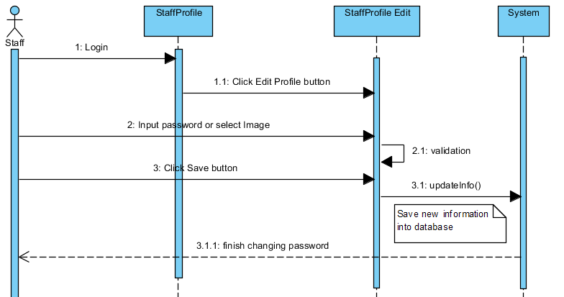

* **View Profile activities**

|  |  |  |
| --- | --- | --- |
| **Author** | Nguyen Ngoc Kieu Trinh | |
| **Use case name** | View Profile Activities | |
| **Actors** | Staffs | |
| **Description** | View Profile Activities | |
| **Requirements** | Staffs can view private information. | |
| **Post-conditions** | Actor login as Staff | |
| **Basic flow** | Actor actions:  1.From ‘Staff Profile’ page, actor clicks on to the ‘Recent Notification’ in the left screen below avatar.   1. Actor click ‘Load Old Activities’ button | System response:  2. System redirects to ‘Staff Profile Activities’ page and display notification of personal:  -Allocation  -‘Load Old Activities’ button.   1. System load old activities |
| **Alternative flow** |  |  |
| **Exception** |  |  |

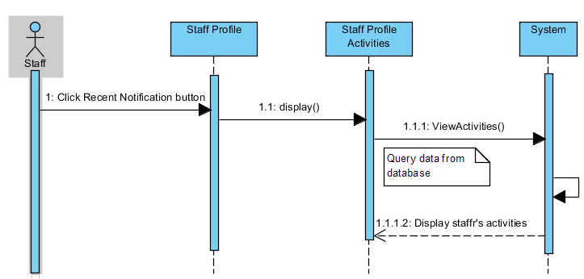

#### Messaging

|  |  |  |  |
| --- | --- | --- | --- |
| **Author** | Nguyen Ngoc Kieu Trinh | | |
| **UseCase Name** | Messaging | | |
| **Actors** | Supervisor or second marker | | |
| **Description** | Supervisor or second marker can send message with students. | | |
| **Requirements** | Supervisor or second marker must be provide message for student. | | |
| **Pre-conditions** |  | | |
| **Post-conditions** |  | | |
| **Basic flow** | 1. Actor click ’Send’ button in the ‘Messaging’ page 2. Actor click ‘Send’ button | System Responses:  2. System redirects to this page and displays form for Actor to input information with the following control :  -“Conversation” is old conversation.  -‘Message’ textfield.  -‘Search’ textfield.  -“Send” button  System checks information input [Exception 1]  6. System add message into database. | |
| **Alternative flow** |  |  |
| **Exceptions** |  |  |

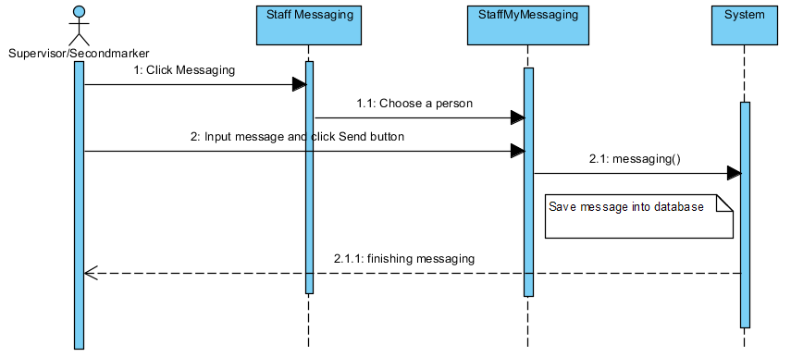

#### Manage documents

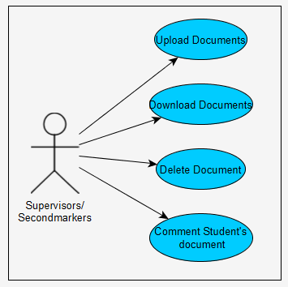

* **Upload Documents**

|  |  |  |
| --- | --- | --- |
| **Author** | Nguyen Ngoc Kieu Trinh | |
| **Use case name** | Staff upload documents | |
| **Actors** | Supervisor / Second marker | |
| **Description** | Staff can upload documents. | |
| **Requirements** | Actor select file need to upload for students. | |
| **Pre-conditions** | Actor has already logged into the System as Staff. | |
| **Post-conditions** | Success: Thank you.  Failed: Refill information | |
| **Basic flow** | Actor actions:  1. From ‘Staff Dashboard’ page, actor clicks on to the ‘Documents’ button.  3. Actor clicks on to ‘Save’ button to upload documents. | System response:  2. System redirects to ‘Staff Documents’ page and display form with the following controls:  -‘Upload document’ file  -‘Save’ button.  -‘Cancel’ button.  4. System checks input information. |
| **Alternative flow** | 1. Actor click ‘Cancel’ button. | 1. –System Cancel upload document. |
| **Exception** |  |  |

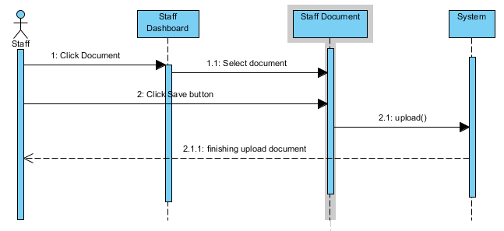

* **Download Document**

|  |  |  |
| --- | --- | --- |
| **Author** | Nguyen Ngoc Kieu Trinh | |
| **Use case name** | Staff download documents | |
| **Actors** | Supervisor / Second marker | |
| **Description** | Staff can download own documents or student’s documents. | |
| **Requirements** | Actor select file need to download. | |
| **Pre-conditions** | Actor has already logged into the System as Staff. | |
| **Post-conditions** | Success: Thank you.  Failed: Refill information | |
| **Basic flow** | Actor actions:  1. From ‘Staff Dashboard’ page, actor clicks on to the ‘Documents’ button.  3. Actor clicks on to ‘Download’ button . | System response:   1. System redirects to ‘Staff Documents’ page and display table with the following controls include two parts.   -The first ‘My uploads’ show history upload of Staff.  -‘Title’  -‘Date’  -‘Download’ button  -‘Delete’ button  -The second ’Student’s Uploads show documents of students send to Staff.  -‘Student ID’  -‘Student Name’  -‘Title’  -‘Date’  -‘Download’ button  -‘Comment’ button.  4. System download documents . |
| **Alternative flow** |  |  |
| **Exception** |  |  |

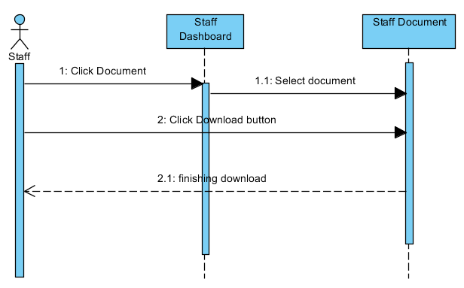

* **Delete Document**

|  |  |  |
| --- | --- | --- |
| **Author** | Nguyen Ngoc Kieu Trinh | |
| **Use case name** | Change status document | |
| **Actors** | Staff | |
| **Description** | Change database document | |
| **Requirements** |  | |
| **Pre-conditions** | Already login into the System as Staff | |
| **Post-conditions** | Success: A Document is changed in the database. | |
| **Basic flow** | Actor actions:  1. From ‘StaffDocuments’ page, actor clicks on to the ‘Delete’ button which actor wants to Change status own document.  3. Actor clicks ‘Yes’ button.[Alternative 1] | System response:  2. A confirms show message box: ”Do you want to delete this documents?”  4. System changes status the document in the database. |
| **Alternative flow** | [Alternative 1]  1. Actor clicks on to ‘No’ button | 2. System redirects to’Satff Documents’ page. |
| **Exception** |  |  |

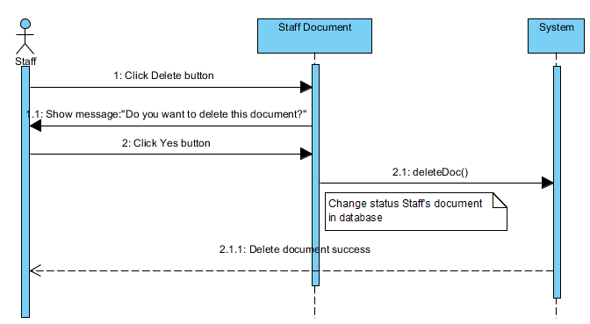

* **Comment Student’s documents**

|  |  |  |  |
| --- | --- | --- | --- |
| **Author** | Nguyen Ngoc Kieu Trinh | | |
| **Use Case Name** | Comment document | | |
| **Actors** | Supervisor or second marker | | |
| **Description** | Supervisor or second marker can comment to document of students whom teach by them. | | |
| **Requirements** | Supervisor or second marker must be provide Mail and Comment to create comment. | | |
| **Pre-conditions** |  | | |
| **Post-conditions** | Success: Comment successful  Fail: Refill information | | |
| **Basic flow** | 1. Actor click ’Comment’ button in the ‘Staff Document’ page 2. Actor click ‘Save’ button | System Responses:  2. System displays dialog box for Staff to input comment with the following control :  -“Comment” text area  -“Save ” button  -‘Close’ button.  System checks information input [Exception 1]   1. System add comment into database then display message ‘Thank for your comment. | |
| **Alternative flow** |  |  |
| **Exceptions** | Actor Actions:  [Exception 1]  1. Actor left ‘Comment text area blank’. | System Response:  2. System displays message to notice staff: ‘Comment can’t be blank’. |

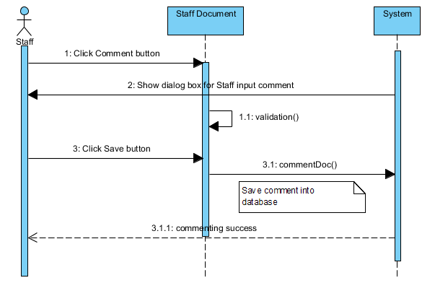

#### Blogging

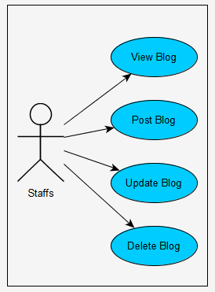

* **View Blog and Post Blog**

|  |  |  |
| --- | --- | --- |
| **Author** | Nguyen Ngoc Kieu Trinh | |
| **Use case name** | View Staff’s blogging | |
| **Actors** | Staff | |
| **Description** | View or post Staff’s blogging | |
| **Requirements** | Staff can view or post their blogging | |
| **Post-conditions** | Actor login as Staff | |
| **Basic flow** | Actor actions:   1. From ‘Staff Dashboard’ page, actor clicks on to the ‘Blogging’ on the side bar in the left screen. 2. Actor click ‘Post’ button. | System response:   1. System redirects to ‘Manager blogging’ page and display form with the following controls:   -Manager’s emotion textfield  -‘Post’ button  -‘Delete’ button  -‘Update’ button.   1. System will post Staff’s emotion to Blogging page. |
| **Alternative flow** | Actor Actions:  [Alternative 1]   1. Actor click ‘Update’ button 2. Actor click ’Delete’ button | System Responses:  -System will update Staff ‘s emotion.  -System will delete Staff ‘s emotion. |
| **Exception** |  |  |

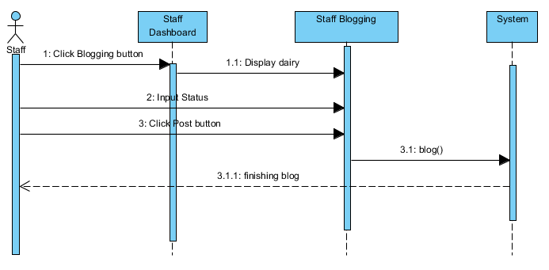

* **Update Blogging**

|  |  |  |
| --- | --- | --- |
| **Author** | Nguyen Ngoc Kieu Trinh | |
| **Use case name** | Update Staff ’s blogging | |
| **Actors** | Staff | |
| **Description** | Update Staff ’s blogging | |
| **Requirements** | Staff update their blogging | |
| **Post-conditions** | Actor login as Staff | |
| **Basic flow** | Actor actions:   1. From ‘Staff Dashboard’ page, actor clicks on to the ‘Blogging’ on the side bar in the left screen. 2. Actor click ‘Update’ button. 3. Actor click ‘Close’ button. 4. Actor click ‘Save change’ button. | System response:   1. System redirects to ‘Staff Blogging’ page and display form with the following controls:   -Staff ’s emotion textfield  -‘Post’ button  -‘Delete’ button  -‘Update’ button.   1. System will show update status dialog with ‘Close’ and ‘Save changes’ button. 2. Update status dialog will be close. 3. System will be update Staff ’s status. |
| **Alternative flow** | Actor Actions:  [Alternative 1]   1. Actor click ’Delete’ button | System Responses:   1. System will delete Staff ‘s emotion. |
| **Exception** |  |  |

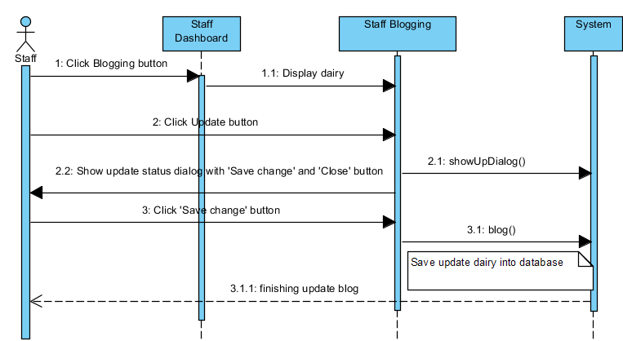

* **Delete Blog**

|  |  |  |
| --- | --- | --- |
| **Author** | Nguyen Ngoc Kieu Trinh | |
| **Use case name** | Delete Staff’s blogging | |
| **Actors** | Staff | |
| **Description** | Delete Staff ’s blogging | |
| **Requirements** | Staff delete their blogging | |
| **Post-conditions** | Actor login as Staff | |
| **Basic flow** | Actor actions:   1. From ‘Staff Dashboard’ page, actor clicks on to the ‘Blogging’ on the side bar in the left screen. 2. Actor click ’Delete’ button 3. Actor click ‘Yes’ button | System response:   1. System redirects to ‘Staff blogging’ page and display form with the following controls:   -Manager’s status textfield  -‘Post’ button  -‘Delete’ button  -‘Update’ button.   1. System will show message: ’Do you want to delete status?’ 2. System will delete status. |
| **Alternative flow** | Actor Actions:  [Alternative 1]   1. Actor click ‘No’ button | System Responses:   1. System will redirects to ‘Staff Blogging’. |
| **Exception** |  |  |

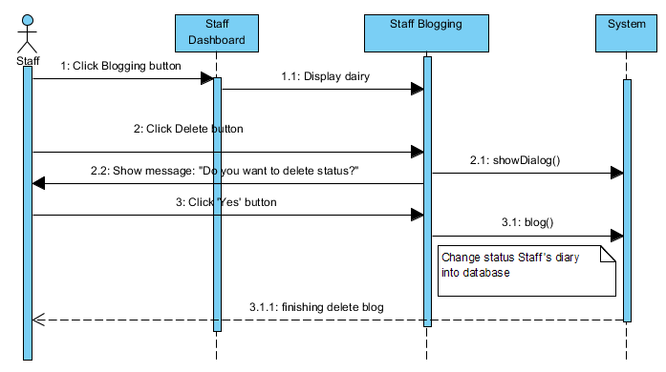

#### Meeting

* **Create new meeting**

|  |  |  |  |
| --- | --- | --- | --- |
| **Author** | Nguyen Ngoc Kieu Trinh | | |
| **Use Case Name** | Create new meeting | | |
| **Actors** | Supervisor or second marker | | |
| **Description** | Staff can create meeting with students. | | |
| **Requirements** | Staff must be provide information about meeting. | | |
| **Pre-conditions** |  | | |
| **Post-conditions** | Success: Create meeting successful.  Fail: Refill information | | |
| **Basic flow** | 1. Actor click ’Meeting’ button in the ‘Staff Dashboard’ page 2. Actor click ‘Submit’ button | System Responses:  2. System redirects to ‘Staff Create Meeting’ page and displays form for Actor to input information with the following control :  -‘Meeting Type’ radio button  -‘Meeting Topic’ textfield  -‘Meeting date’ date picker  -‘Meeting place’ textfield  -‘Select Student invite’ list menu  -‘Submit’ button  -‘Reset’ button  System checks information input [Exception 1]   1. System add new meeting into database. | |
| **Alternative flow** | 1. Actor click ‘Reset’ button   ‘ | 1. System will reset form. |
| **Exceptions** | Actor Actions:  [Exception 1]  1. Actor left ‘Meeting topic ‘blank.   1. Actor left ‘Meeting place’ blank. 2. Actor left ‘Select student invite’ | System Response:   1. System displays message :   ‘Meeting Topic can’t be blank.’   1. System displays message:   ‘Meeting place can’t be blank.’   1. System show message: ‘Student can’t be blank’ |

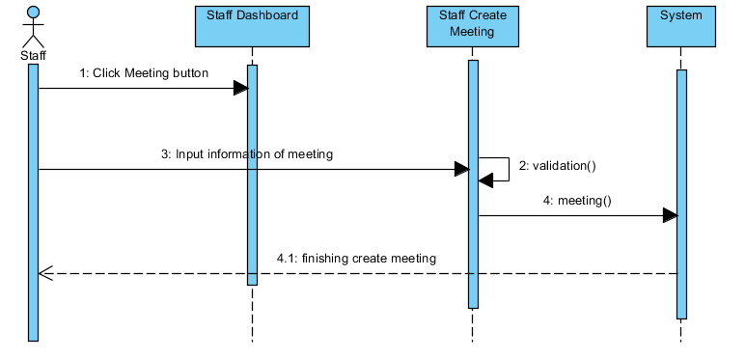

### Students

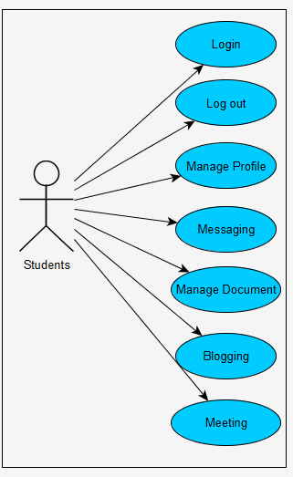

#### Login

|  |  |  |
| --- | --- | --- |
| **Author** | Nguyen Ngoc Kieu Trinh | |
| **Use Case Name** | Login | |
| **Actors** | Students | |
| **Description** | Student want to login to website as a Student. | |
| **Requirements** | Actor provides user ID and password | |
| **Pre-conditions** |  | |
| **Post-conditions** | Success: Student logged in to website.  Fail: Refill information | |
| **Basic flow** | Actor Actions:  1. Actor go to Login page of website.  3. Actor inputs ID and Password, then click the Login button. | System Responses:  2. System redirects to Login page and displays Login form on the left with the following control:  - ‘ID’ textfield  - ‘Password’ textfield  - ‘Sign In’ button  -‘Forgot Password’ link  4. System checks the information  [Exception 1]  5. System redirects to Actor’s Login page. |
| **Alternative flow** | Actor Actions:   1. Actor click ‘Sing In’ button   . | System Responses:   1. System checks the information   [Exception 1]   1. System redirects to Actor’s Login page and show message ‘Login failed. Try again’ |
| **Exception** | Actor Actions:  [Exception 1]   1. Actor input invalid id and password. 2. Actor input ID and click Sign In button 3. Actor input username and password don’t same with database. | -System show message :   1. System show message:” ‘Login failed. Try again’ 2. System show message ‘Login failed. Try again’   -System show message ‘Login failed. Try again’ |

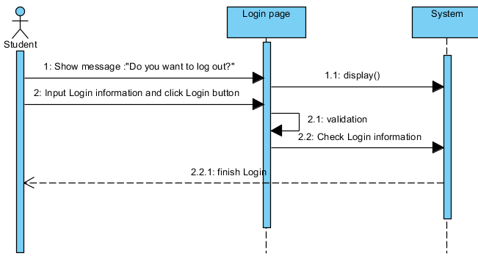

#### Logout

|  |  |  |
| --- | --- | --- |
| **Author** | Nguyen Ngoc Kieu Trinh | |
| **Use Case Name** | Log out | |
| **Actors** | Student | |
| **Description** | Student wants to log out of the System. | |
| **Requirements** | Actor click log out button | |
| **Pre-conditions** | Actor has logged in. | |
| **Post-conditions** | Success: Actor Logged out. | |
| **Basic flow** | Actor Actions:  1. Actor clicks ‘Log out’ button on the menu in the left screen.   1. Actor clicks ‘Yes’ button in the alert. | System Responses:  - System show message :”Do you want to log out?”  - System process to Log user out then redirect to Login page. |
| **Alternative flow** | Actor action:   1. Actor click ‘No’ button . | System Responses:  -System cancel Log out. |
| **Exception** |  |  |

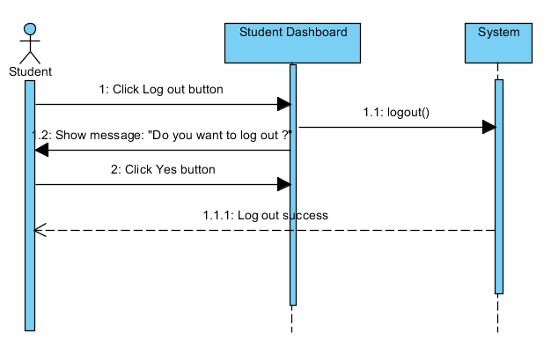

#### Manage profile

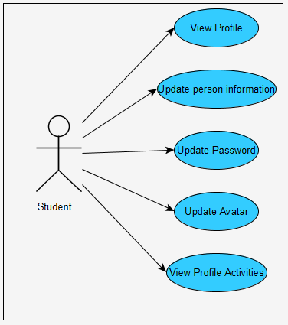

* **View Profile**

|  |  |  |
| --- | --- | --- |
| **Author** | Nguyen Ngoc Kieu Trinh | |
| **Use case name** | View Profile | |
| **Actors** | Student | |
| **Description** | View Profile Student | |
| **Requirements** | Student can view private information. | |
| **Post-conditions** | Actor login as Student | |
| **Basic flow** | Actor actions:   1. From ‘Login’ page, actor clicks on to the ‘Profile’ on the side bar in the left screen. | System response:  2. System redirects to ‘Profile’ page and display all of personal info in the textbox :  -ID  -Name  -Email  -Address  -Academic Year  -Birthday  -Mobile |
| **Alternative flow** |  |  |
| **Exception** |  |  |

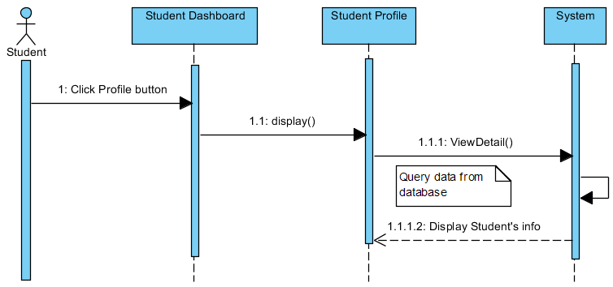

* **Update Student’s information**

|  |  |  |
| --- | --- | --- |
| **Author** | Nguyen Ngoc Kieu Trinh | |
| **Use Case Name** | Update Profile | |
| **Actors** | Student | |
| **Description** | Student wants to Update his/her profile’s information. | |
| **Requirements** | Student provides profile information | |
| **Pre-conditions** | Student has logged in. | |
| **Post-conditions** | Success: Profile’s information of this user has been updated.  Fail: Refill information | |
| **Basic flow** | Actor Actions:  1. Actor clicks ‘Edit Profile’ button below avatar of his/her in ‘Student Profile’ page.   1. Actor updates information of them and click ‘Save’ button.   [Alternative 1] | System Responses:   1. System redirects to ‘Student Profile Edit ‘page and displays Update Profile form with the following control :   - ‘Full Name’ textfield  - ‘Birthday’ date picker  - ‘Address’ textfield  - ‘Email’ textfield  - ‘Phone’ textfield  - ‘Save’ button  - ‘Cancel’ button  4. System checks the information  [Exception 1]  5. System update the account into database and then redirects to ‘Student Profile’ page. |
| **Alternative flow** | Actor Actions:  [Alternative 1]   1. Actor click ‘Cancel’ button. | System Responses:   1. Information not change and system returns to ‘Staff Profile’ page. |
| **Exception** | Actor Actions:  [Exception 1]  1. Actor lefts ‘Full Name’ textfield blank.  2. Actor lefts ‘Phone’ textfield blank.  3. Actor lefts ‘Address’ textfield blank.  4. Actor left ‘Email’ textfield blank.  5. Actor left ‘Mobile’ text blank | System Responses:  System displays message to Actor :  - ‘Full Name can’t be blank’’.  - ‘Phone can’t be blank’.  -‘Address can’t be blank’.  -‘Email can’t be blank.’  -‘Mobile can’t be blank.’ |

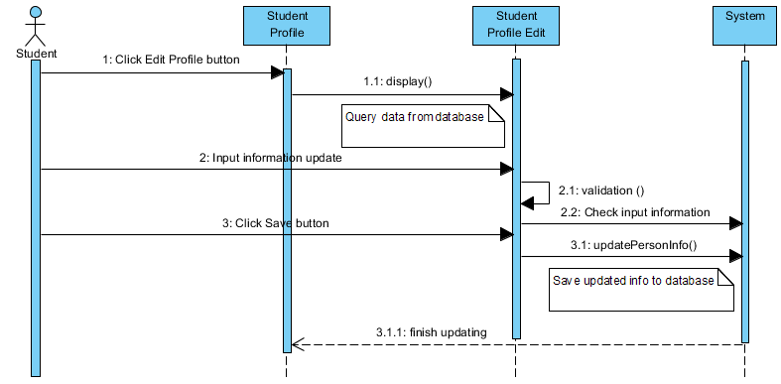

* **Update password and avatar**

|  |  |  |
| --- | --- | --- |
| **Author** | Nguyen Ngoc Kieu Trinh | |
| **Use case name** | Change Password | |
| **Actors** | Student | |
| **Description** | Student want to Change Password and Avatar | |
| **Requirements** | Actor provides Current Password | |
| **Pre-conditions** | Actor has logged in as Student | |
| **Post-conditions** | Success: The password of Student has changed. | |
| **Basic flow** | Actor actions:  1. From ‘Student Profile’ page, actor clicks on to the ‘Edit Profile’ button.  3. Actor clicks on to ‘Save’ button to finish changing. [Alternative 1] | System response:  2. System redirects to ‘Student Profile Edit’ page and display form with the following controls:  -‘Current Password’ textfield.  -‘New Password’ textfield.  -‘Re-type New Password’ textfield.  -‘Image’ box  -‘Select image’ button  -‘Save’ button.  ‘Cancel’ button  4. System checks input information.  [Exception 1]  5. System update new password and new avatar of Student into the database. |
| **Alternative flow** | [Alternative 1]  -Actor click ‘Cancel’ button | -System redirect to Student Profile page. |
| **Exception** | [Exception 1]  1. Actor lefts ‘Current Password’ textfield.  2. Actor lefts ‘New Password’ textfield.  3. Actor lefts ‘Re-type New Password’ textfield.   1. ‘Re-type New Password’ textfield is not same as ‘New Password’ textfield. | System displays a message to notice actor:  -“Current Password can’t be blank.”  -“New Password can’t be blank.”  -“Re-typeNew Password can’t be blank.”  “Re-type New Password and New Password must be same.” |

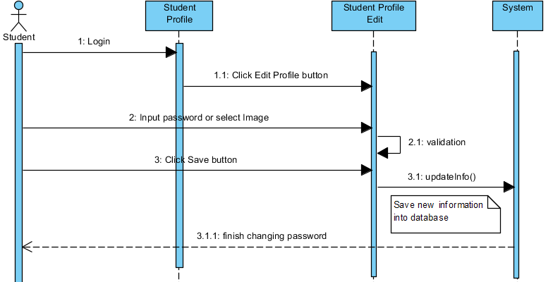

* **View Profile activities**

|  |  |  |
| --- | --- | --- |
| **Author** | Nguyen Ngoc Kieu Trinh | |
| **Use case name** | View Profile Activities | |
| **Actors** | Student | |
| **Description** | View Profile Activities | |
| **Requirements** | Student can view private information. | |
| **Post-conditions** | Actor login as Student | |
| **Basic flow** | Actor actions:   1. From ‘Student Profile’ page, actor clicks on to the ‘Recent Notification’ in the left screen below avatar. 2. Actor click ‘Load Old Activities’ button | System response:  2. System redirects to ‘Student Profile Activities’ page and display notification of personal:  -Allocation  -‘Load Old Activities’ button.   1. System will load old activities and display to form. |
| **Alternative flow** |  |  |
| **Exception** |  |  |

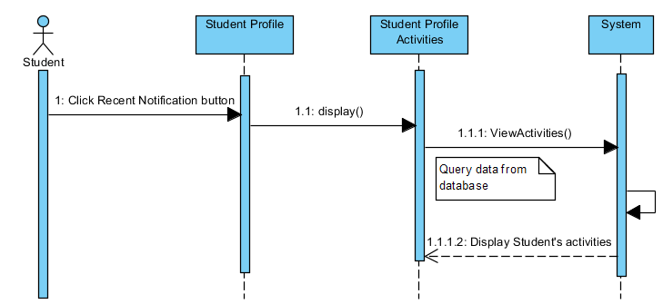

#### Messaging

|  |  |  |  |
| --- | --- | --- | --- |
| **Author** | Nguyen Ngoc Kieu Trinh | | |
| **UseCase Name** | Messaging | | |
| **Actors** | Student | | |
| **Description** | Student can send message with Staff. | | |
| **Requirements** | Student must be provide message for staff | | |
| **Pre-conditions** |  | | |
| **Post-conditions** |  | | |
| **Basic flow** | Actor action   1. Actor click ’Send’ button in the ‘Messaging’ page 2. Actor click ‘Send’ button | System Responses:  2. System redirects to this page and displays form for Actor to input information with the following control :  -“Conversation” is old conversation.  -‘Message’ textfield.  -‘Search’ textfield.  -“Send” butto   1. System will send message and add message into database. | |
| **Alternative flow** |  |  |
| **Exceptions** |  |  |

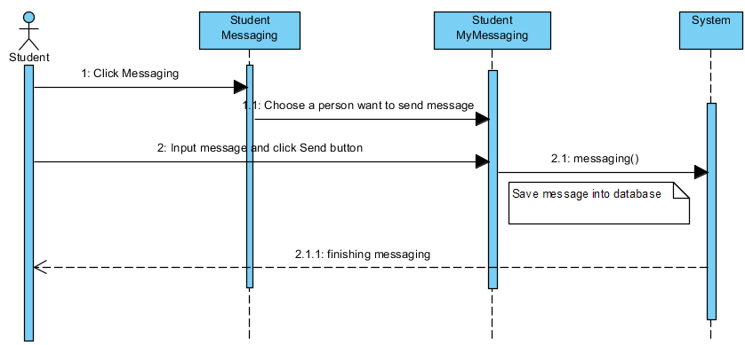

#### Manage documents

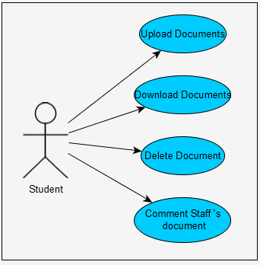

* **Upload Documents**

|  |  |  |
| --- | --- | --- |
| **Author** | Nguyen Ngoc Kieu Trinh | |
| **Use case name** | Student upload documents | |
| **Actors** | Student | |
| **Description** | Student can upload documents. | |
| **Requirements** | Actor select file need to upload for Staff | |
| **Pre-conditions** | Actor has already logged into the System as Student. | |
| **Post-conditions** | Success: Thank you.  Failed: Refill information | |
| **Basic flow** | Actor actions:  1. From ‘Student Dashboard’ page, actor clicks on to the ‘Documents’ button.  3. Actor clicks on to ‘Save’ button to upload documents. | System response:  2. System redirects to ‘Student Documents’ page and display form with the following controls:  -‘Upload document’ file  -‘Save’ button.  -‘Cancel’ button.  4. System checks input information. |
| **Alternative flow** | 1. Actor click ‘Cancel’ button. | 1. System Cancel upload document. |
| **Exception** |  |  |

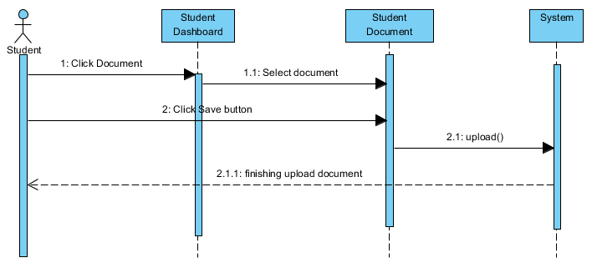

* **Download Document**

|  |  |  |
| --- | --- | --- |
| **Author** | Nguyen Ngoc Kieu Trinh | |
| **Use case name** | Student can download documents | |
| **Actors** | Student | |
| **Description** | Student can download own documents or Staff’s documents. | |
| **Requirements** | Actor select file need to download. | |
| **Pre-conditions** | Actor has already logged into the System as Student. | |
| **Post-conditions** | Success: Thank you.  Failed: Refill information | |
| **Basic flow** | Actor actions:  1. From ‘Student Dashboard’ page, actor clicks on to the ‘Documents’ button.  3. Actor clicks on to ‘Download’ button . | System response:   1. System redirects to ‘Student Documents’ page and display table with the following controls include two parts.   -The first ‘My uploads’ show history upload of Staff.  -‘Title’  -‘Date’  -‘Download’ button  -‘Delete’ button  -The second ’Staff’s Uploads show documents of Staff send to Student  -‘Staff ID’  -‘Staff Name’  -‘Staff Type’  -‘Title’  -‘Date’  -‘Download’ button  -‘Comment’ button.  4. System download documents . |
| **Alternative flow** |  |  |
| **Exception** |  |  |

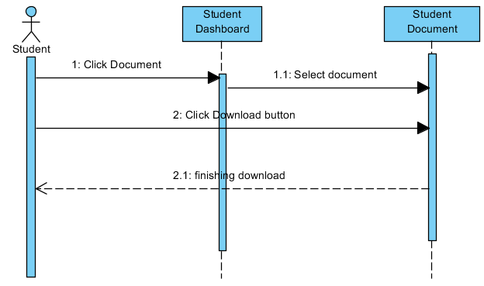

* **Delete Document**

|  |  |  |
| --- | --- | --- |
| **Author** | Nguyen Ngoc Kieu Trinh | |
| **Use case name** | Change status document | |
| **Actors** | Student | |
| **Description** | Change database document | |
| **Requirements** |  | |
| **Pre-conditions** | Already login into the System as Student | |
| **Post-conditions** | Success: A Document is changed in the database. | |
| **Basic flow** | Actor actions:  1. From ‘Student Documents’ page, actor clicks on to the ‘Delete’ button which actor wants to Change status own document.  3.Actor clicks ‘Yes’ button.[Alternative 1] | System response:  2. A confirms show message box: ”Do you want to delete this documents?”  4. System changes status the document in the database. |
| **Alternative flow** | [Alternative 1]  1. Actor clicks on to ‘No’ button | 2. System redirects to’ Student Documents’ page. |
| **Exception** |  |  |

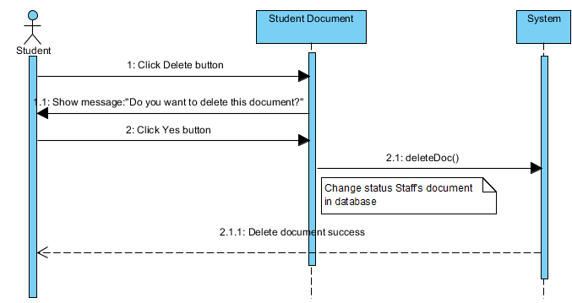

* **Comment Staff’s documents**

|  |  |  |  |
| --- | --- | --- | --- |
| **Author** | Nguyen Ngoc Kieu Trinh | | |
| **Use Case Name** | Comment document | | |
| **Actors** | Student | | |
| **Description** | Students can comment to document of Staff who teach them | | |
| **Requirements** | Student must be provide User ID or name to comment document. | | |
| **Pre-conditions** |  | | |
| **Post-conditions** | Success: Comment successful  Fail: Refill information | | |
| **Basic flow** | 1. Actor click ’Comment’ button in the ‘Staff Document’ page 2. Actor click ‘Save’ button | System Responses:  2. System displays dialog box for Staff to input comment with the following control :  -“Comment” text area  -“Save ” button  -‘Close’ button.  System checks information input [Exception 1]   1. System add comment into database then display message ‘Thank for your comment. | |
| **Alternative flow** |  |  |
| **Exceptions** | Actor Actions:  [Exception 1]  1. Actor left ‘Comment text area blank’. | System Response:  2. System displays message to notice Student: ‘Comment can’t be blank’. |

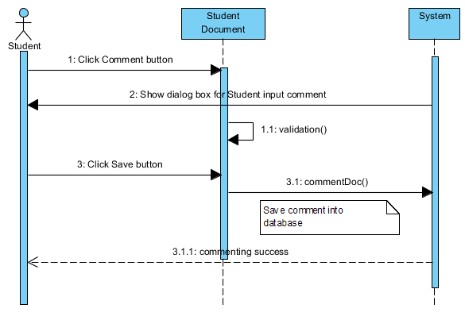

#### Blogging

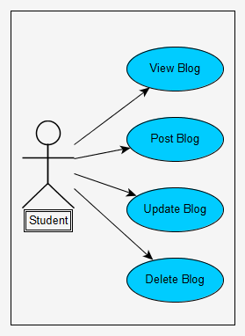

* **View Blog and Post Blog**

|  |  |  |
| --- | --- | --- |
| **Author** | Nguyen Ngoc Kieu Trinh | |
| **Use case name** | View Student’s blogging | |
| **Actors** | Student | |
| **Description** | View or post Student’s blogging | |
| **Requirements** | Student can view or post their emotion. | |
| **Post-conditions** | Actor login as Student | |
| **Basic flow** | Actor actions:   1. From ‘Student Dashboard’ page, actor clicks on to the ‘Blogging’ on the side bar in the left screen. 2. Actor click ‘Post’ button. | System response:   1. System redirects to ‘Student blogging’ page and display form with the following controls:   - Student ’s emotion textfield  -‘Post’ button  -‘Delete’ button  -‘Update’ button.   1. System will post Student’s emotion to Blogging page. |
| **Alternative flow** | Actor Actions:  [Alternative 1]   1. Actor click ‘Update’ button 2. Actor click ’Delete’ button | System Responses:   1. System will update Student ‘s emotion. 2. System will delete Student ‘s emotion. |
| **Exception** |  |  |

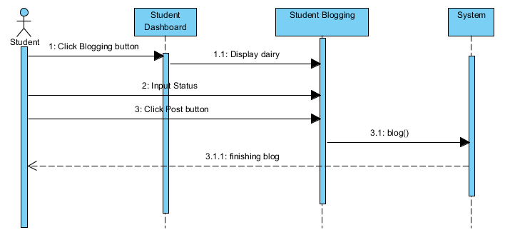

* **Update Blogging**

|  |  |  |
| --- | --- | --- |
| **Author** | Nguyen Ngoc Kieu Trinh | |
| **Use case name** | Update Student ’s blogging | |
| **Actors** | Student | |
| **Description** | Update Student’s blogging | |
| **Requirements** | Student can update their blogging | |
| **Post-conditions** | Actor login as Student | |
| **Basic flow** | Actor actions:   1. From ‘Staff Dashboard’ page, actor clicks on to the ‘Blogging’ on the side bar in the left screen. 2. Actor click ‘Update’ button. 3. Actor click ‘Close’ button. 4. Actor click ‘Save change’ button. | System response:   1. System redirects to ‘Student Blogging’ page and display form with the following controls:   - Student’s emotion textfield  -‘Post’ button  -‘Delete’ button  -‘Update’ button.   1. System will show update status dialog with ‘Close’ and ‘Save changes’ button. 2. Update status dialog will be close. 3. System will be update Student ’s status. |
| **Alternative flow** | Actor Actions:  [Alternative 1]   1. Actor click ’Delete’ button | System Responses:   1. System will delete Student ‘s emotion. |
| **Exception** |  |  |

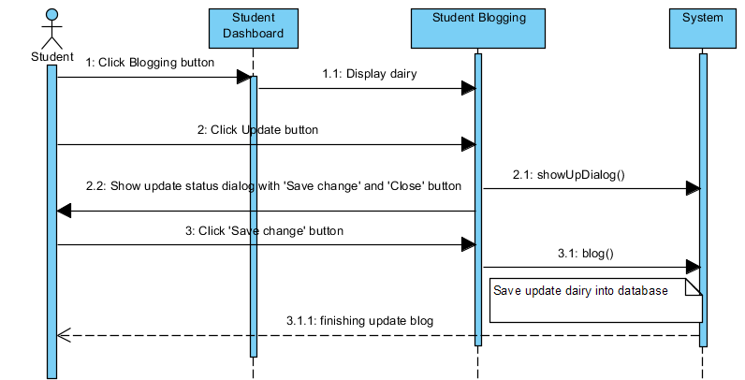

* **Delete Blog**

|  |  |  |
| --- | --- | --- |
| **Author** | Nguyen Ngoc Kieu Trinh | |
| **Use case name** | Delete Student’s blogging | |
| **Actors** | Student | |
| **Description** | Delete Student ’s blogging | |
| **Requirements** | Student can delete their blogging | |
| **Post-conditions** | Actor login as Student | |
| **Basic flow** | Actor actions:   1. From ‘Student Dashboard’ page, actor clicks on to the ‘Blogging’ on the side bar in the left screen. 2. Actor click ’Delete’ button 3. Actor click ‘Yes’ button | System response:   1. System redirects to ‘Student blogging’ page and display form with the following controls:   - Student’s status textfield  -‘Post’ button  -‘Delete’ button  -‘Update’ button.   1. System will show message: ’Do you want to delete status?’ 2. System will delete status. |
| **Alternative flow** | Actor Actions:  [Alternative 1]   1. Actor click ‘No’ button | System Responses:   1. System will redirects to ‘Student Blogging’. |
| **Exception** |  |  |

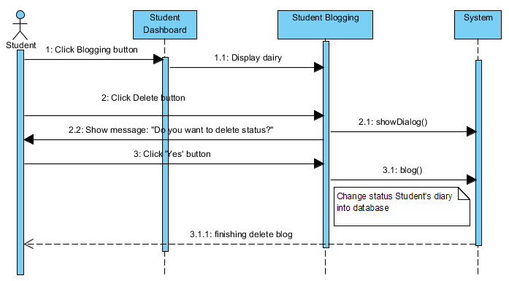

#### Meeting

* **Participation meeting**

|  |  |  |  |
| --- | --- | --- | --- |
| **Author** | Nguyen Ngoc Kieu Trinh | | |
| **Use Case Name** | Participation meeting | | |
| **Actors** | Students | | |
| **Description** | Student can participate meeting | | |
| **Requirements** | Student can commune with other students or staff. | | |
| **Pre-conditions** |  | | |
| **Post-conditions** |  | | |
| **Basic flow** | 1. Actor click ’Meeting’ button in the ‘Student Dashboard’ page 2. Actor click item in ‘Current meeting’ menu list in ‘Student Meeting’ page. 3. Actor click ‘Send’ button | System Responses:  2. System redirects to ‘Student Meeting’ page and displays form for Actor to input information with the following control :  -‘Current meeting’ menu list  -‘List meeting’  -‘Search meeting’   1. System redirects to ‘Student My Meeting’ page with the following control:   -‘Message’ textfield  -‘Send’ button   1. System will be send message and add message into database. | |
| **Alternative flow** |  |  |
| **Exceptions** |  |  |

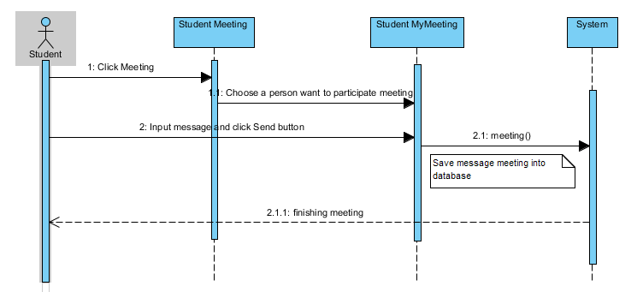

## Entity Relationship Diagram

### Conceptual

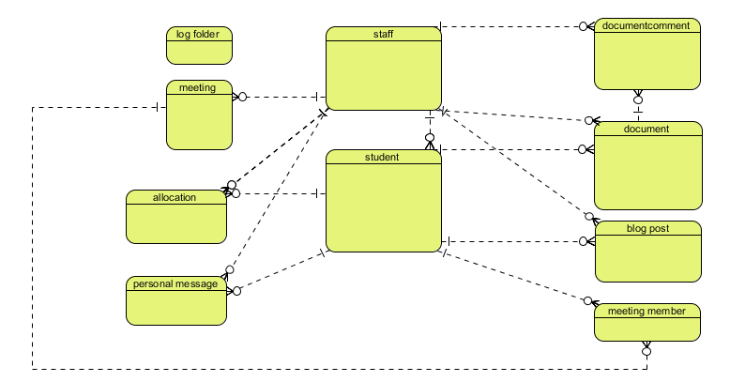

### Logical

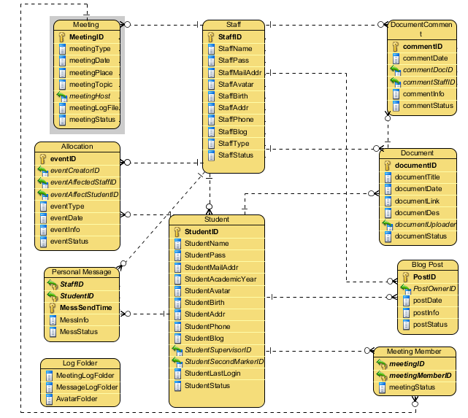

### Physical

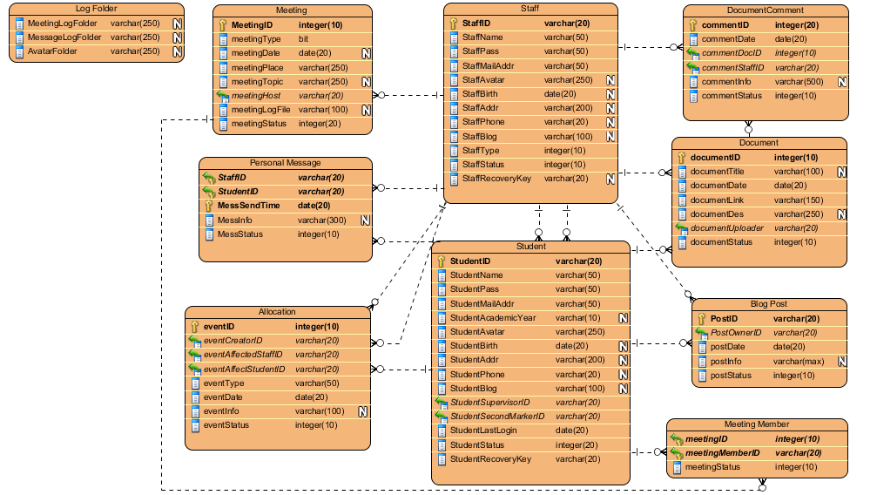

## Table Properties

### Properties of tblAllocations

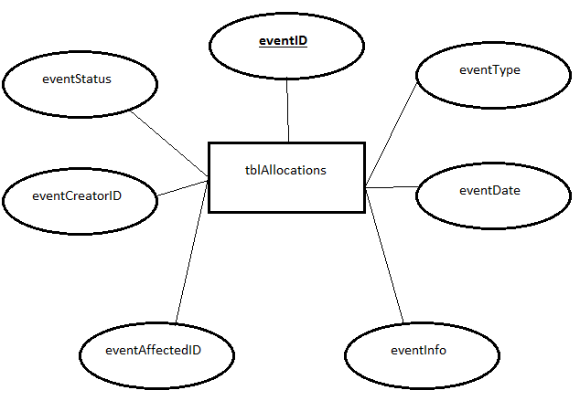

### Properties of tblMeetingMembers

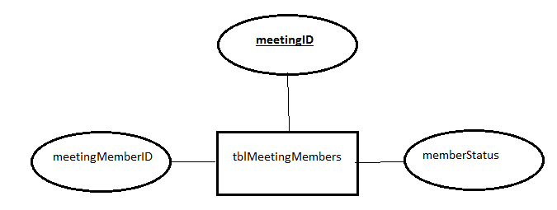

### Properties of tblDocuments

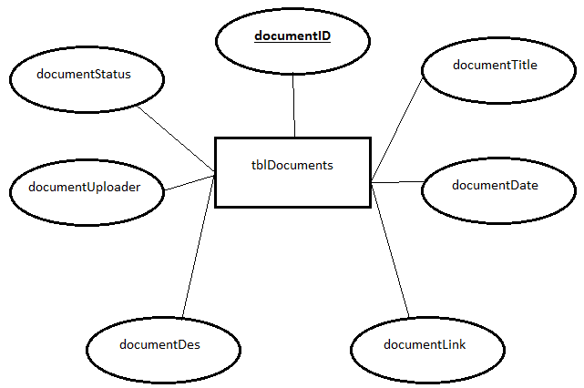

### Properties of tblDocumentComments

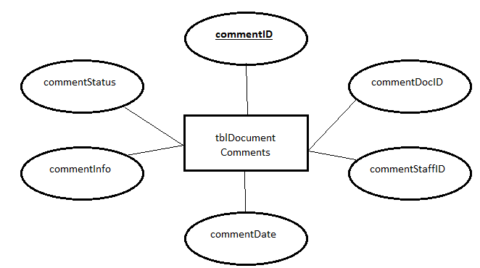

### Properties of tblMeetings

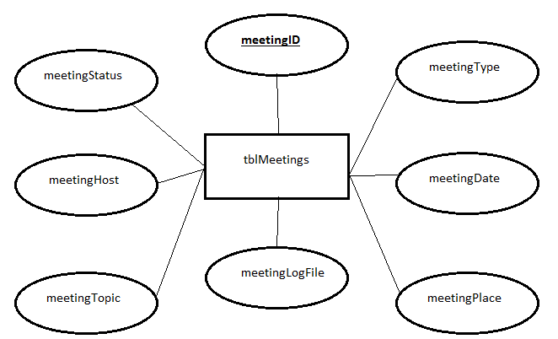

### Properties of tblPersonalMessages

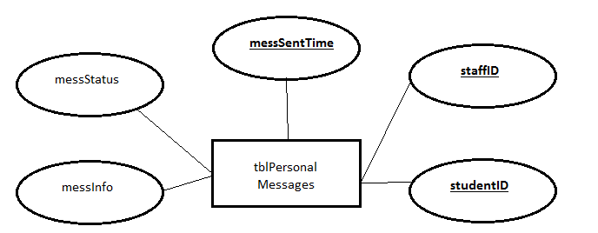

### Properties of tblBlogPosts

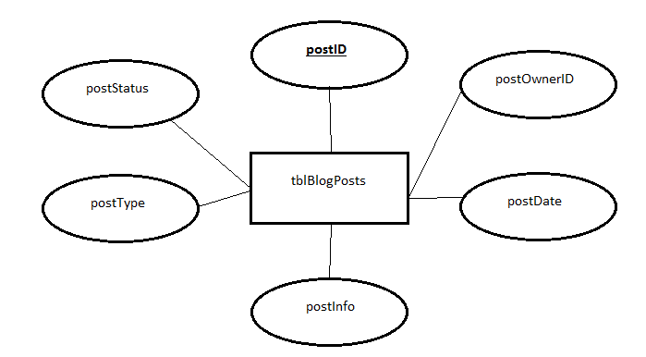

### Properties of tblStaffs

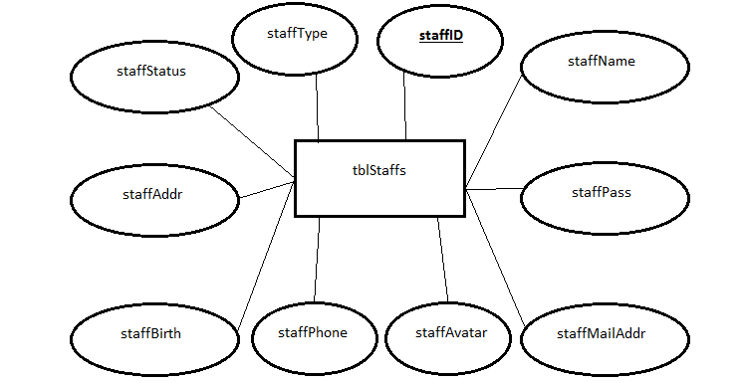

### Properties of tblStudents

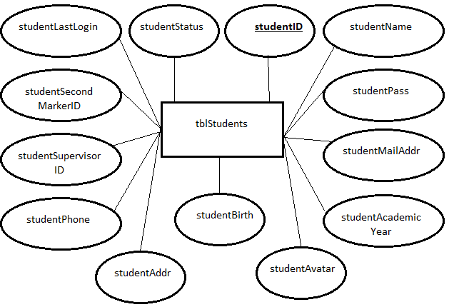

## Database relationship diagram

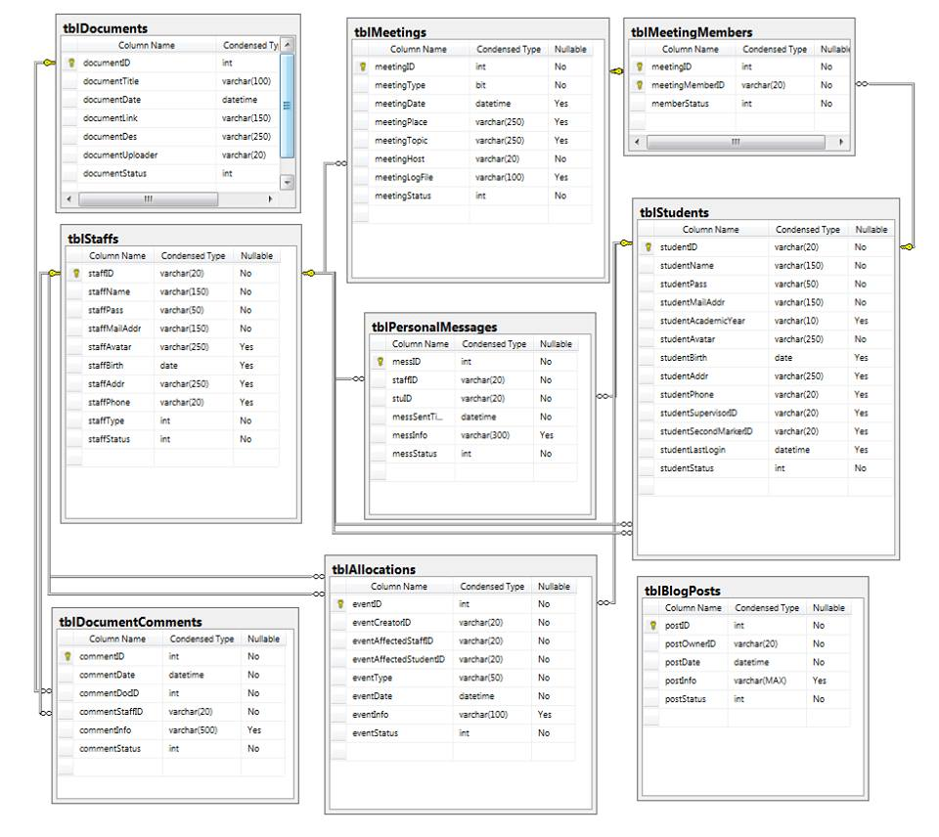

## Table Definition

### Table Allocations

|  |  |  |  |  |
| --- | --- | --- | --- | --- |
| **Name** | **Data Type** | **Nullable** | **Key/Constrain** | **Comment** |
| eventID | int | No | PK | Store event's identical number |
| eventType | varchar(50) | No |  | Represent event type according to specic action |
| eventDate | datetime | No |  | Represent the time on which the event occurs |
| eventInfo | varchar(100) | Yes |  | Store event's information in brief. |
| eventAffectedID | varchar(20) | No | FK | Represent the person that is affected by this event |
| eventCreatorID | varchar(20) | No | FK | Represent the person who issue this event |
| eventStatus | int | No |  | Represent status of this event. |
|  |  |  |  |  |
|  |  |  |  |  |
|  |  |  | **eventStatus** | **Status** |
|  |  |  | 1 | Applied |
|  |  |  | -1 | Error Occurred |

### Table MeetingMembers

|  |  |  |  |  |
| --- | --- | --- | --- | --- |
| **Name** | **Data Type** | **Nullable** | **Key/Constrain** | **Comment** |
| meetingID | int | No | PK/FK | Represent identical number of the meeting in which this member attends. |
| meetingMemberID | varchar(20) | No | PK/FK | Represent identical number of the member. |
| memberStatus | int | No |  | Indicate current status of meeting invitation. |
|  |  |  |  |  |
|  |  |  |  |  |
|  |  |  | **memberStatus** | **Status** |
|  |  |  | 1 | Invited |
|  |  |  | 0 | Canceled(By Meeting cancelation or staff decision). |

### Table Documents

|  |  |  |  |  |
| --- | --- | --- | --- | --- |
| **Name** | **Data Type** | **Nullable** | **Key/Constrain** | **Comment** |
| documentID | int | No | PK | Store document's idential number. |
| documentTitle | varchar(100) | Yes |  | Store document's title. |
| documentDate | datetime | No |  | Store document's upload time. |
| documentLink | varchar(150) | No |  | Store the path or link that lead to document. |
| documentDes | varchar(250) | Yes |  | Store the brief of document description. |
| documentUploader | varchar(20) | No | FK | Represent the person who uploaded the document |
| documentStatus | int | No |  | Indicate current status of this document. |
|  |  |  |  |  |
|  |  |  | **documentStatus** | **Status** |
|  |  |  | 0 | Not Available.Removed(By uploader or by removing uploader. |
|  |  |  | 1 | Available |

### Table DocumentComments

|  |  |  |  |  |
| --- | --- | --- | --- | --- |
| **Name** | **Data Type** | **Nullable** | **Key/Constrain** | **Comment** |
| commentID | int | No | PK | Store comment's identical number. |
| commentDocID | int | No | FK | Store identical number of the document that this comment is for. |
| commentStaffID | varchar(20) | No | FK | Represent the person who made this comment. |
| commentDate | datetime | No |  | Indicate the specific time when this comment is made. |
| commentInfo | varchar(500) | Yes |  | Store the comment information. |
| commentStatus | int | No |  | Indicate status of this comment |
|  |  |  |  |  |
|  |  |  | **CommentStatus** | **Status** |
|  |  |  | 0 | Removed(By staff/ By Staff Removal) |
|  |  |  | 1 | Recorded |

### Table Meetings

|  |  |  |  |  |
| --- | --- | --- | --- | --- |
| **Name** | **Data Type** | **Nullable** | **Key/Constrain** | **Comment** |
| meetingID | int | No | PK | Store identical number of this meeting. |
| meetingType | bit | No |  | Indicate the type of the meeting. |
| meetingDate | datetime | Yes |  | Store specific time when the meeting will occur |
| meetingPlace | varchar(250) | Yes |  | Represent the place where the meeting will occur |
| meetingTopic | varchar(250) | Yes |  | Store the main point of the meeting. |
| meetingHost | varchar(20) | No | FK | Represent host of the meeting. |
| meetingLogFile | varchar(100) | Yes |  | Represent the log file of this meeting. |
| meetingStatus | int | No |  | Indicate status of the meeting. |
|  |  |  |  |  |
|  |  |  | **meetingStatus** | **Status** |
|  |  |  | 1 | Schedueled |
|  |  |  | 2 | Occurred |

### Table Personal Message

|  |  |  |  |  |
| --- | --- | --- | --- | --- |
| **Name** | **Data Type** | **Nullable** | **Key/Constrain** | **Comment** |
| messSentTime | datetime | No | PK | Store the date and time when the message was sent. |
| staffID | varchar(20) | No | PK/FK | Represent the staff. |
| studentID | varchar(20) | No | PK/FK | Represent the student. |
| messInfo | varchar(300) | Yes |  | Store the main part of the message. |
| messStatus | int | No |  | Indicate the message's status. |
|  |  |  |  |  |
|  |  |  |  |  |
|  |  |  | **messStatus** | **Status** |
|  |  |  | 0 | Removed.(By reallocation/remove student or staff) |
|  |  |  | 1 | OK |

### Table BlogPost

|  |  |  |  |  |
| --- | --- | --- | --- | --- |
| **Name** | **Data Type** | **Nullable** | **Key/Constrain** | **Comment** |
| postID | varchar(20) | No | PK | Store post's identical number. |
| postOwnerID | varchar(20) | No | FK | Represent the person who posted this. |
| postDate | datetime | No |  | Represent the time when this was posted. |
| postInfo | varchar(MAX) | Yes |  | Store the main part of this post. |
| postType | int | No |  | Indicate post type |
| postStatus | int | No |  | Indicate post's status |
|  |  |  |  |  |
|  |  |  | **postStatus** | **Status** |
|  |  |  | 0 | Removed(By User /By removal of user) |
|  |  |  | 1 | OK |

### Table Staffs

|  |  |  |  |  |
| --- | --- | --- | --- | --- |
| **Name** | **Data Type** | **Nullable** | **Key/Constrain** | **Comment** |
| staffID | varchar(20) | No | PK | Store staff's identical number |
| staffName | varchar(150) | No |  | Store Staff's Name. |
| staffPass | varchar(50) | No |  | Store Staff's Password. |
| staffMailAddr | varchar(150) | No |  | Store Staff's Mail Address. |
| staffAvatar | varchar(250) | Yes |  | Represent Staff's Avatar. |
| staffBirth | datetime | Yes |  | Store Staff's Birthday. |
| staffAddr | varchar(250) | Yes |  | Store Staff's Address. |
| staffPhone | varchar(20) | Yes |  | Store Staff's Phone Number. |
| staffType | int | No |  | Indicate Staff Type. |
| staffStatus | int | No |  | Indicate Staff Status. |
|  |  |  |  |  |
|  |  |  |  |  |
|  |  |  | staffStatus | Status |
|  |  |  | 1 | Activated |
|  |  |  | 2 | Removed |

### Table Students

|  |  |  |  |  |
| --- | --- | --- | --- | --- |
| **Name** | **Data Type** | **Nullable** | **Key/Constrain** | **Comment** |
| studentID | varchar(20) | No | PK | Store student's identical number |
| studentName | varchar(150) | No |  | Store student's Name. |
| studentPass | varchar(50) | No |  | Store student's Password. |
| studentMailAddr | varchar(150) | No |  | Store student's Mail Address. |
| studentAcademicYear | varchar(10) | Yes |  | Store student's academic year |
| studentAvatar | varchar(250) | No |  | Represent student's Avatar. |
| studentBirth | datetime | Yes |  | Store student's Birthday. |
| studentAddr | varchar(250) | Yes |  | Store student's Address. |
| studentPhone | varchar(20) | Yes |  | Store student's Phone Number. |
| studentSupervisorID | varchar(20) | Yes | FK | Represent student's Supervisor. |
| studentSecondMarkerID | varchar(20) | Yes | FK | Represent student's second marker. |
| studentLastLogin | datetime | Yes |  | Indicate the last time when student login. |
| studentStatus | int | No |  | Indicate student Status. |
|  |  |  |  |  |
|  |  |  |  |  |
|  |  |  | **studentStatus** | **Status** |
|  |  |  | 1 | Activated |
|  |  |  | 2 | Removed |

## Class diagram

### DTO

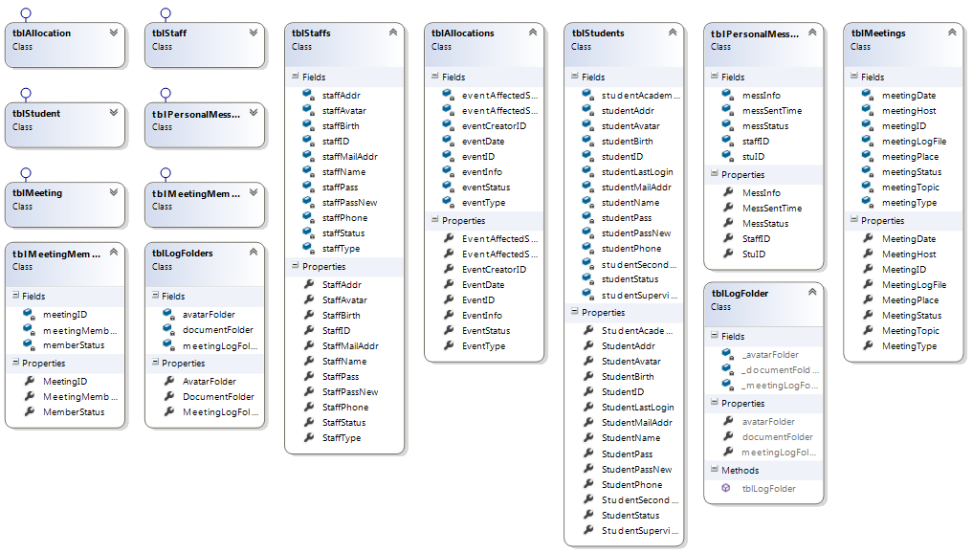

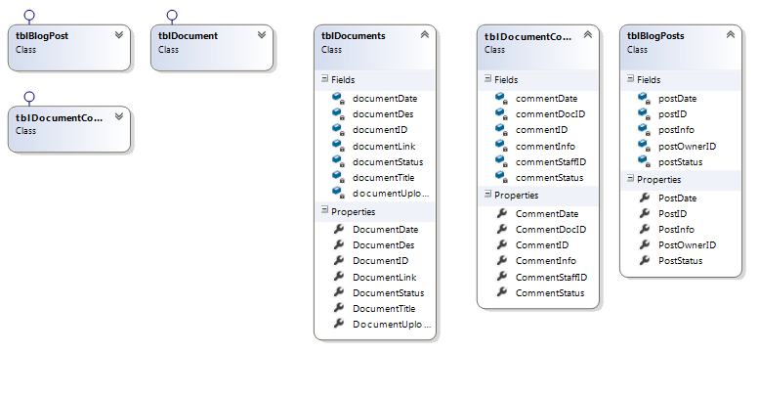

### DAO

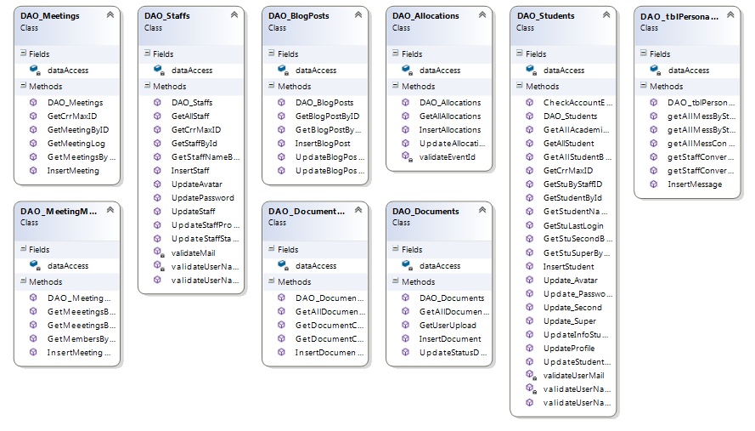

### Connection

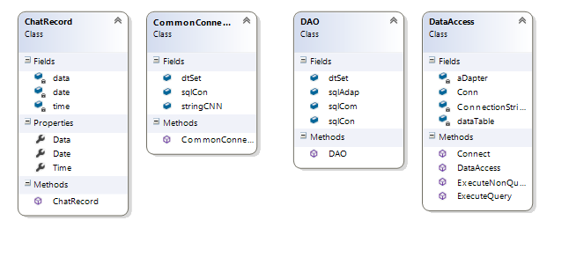

# Human computer interaction discussion

## Graphic User interface (Drafting)

* Based on analyzing above, the basic interfaces are drawn by Microsoft word to visualize the core elements of UI of the website. This reduces time cost for designer to realize the UI by using tools on computer.

### Manager report

* This page has two graphs which show average message of supervisors/second markers communicate with students in a week .It helps manager easily manage between supervisors/secondmarker and students.

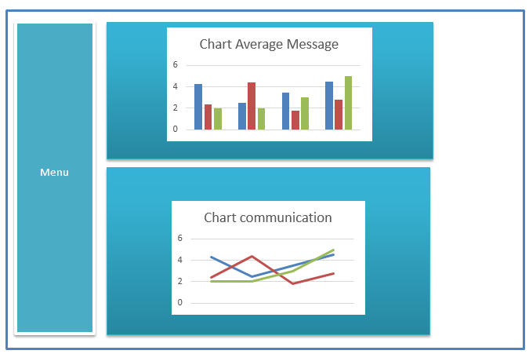

### Personal profile

-This page displays user’s information.

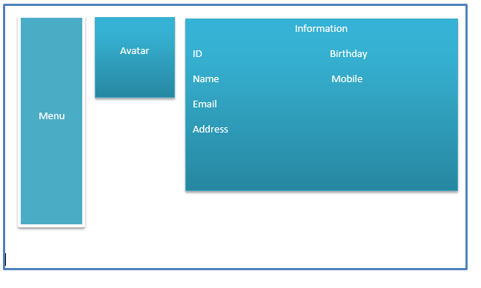

### Blogging

- User can writes down their emotion or thinking.

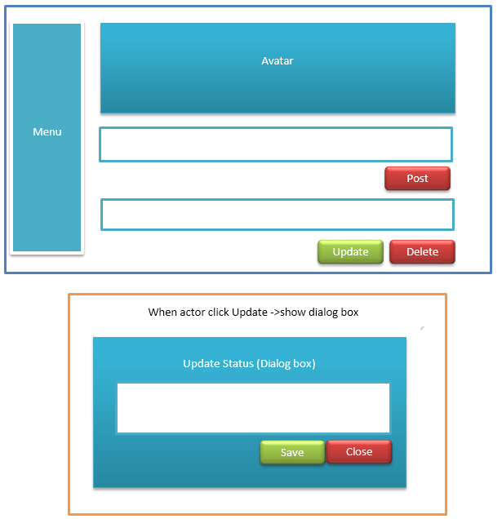

### Manage Staff

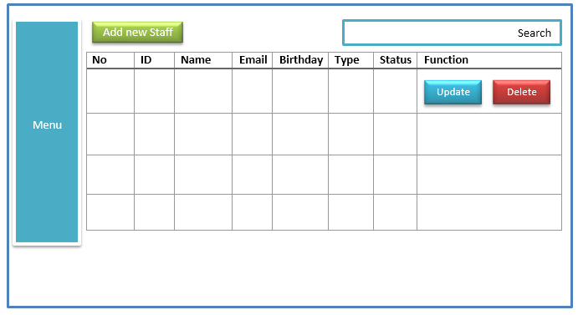

-When manager click Update system redirect to Update Staff page which shows staff’s information and manager can update some information if they permission.

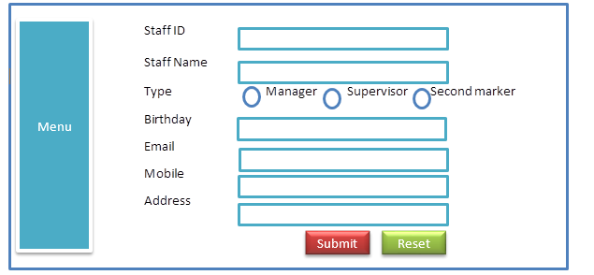

-Manager can add new staff by click Add new Staff button and then they should input information for staff.

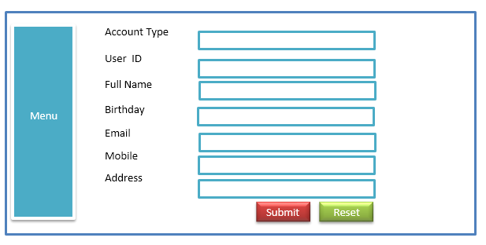

### Allocate students

-This page help manager assign supervisor/secondmarker for students.

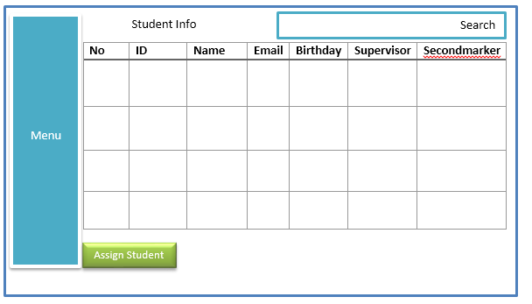

### Manager dashboard

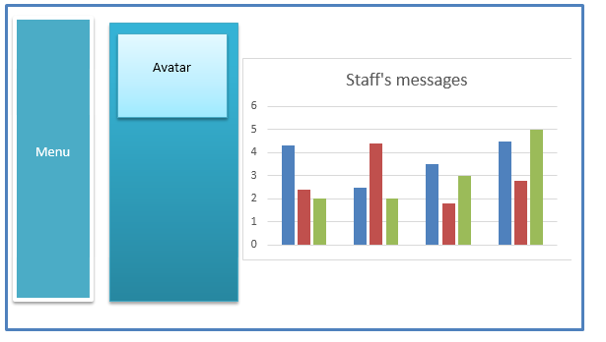

### Create Meeting

-This page helps supervisor/secondmarker can create meeting online or offline so guidance students complete projects.

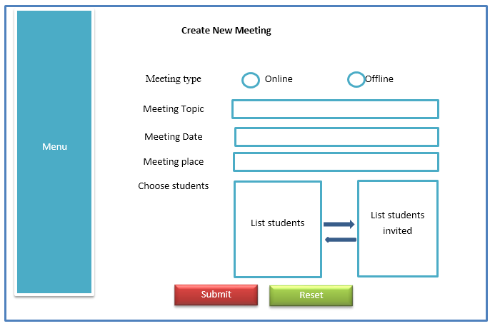

### Meeting

-This page displays free screen chat for students and supervisor/secondmarker conversation.

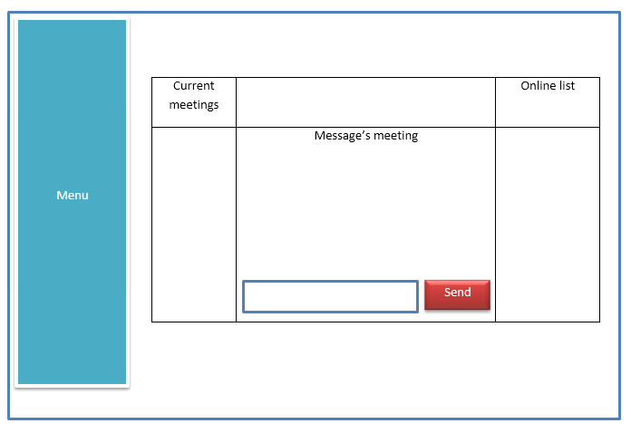

### Upload document

-This page displays user’s document uploaded and document’s other people send for user .Also, user can upload document for other people from this page.

Note: user can comment document of others but user cannot delete it.

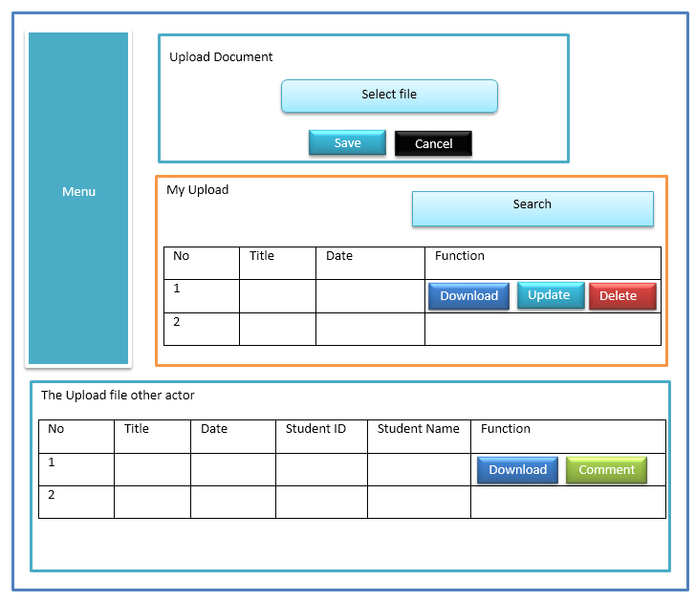

## Design interface by Quy

- In this coursework Quy design interface from basic interface and he has some creative design helps user easily interact system.

-The first ,this is an internal system so user should login before come user home page.

#### Login

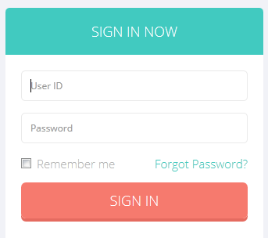

#### Manager

##### Manager Dashboard

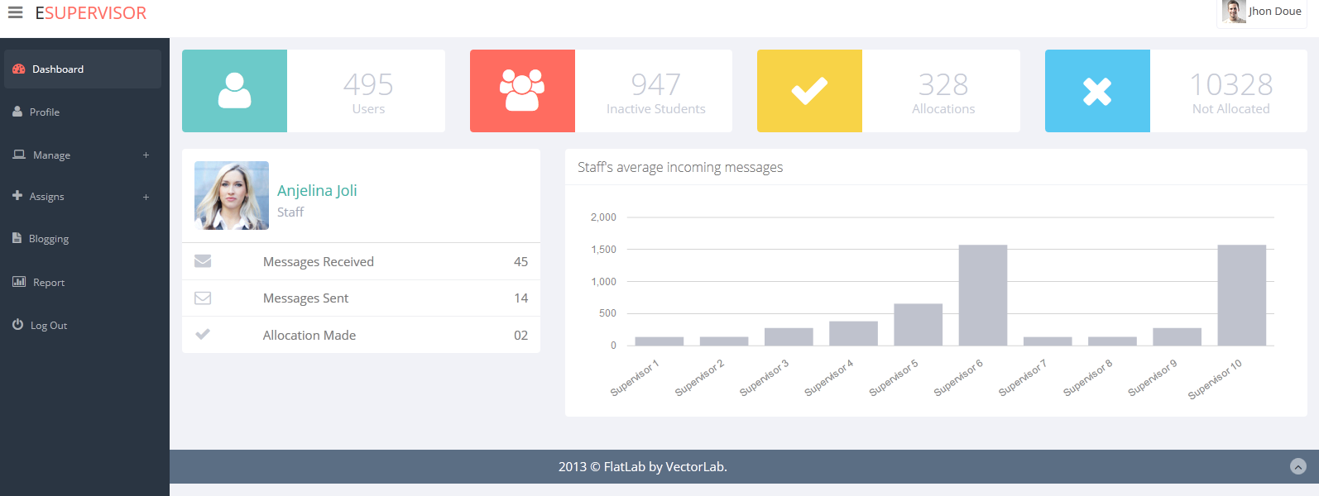

##### Manager Profile

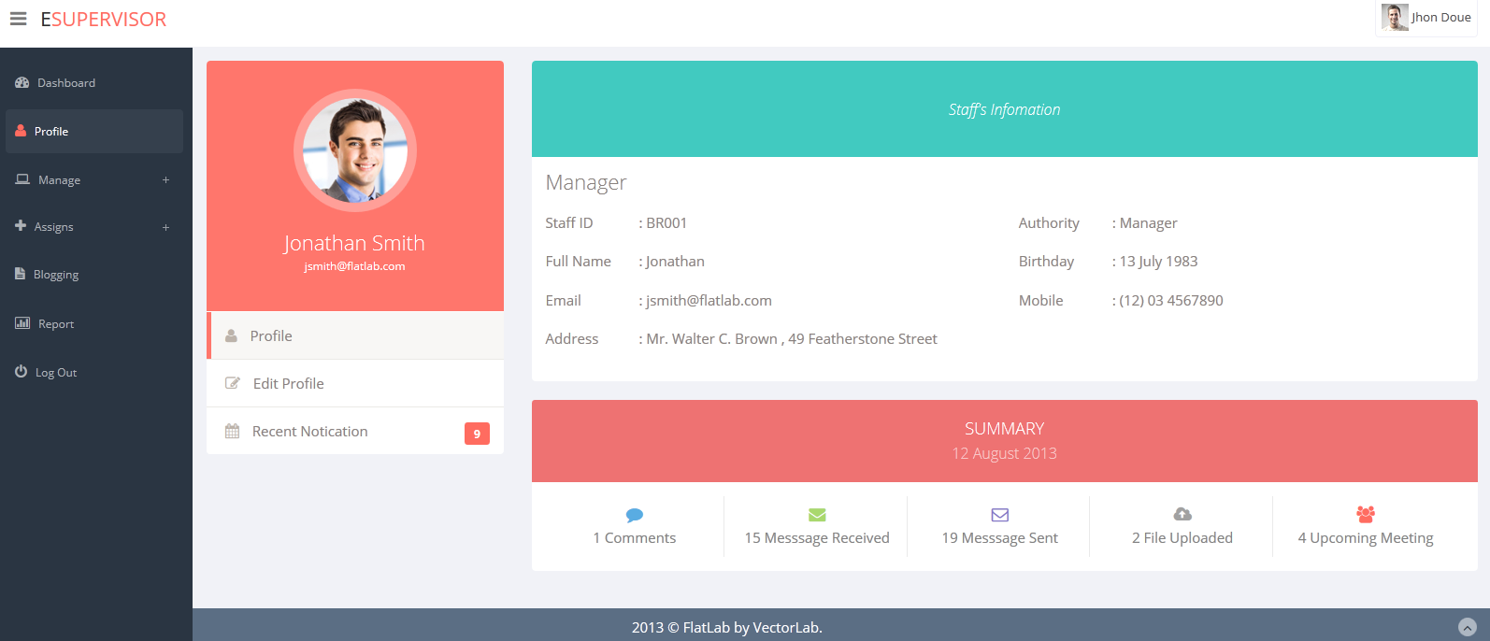

##### Manager Edit Profile

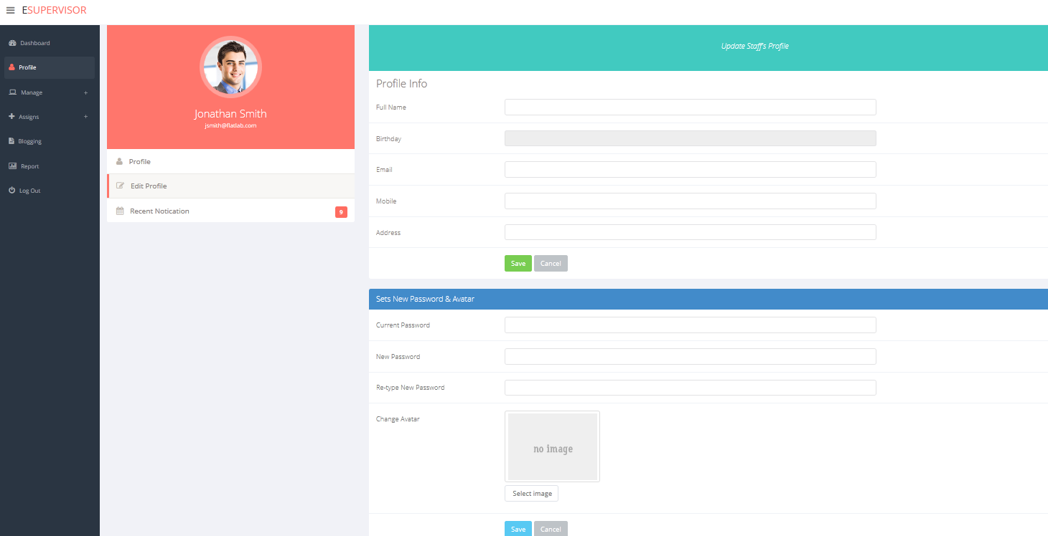

##### Manager activity

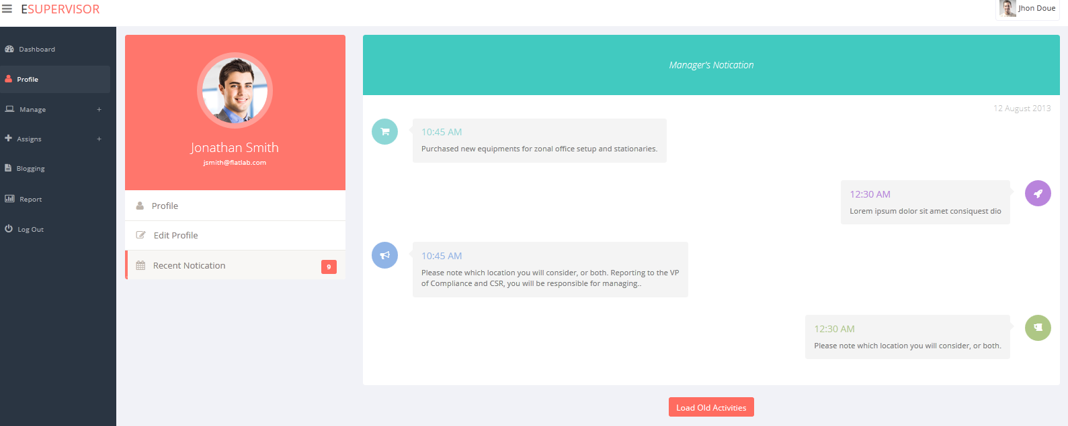

##### Managing Staff

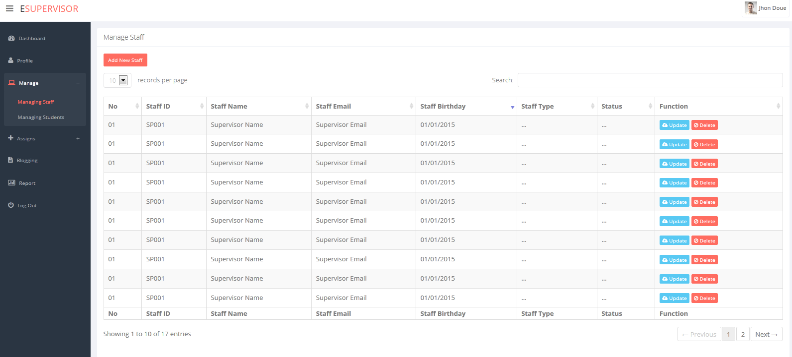

##### Add New Staff

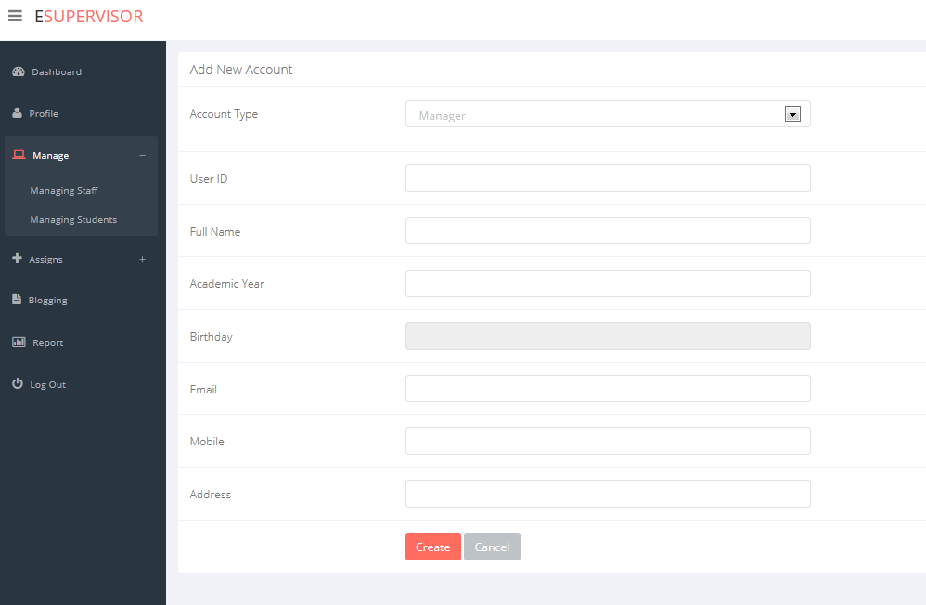

##### Update Staff’s info

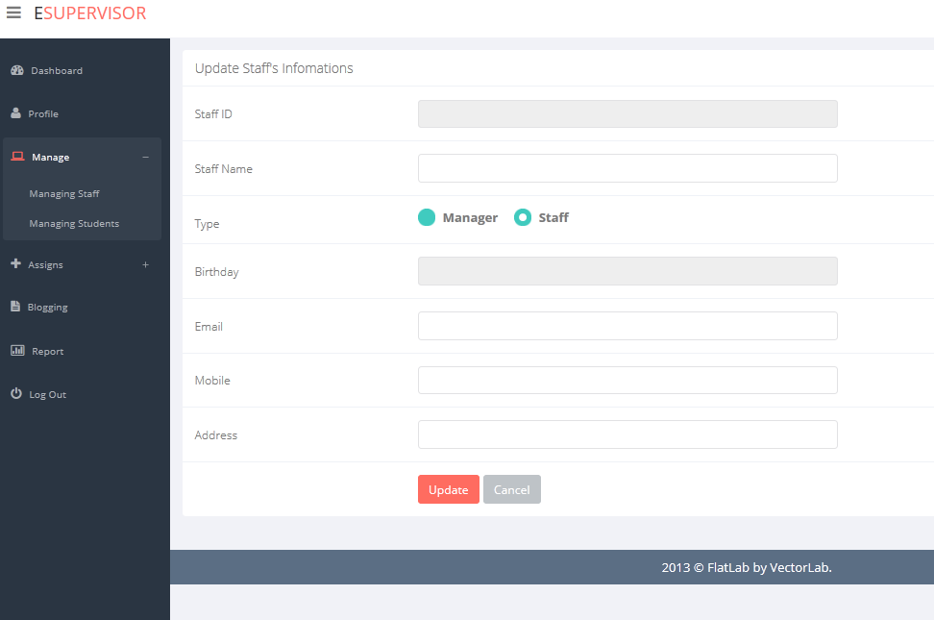

##### Managing Student

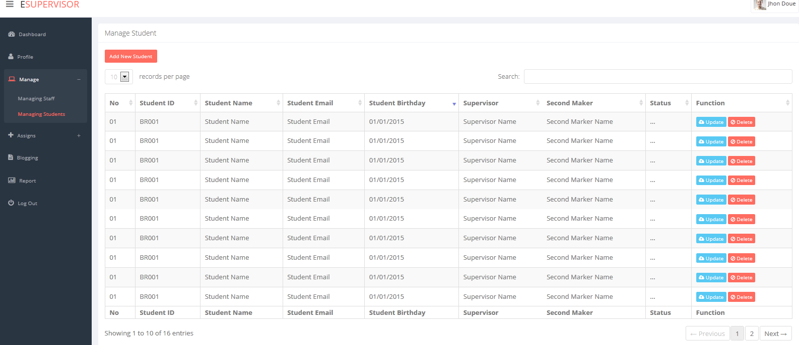

##### Update Student’s info

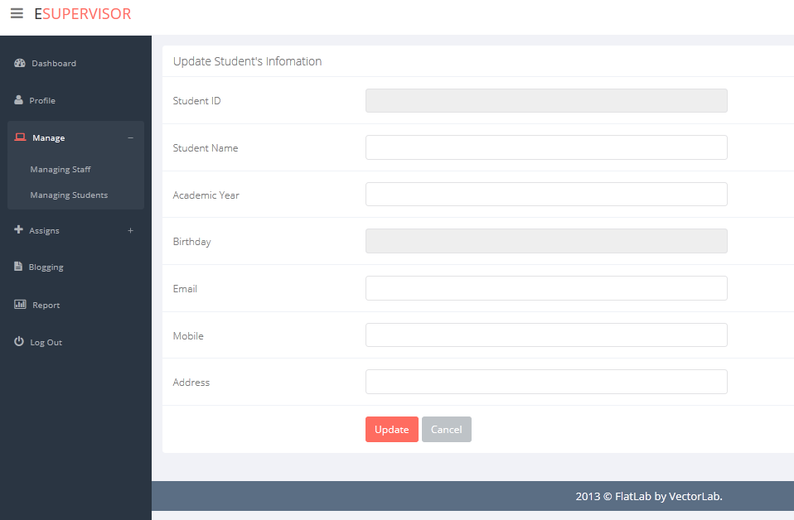

##### Staff Allocation

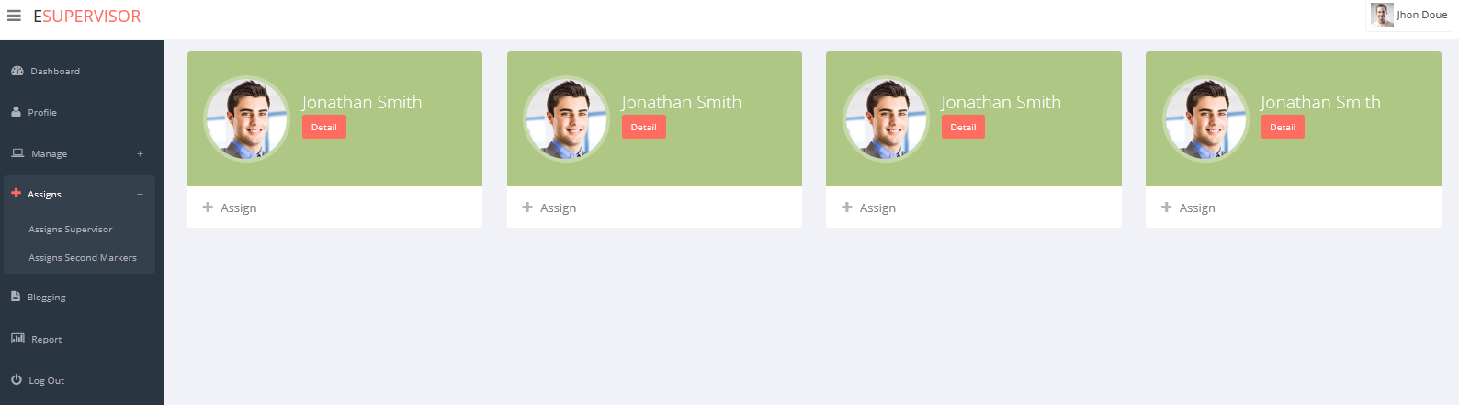

##### Student Allocation

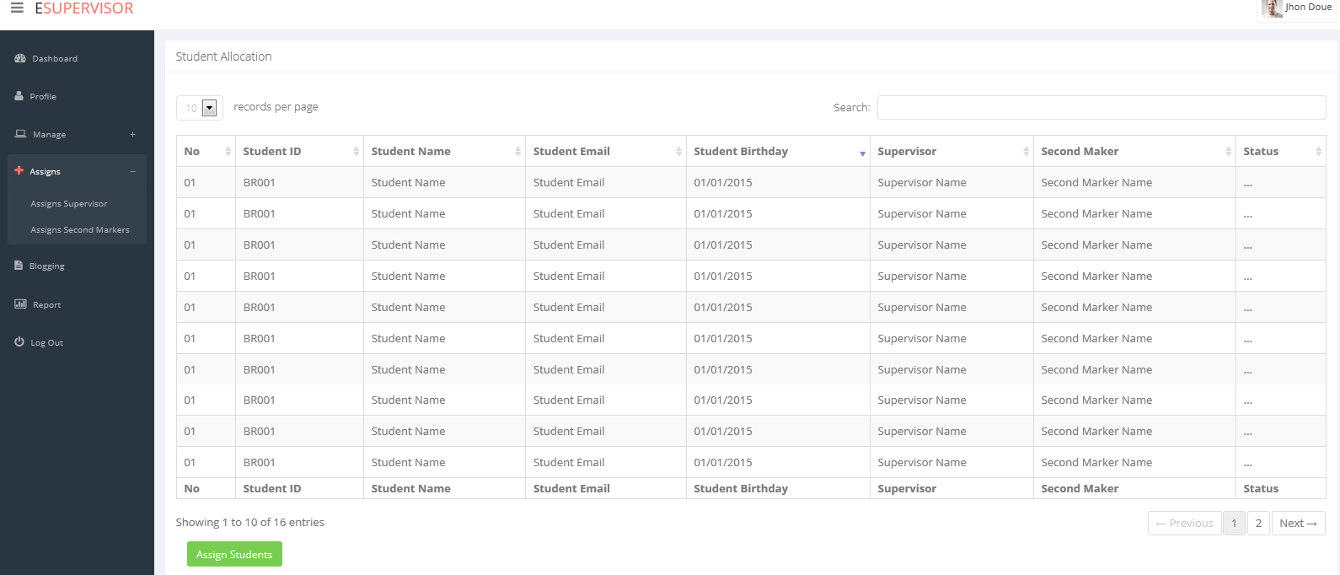

##### Blogging

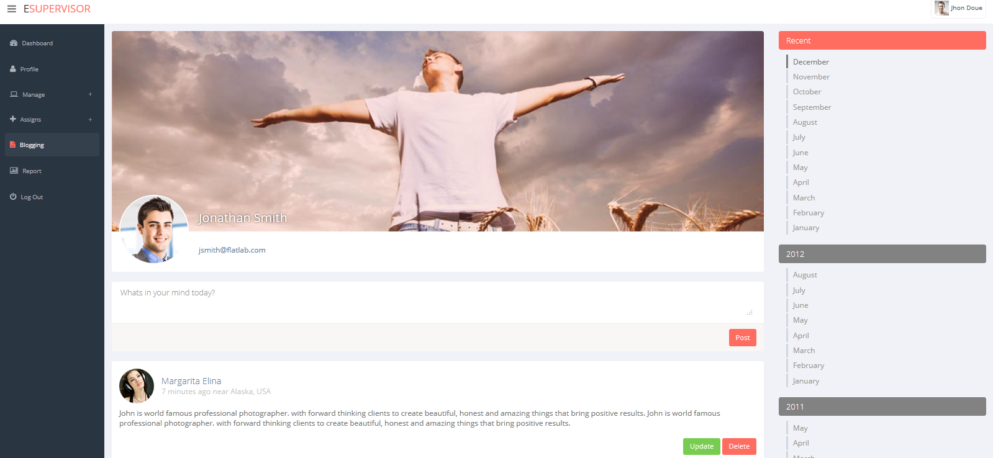

##### Report

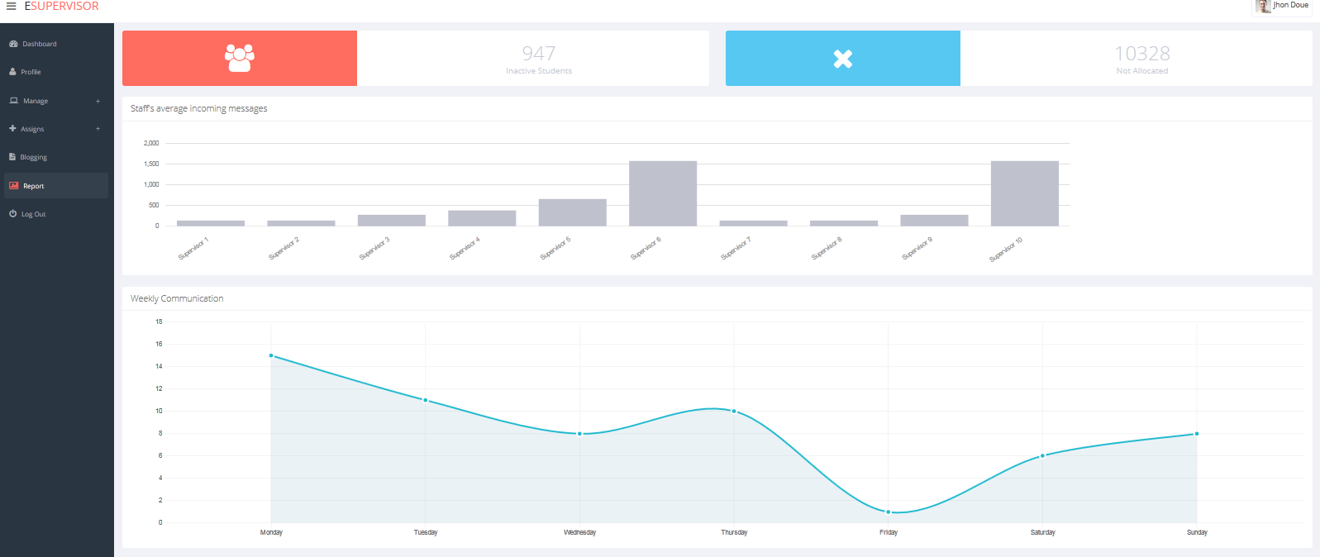

#### Staff’s UI

##### Dashboard

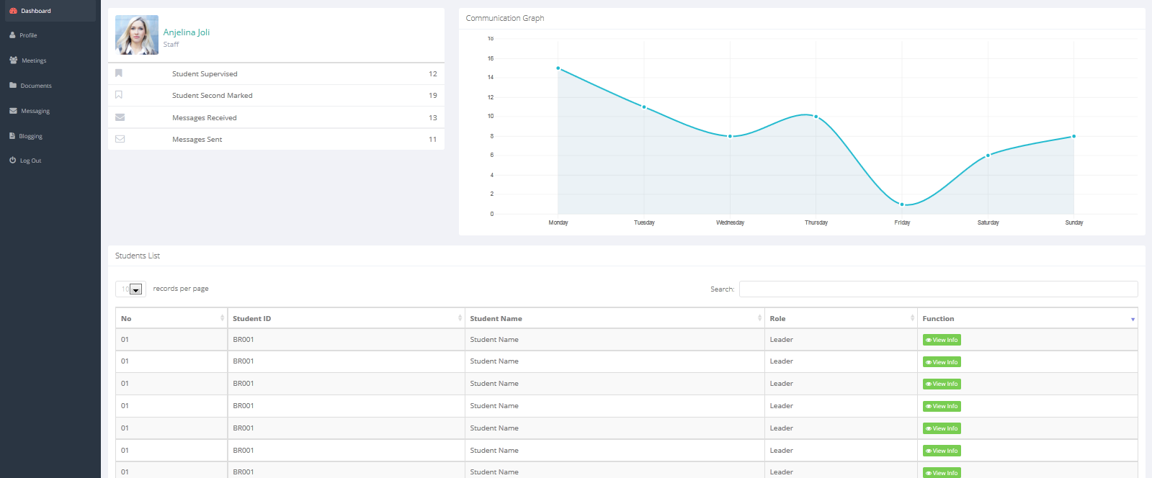

##### Profile

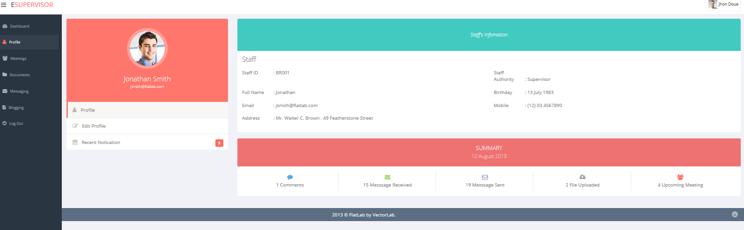

##### Edit profile

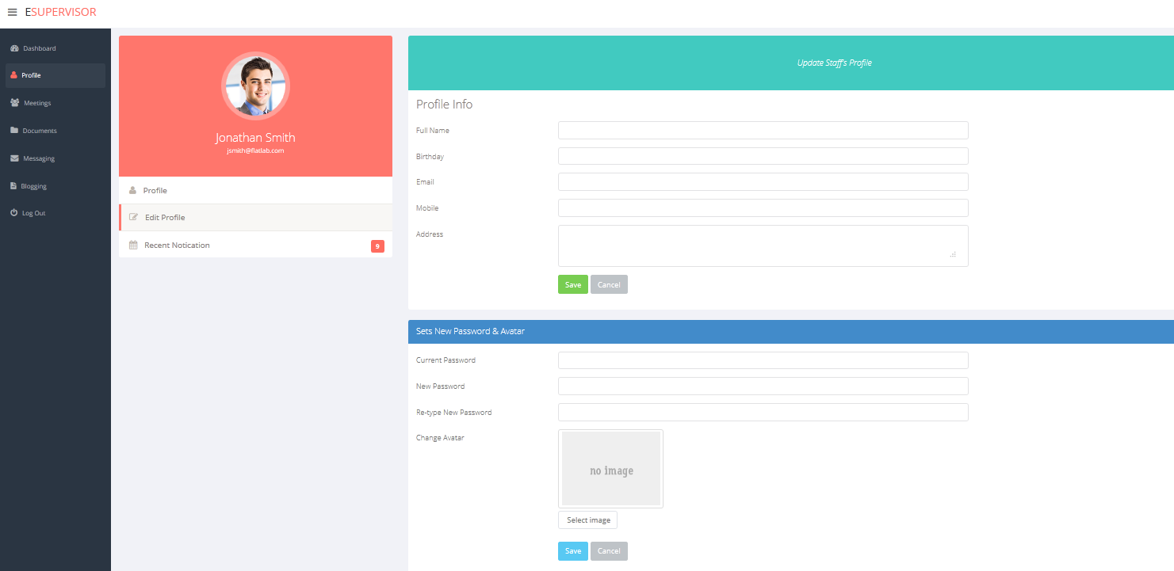

##### Profile Activity

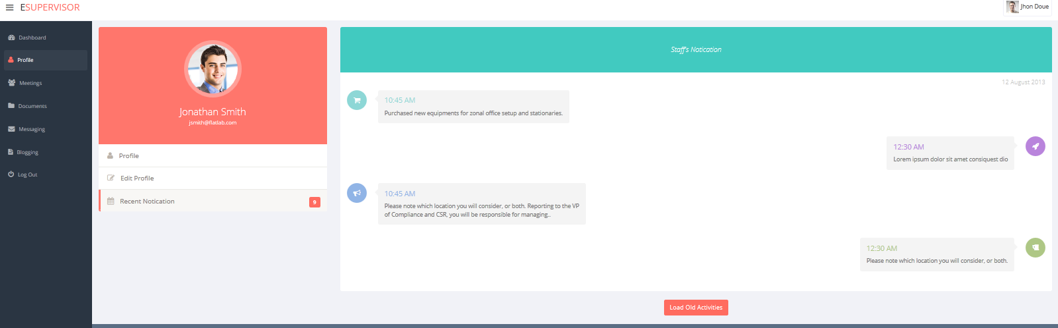

##### Staff meeting

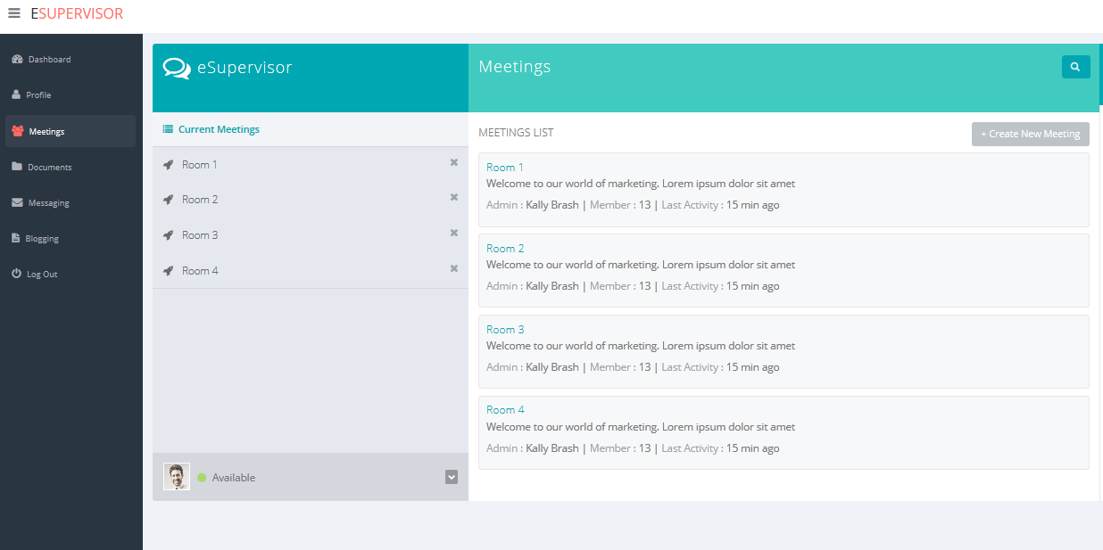

##### My Meeting

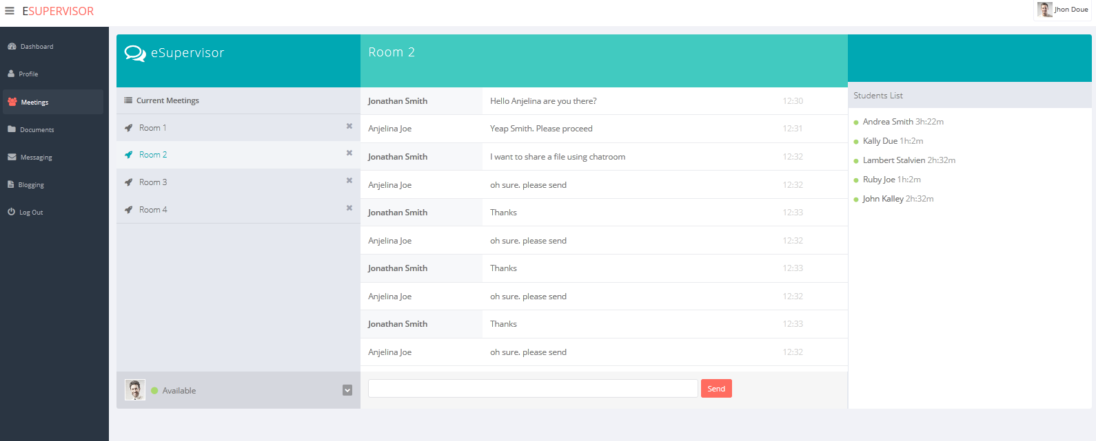

##### Create new meeting

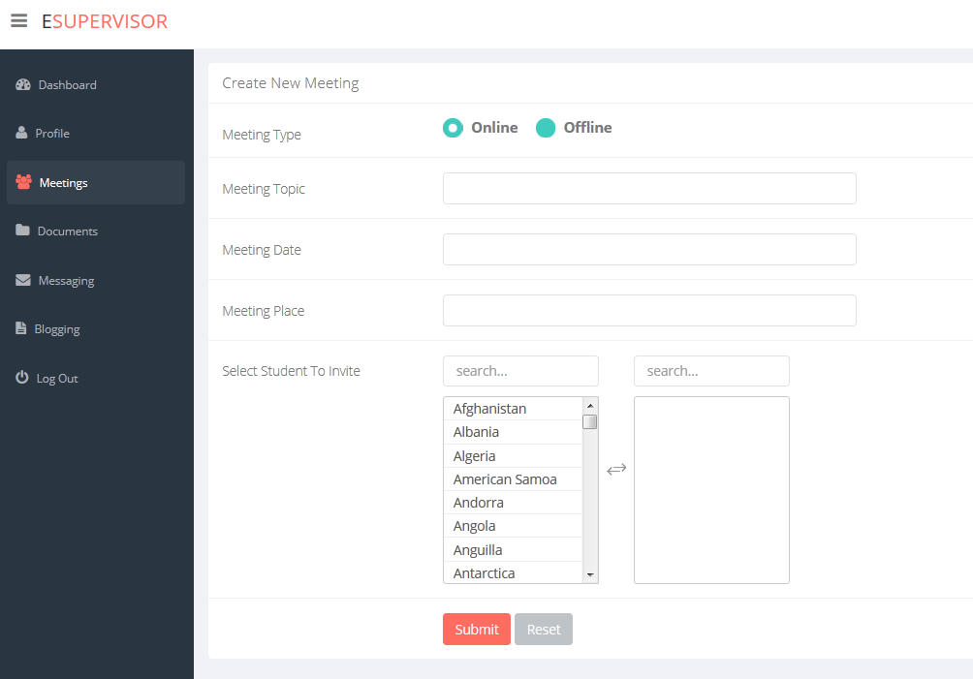

##### Documents

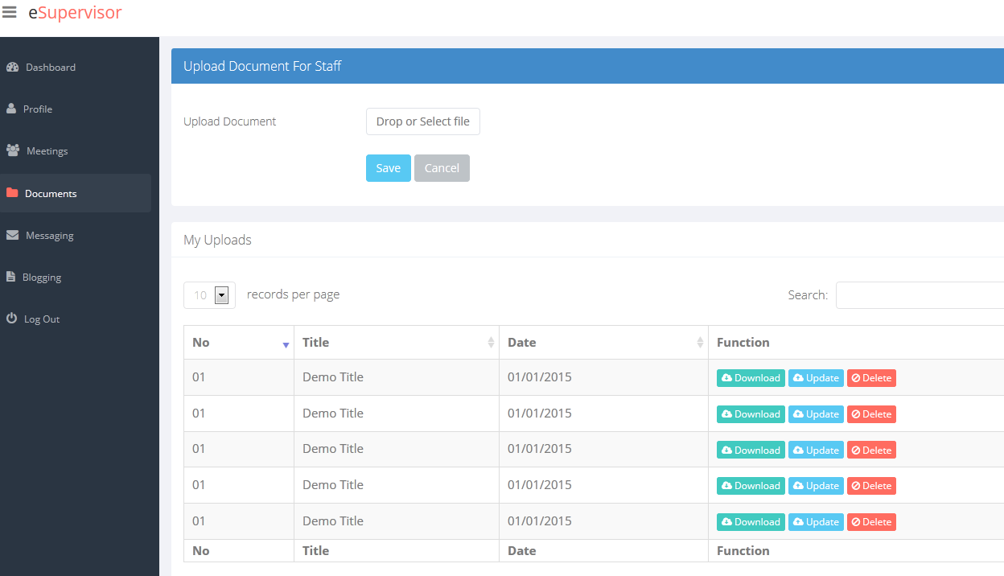

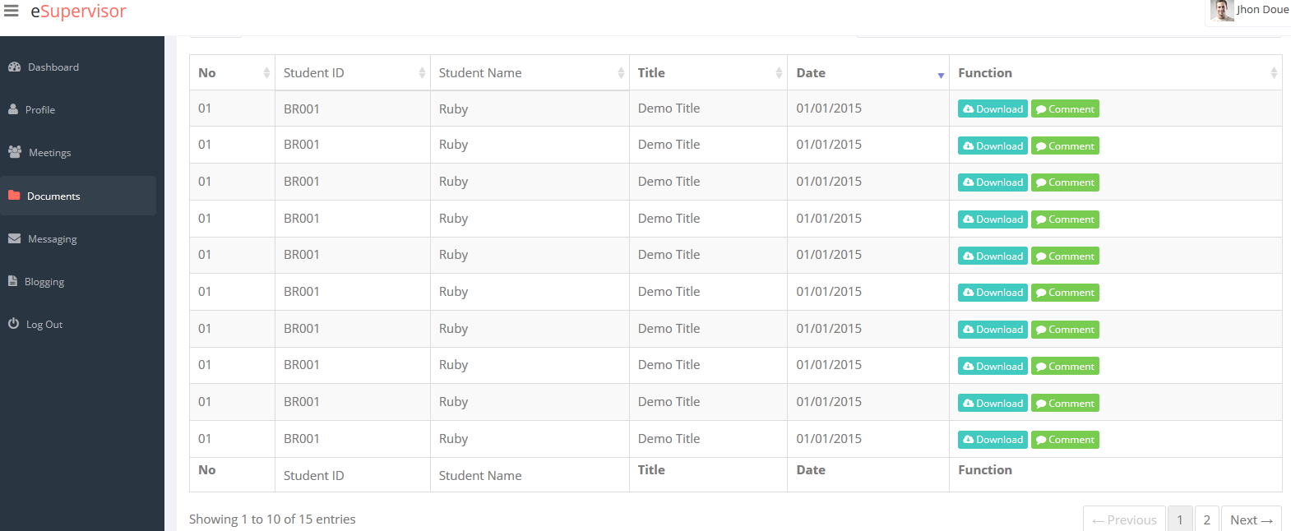

##### Messaging

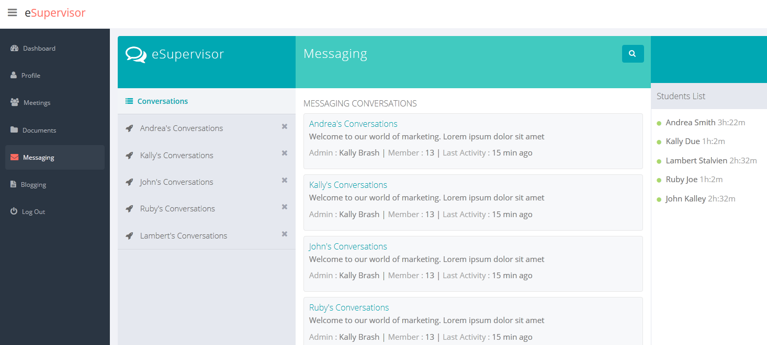

##### My Messaging

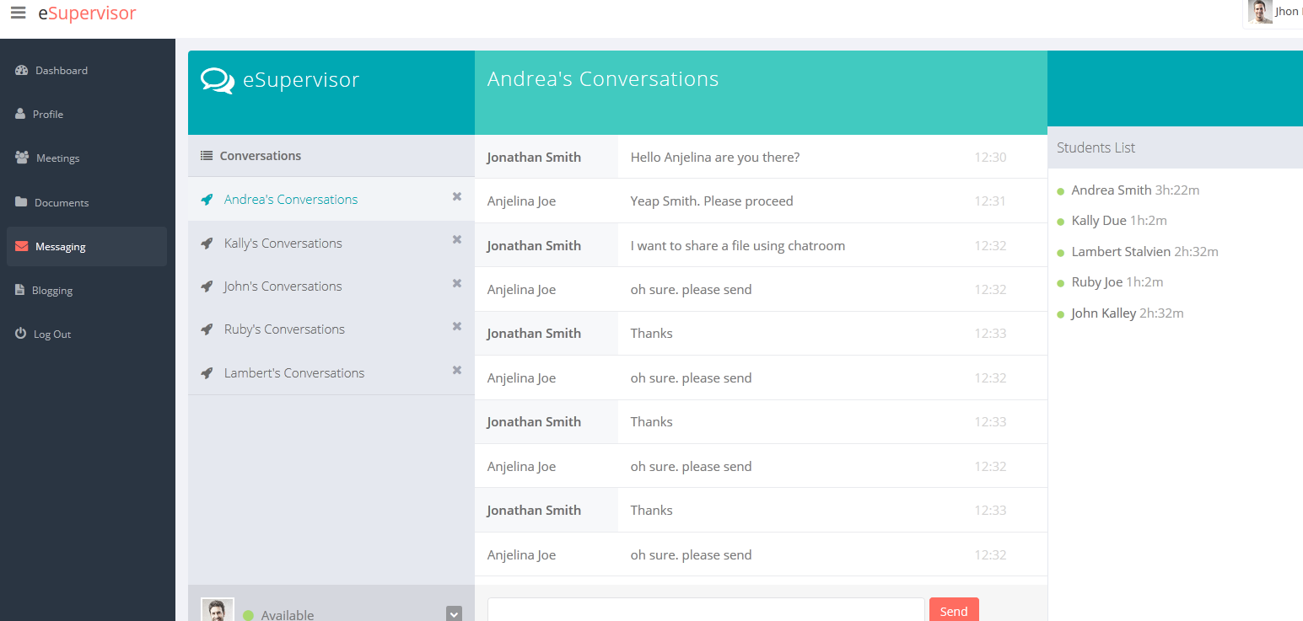

##### Blogging

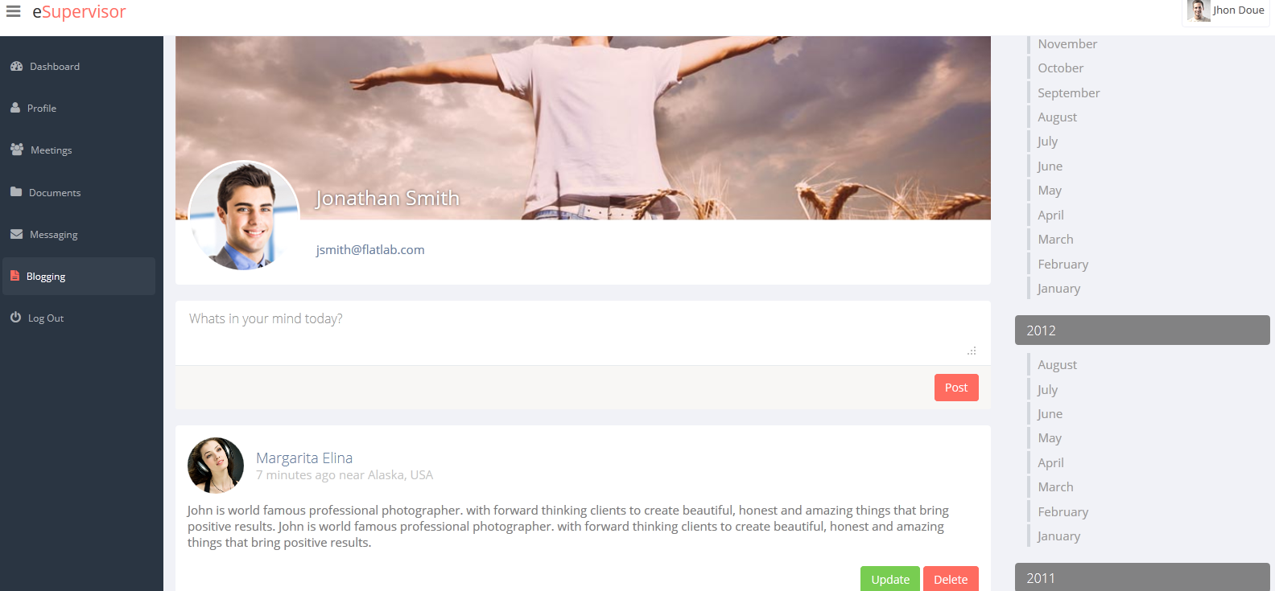

#### Student’s UI

##### Student dashboard

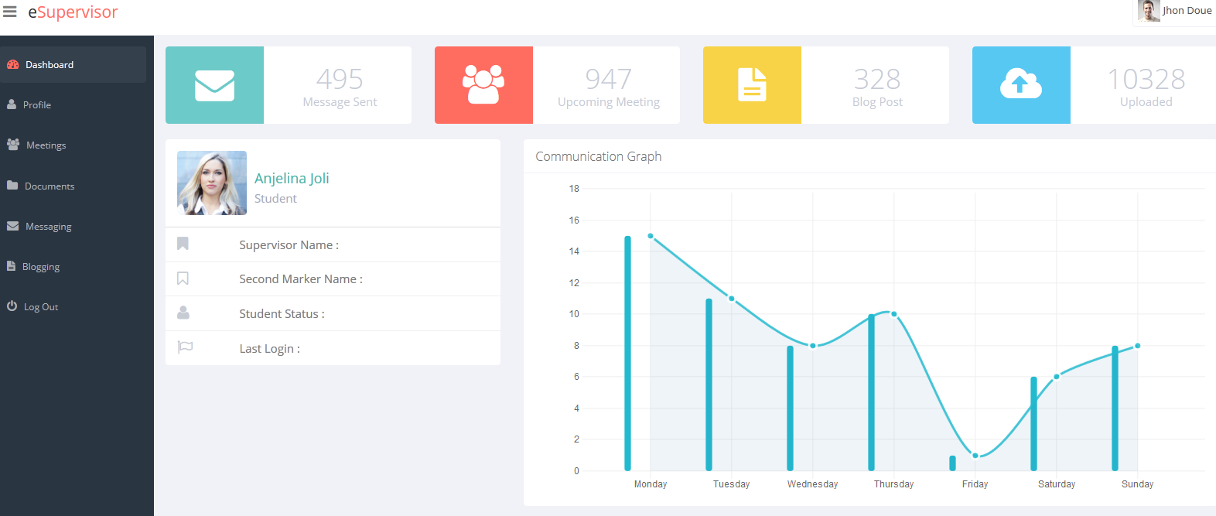

##### Profile

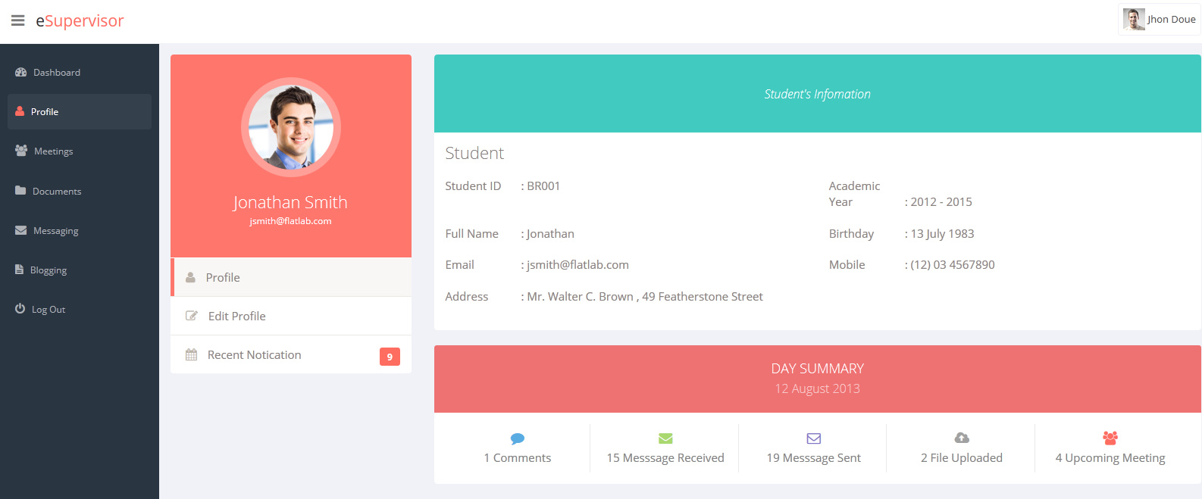

##### Edit profile

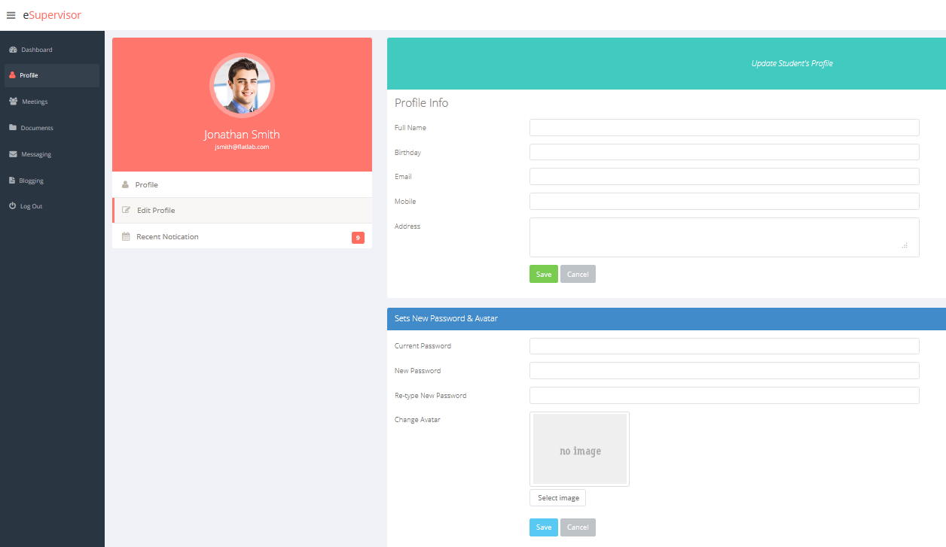

##### Activity

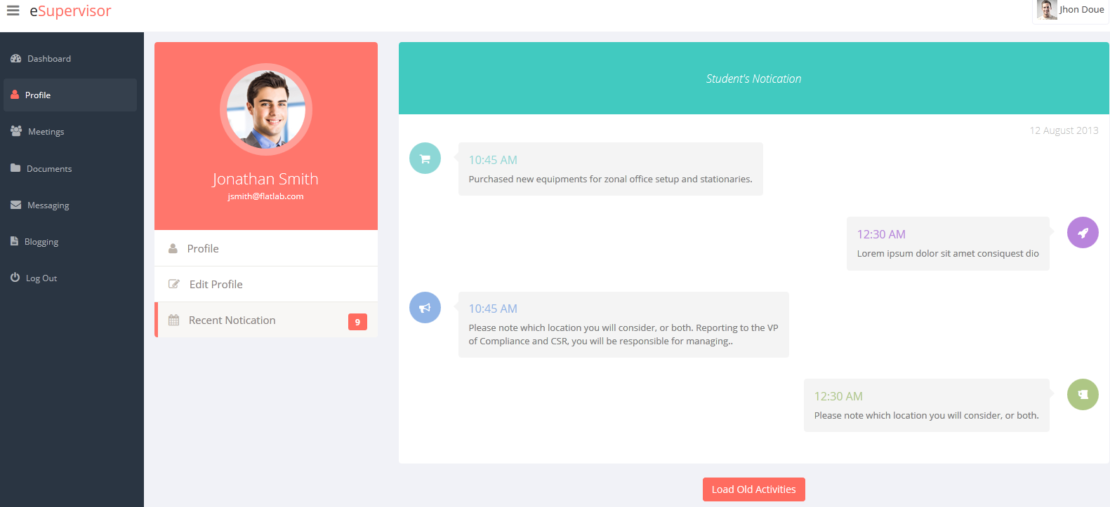

##### Meeting

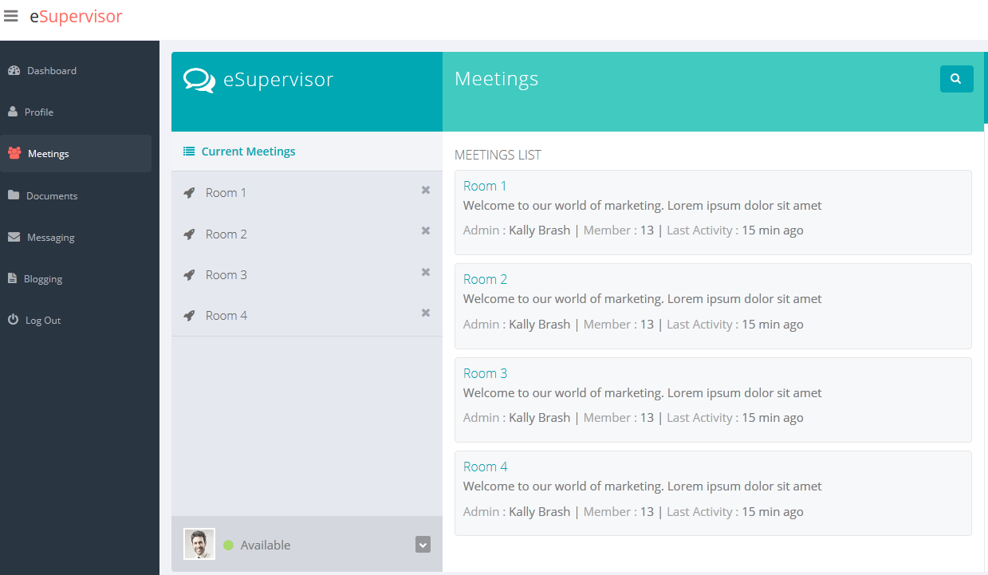

##### My meeting

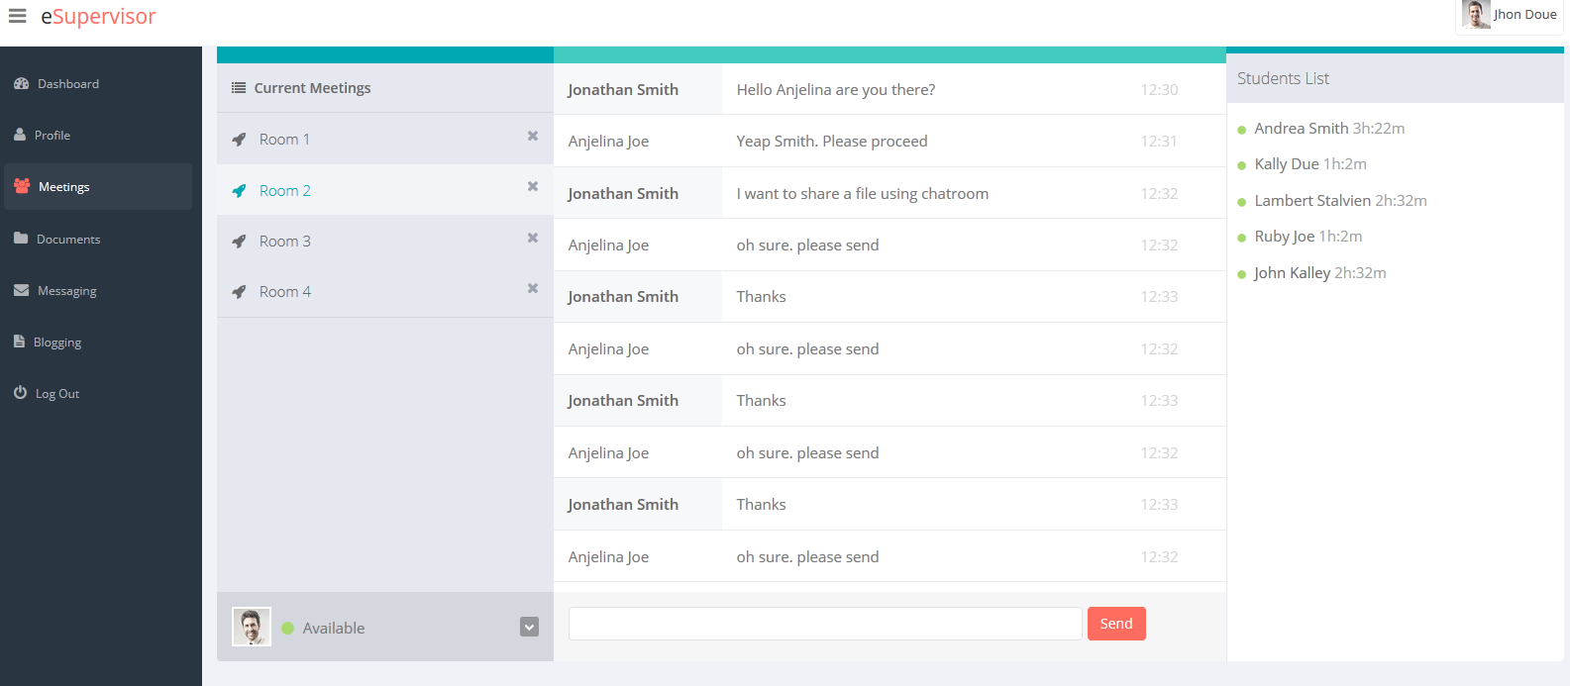

##### Documents

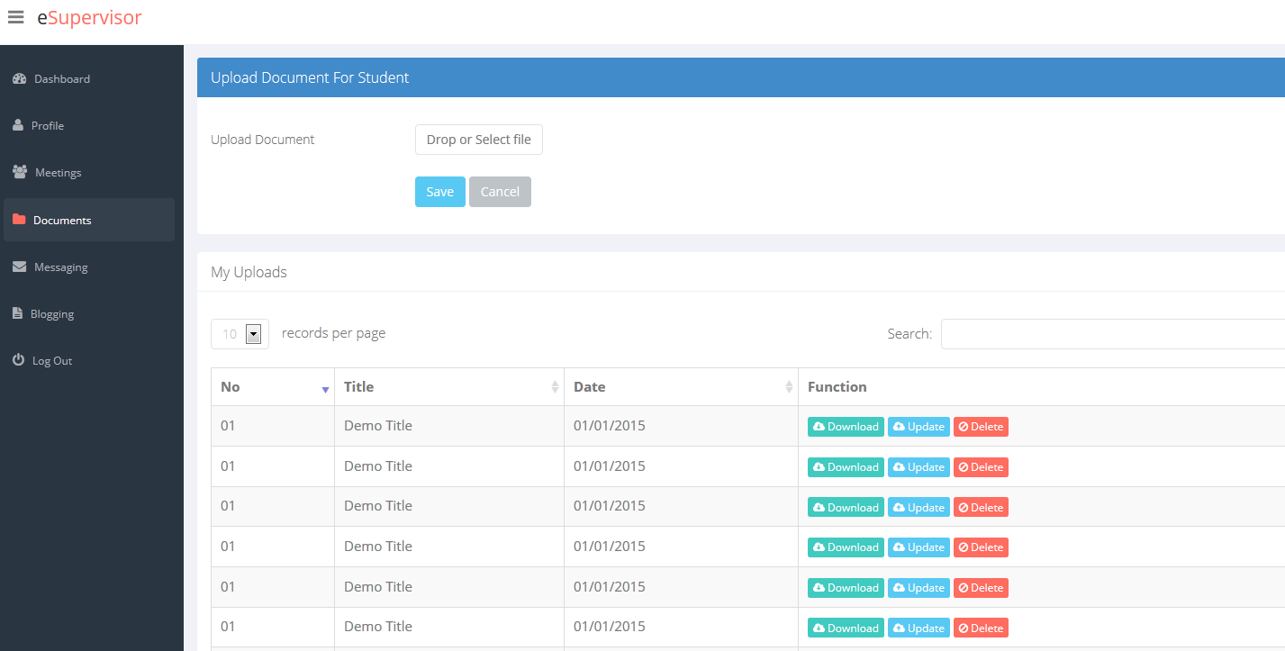

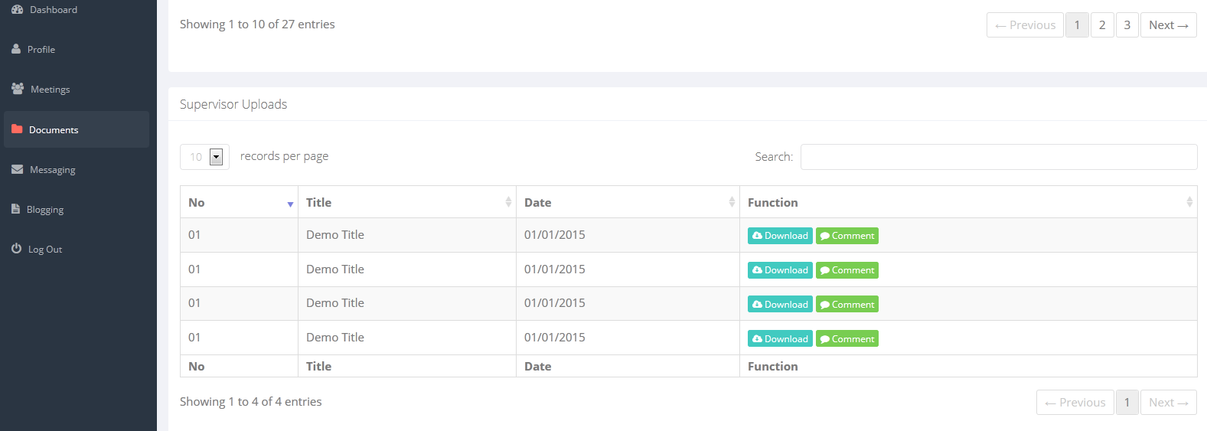

##### Messaging

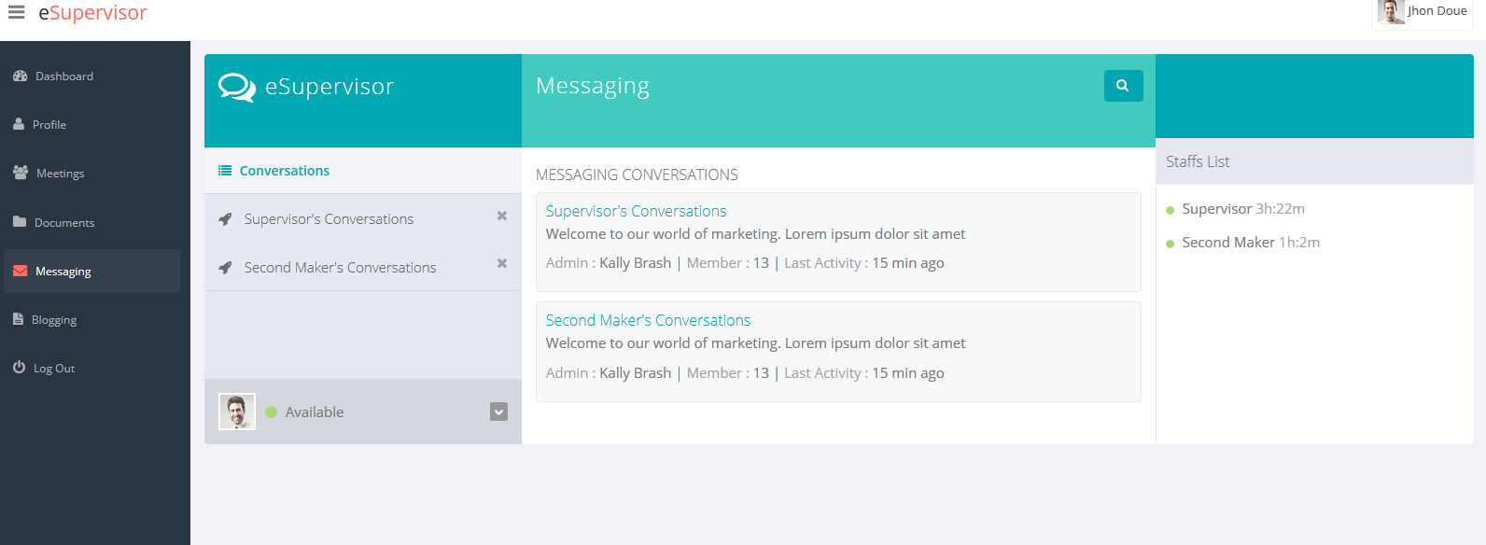

##### My Messaging

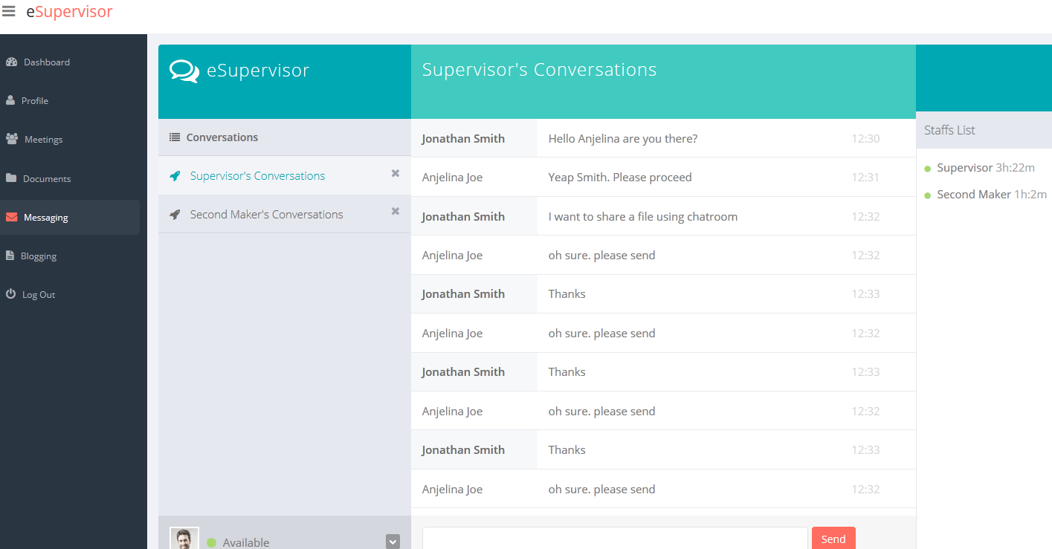

##### Blogging

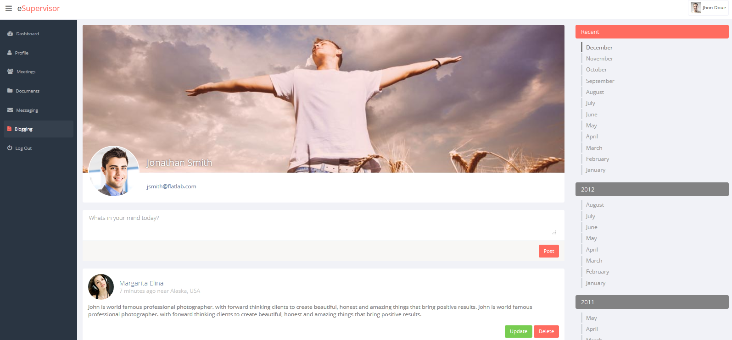

## Full Design

As we developed the site, there are some changes that had been made by Nhut and Nguyen and Mr Quy showed no working effort in this progress. And because of that, since Nhut and Nguyen are not good in term of graphical design so some pages’ design are not actually good and in a line with the others.

### “Login” page use for all actor.

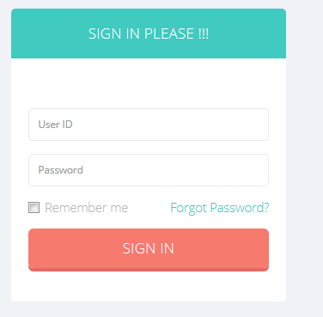

### Student

##### “Student Dashboard” page

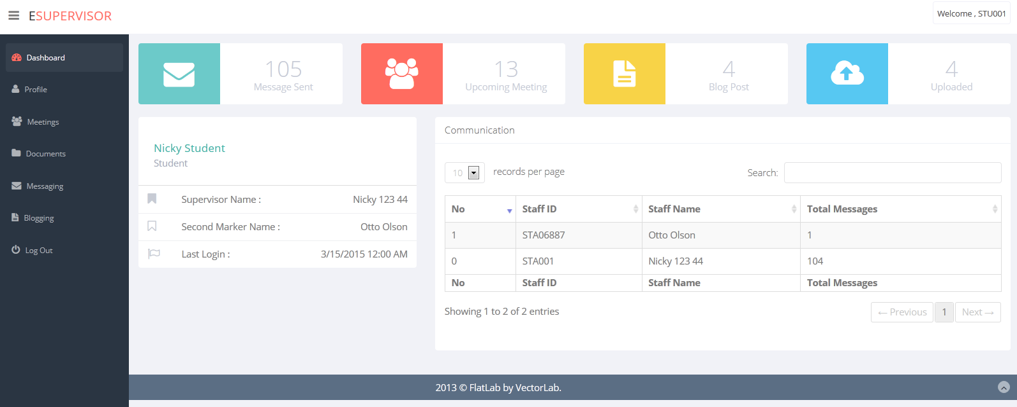

##### “Student Profile” page

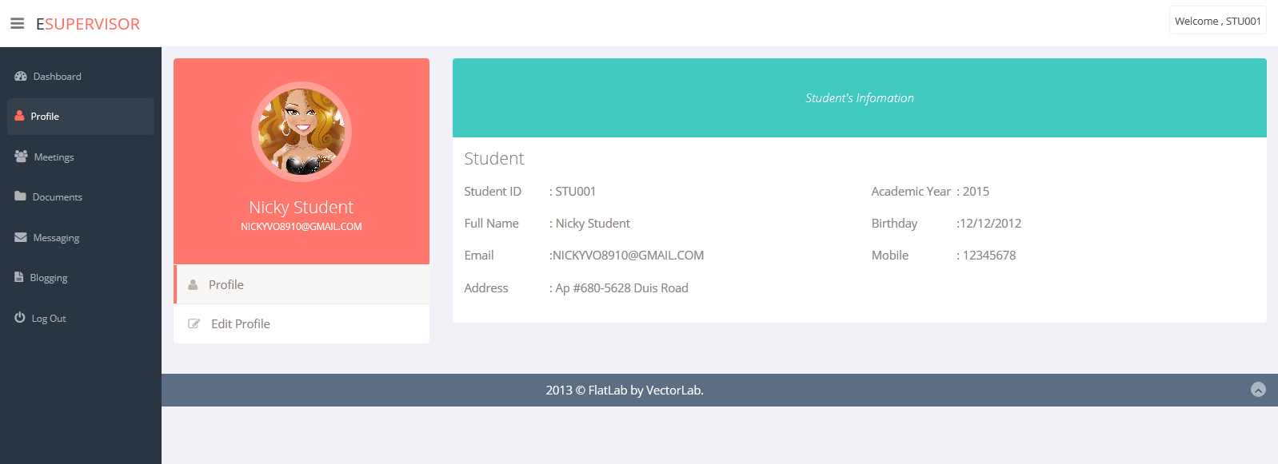

##### “Student Edit Profile” page

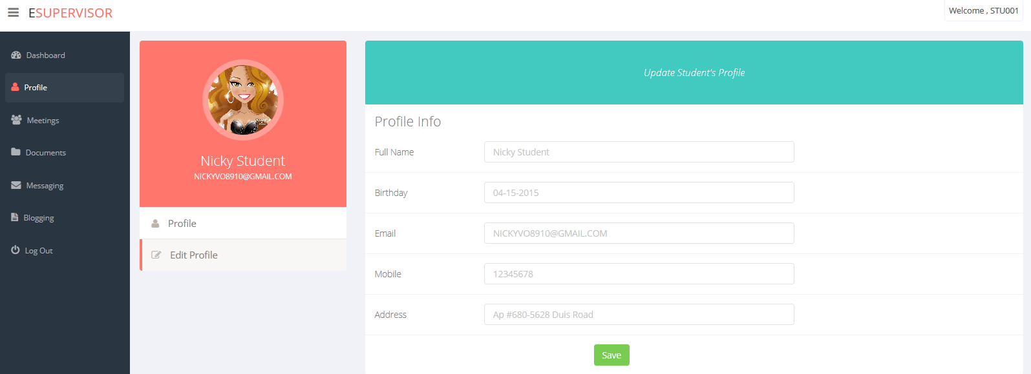

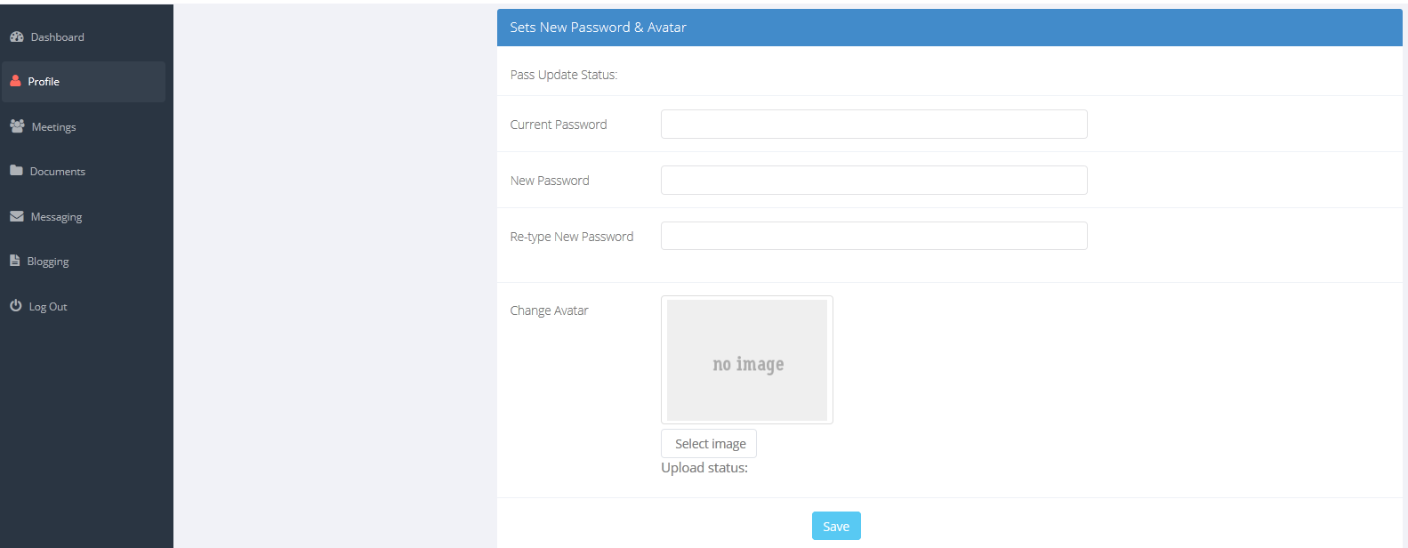

##### “Student Meeting” page

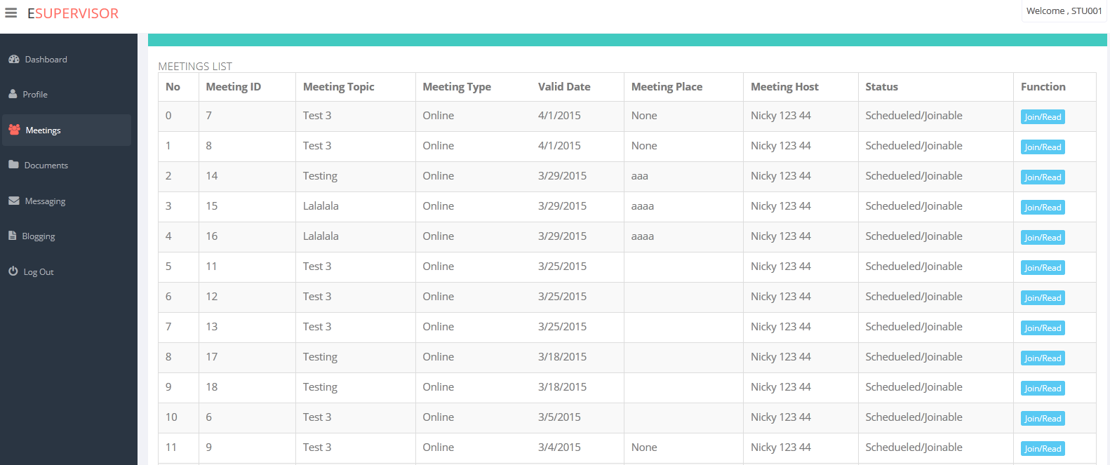

##### “Student Document” page

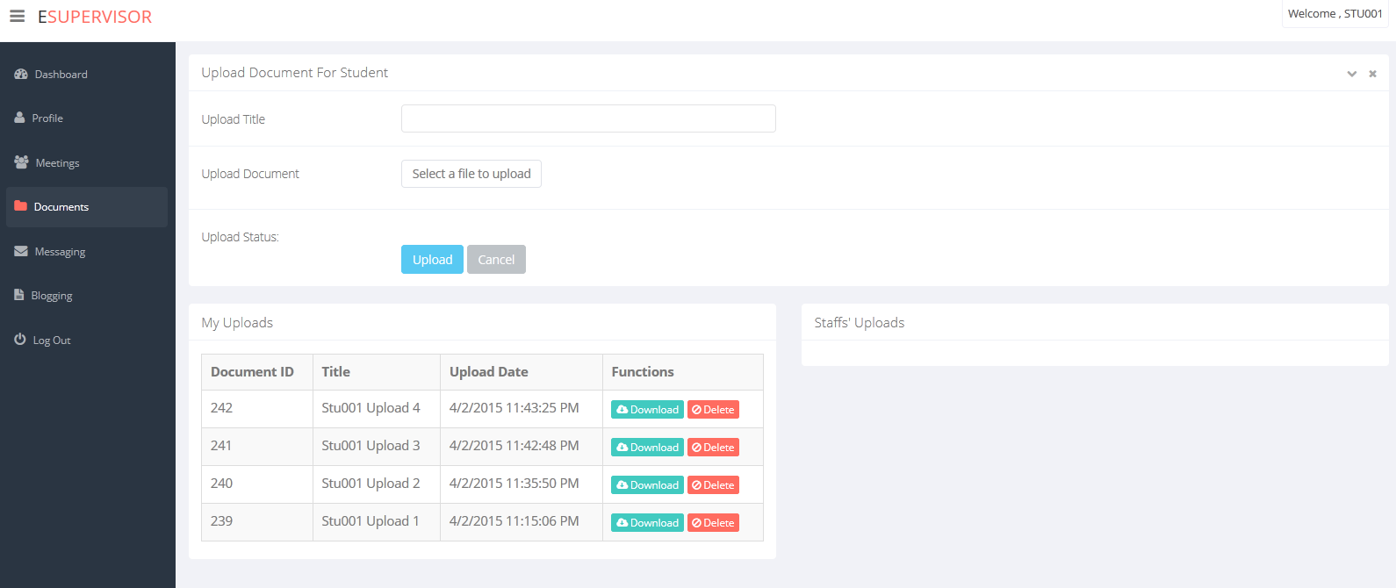

##### “Student Meeting “page

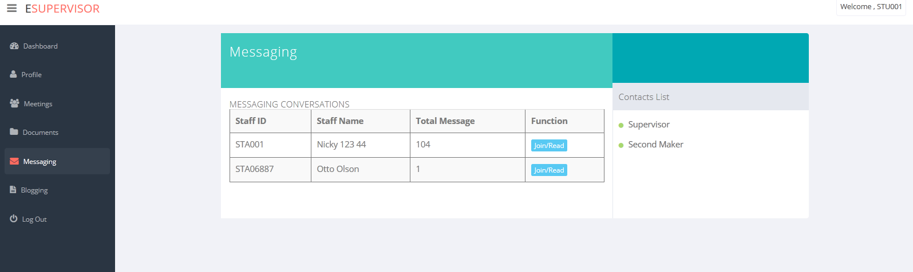

##### “Student Blogging” page

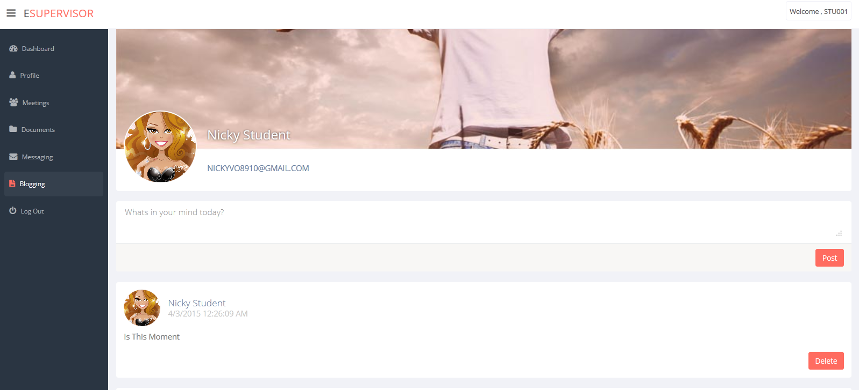

### Manager

##### “manager Dashboard” page

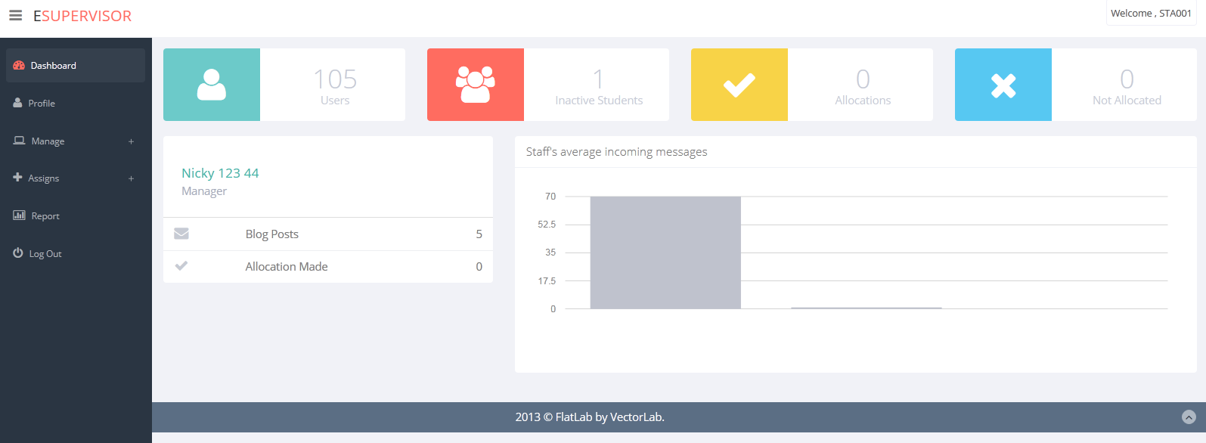

##### “manager Profile” page

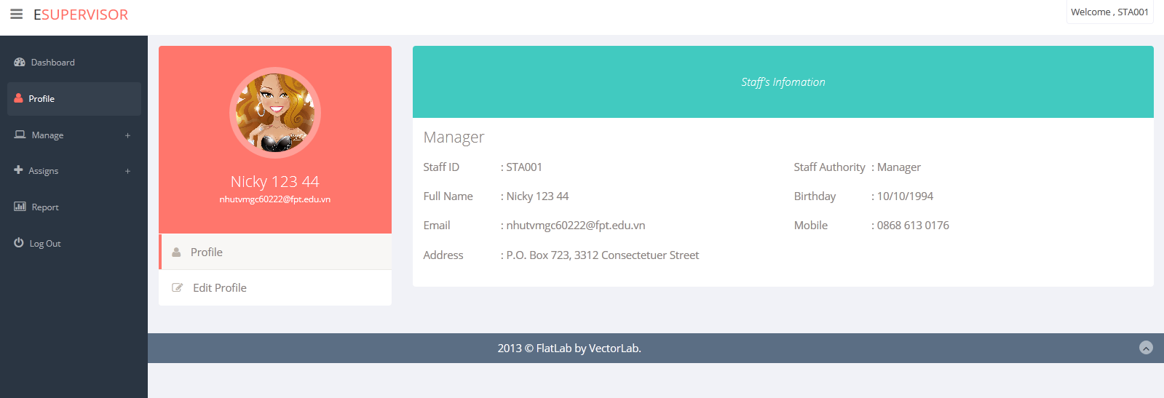

##### “Managing Staff “page

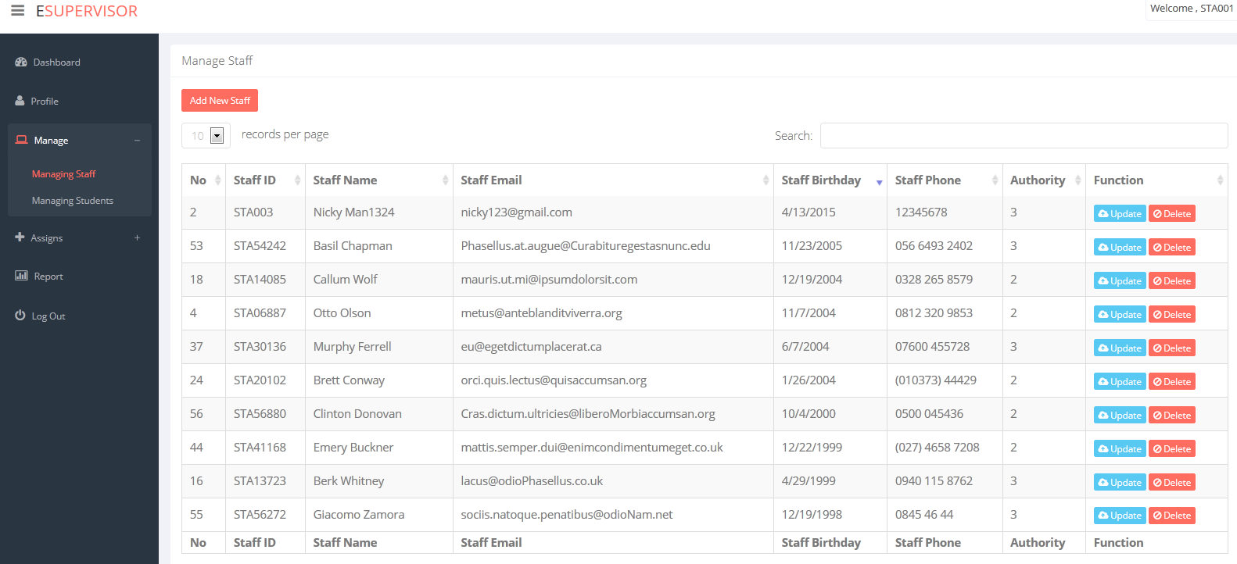

##### “Managing Student” page

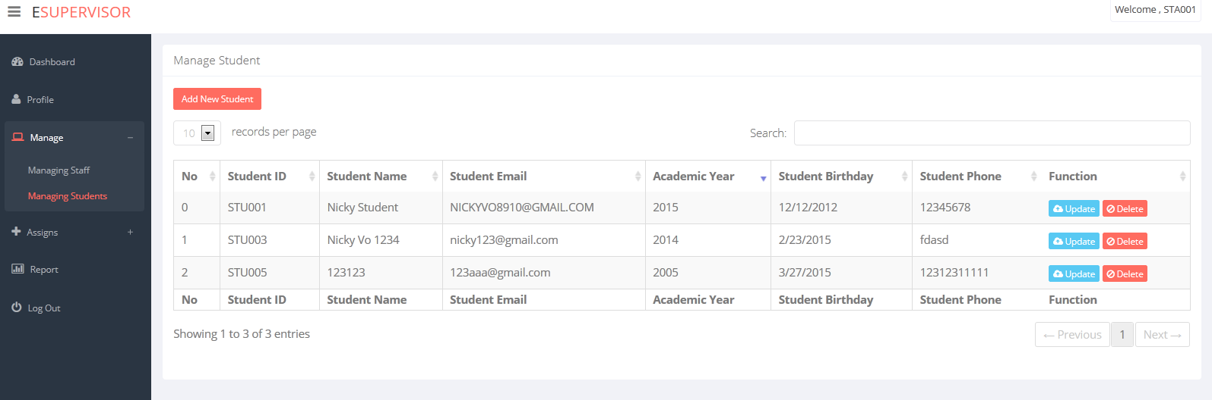

##### “Add New Account” page

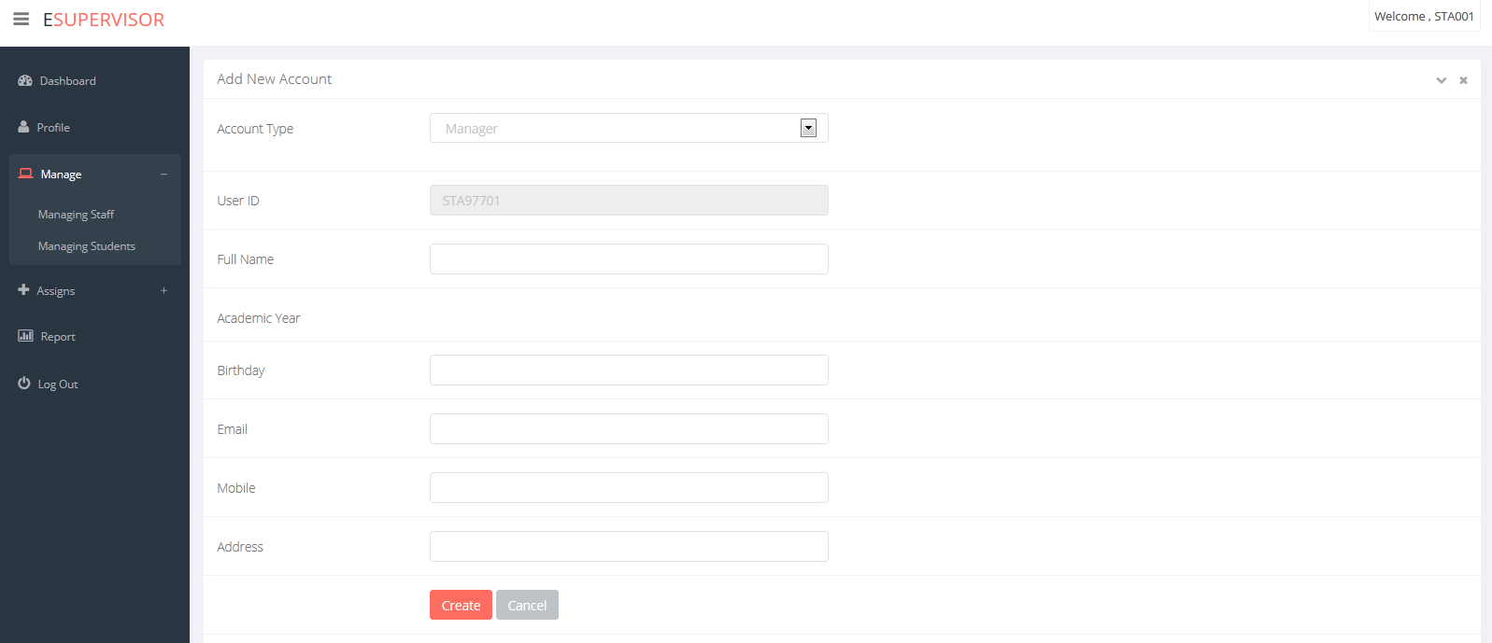

##### “Staff Allocation” page

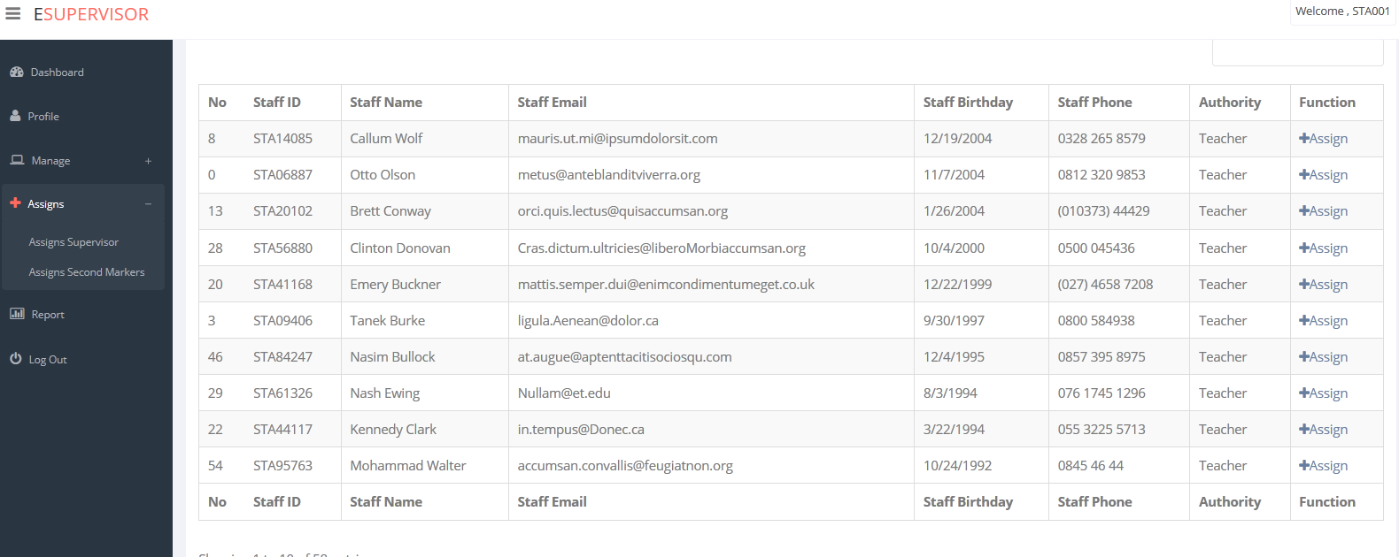

##### “Manager Report” page

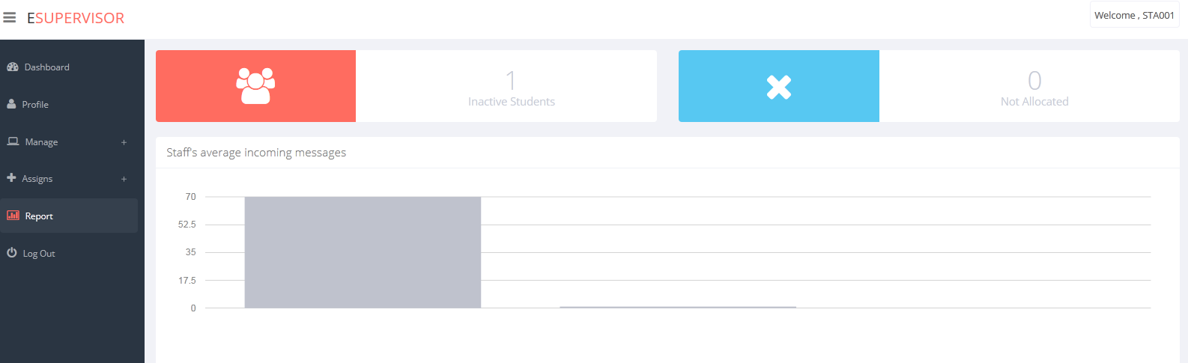

### Supervisor/Second marker

##### “Staff Dashboard” page

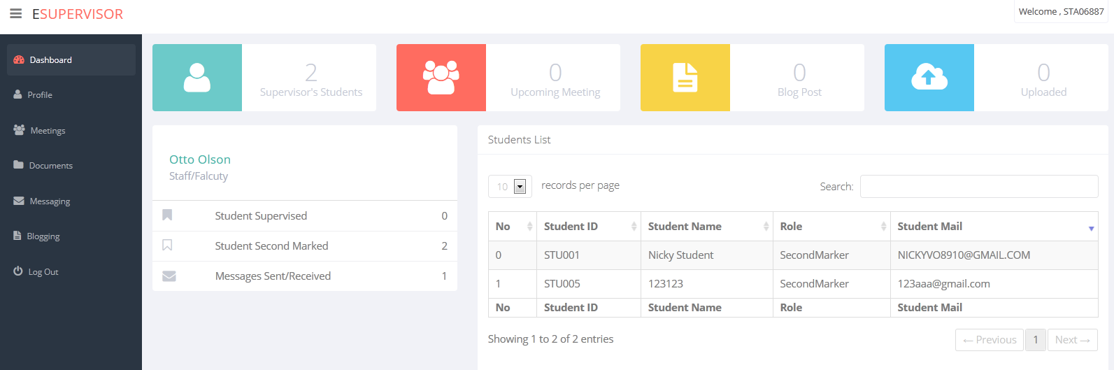

##### “Staff Profile” page

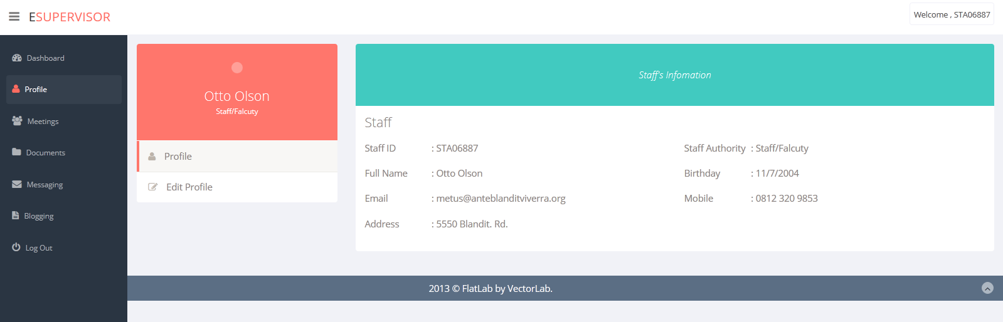

##### “Staff Messaging” page

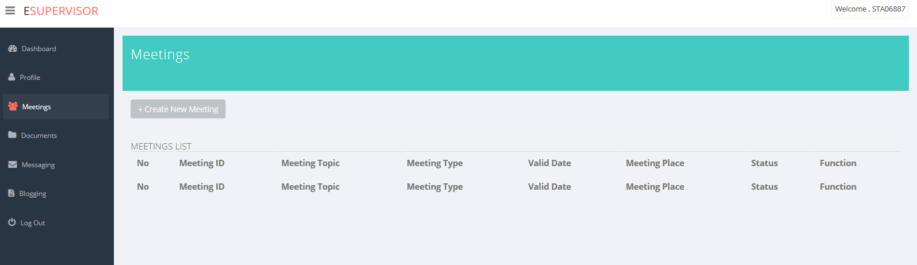

##### “Create New Meeting” page

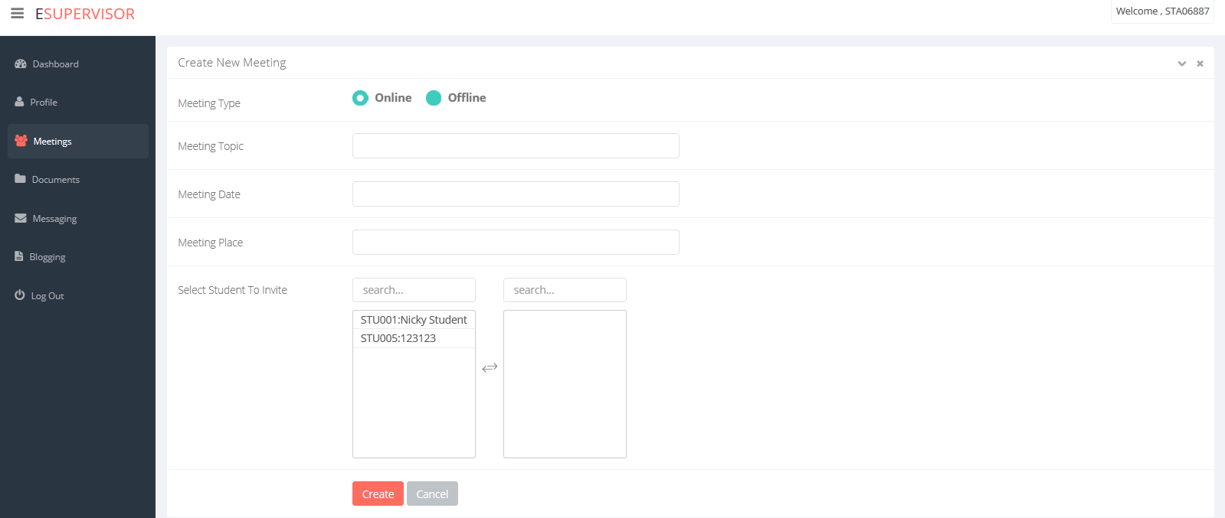

##### “Staff Document” page

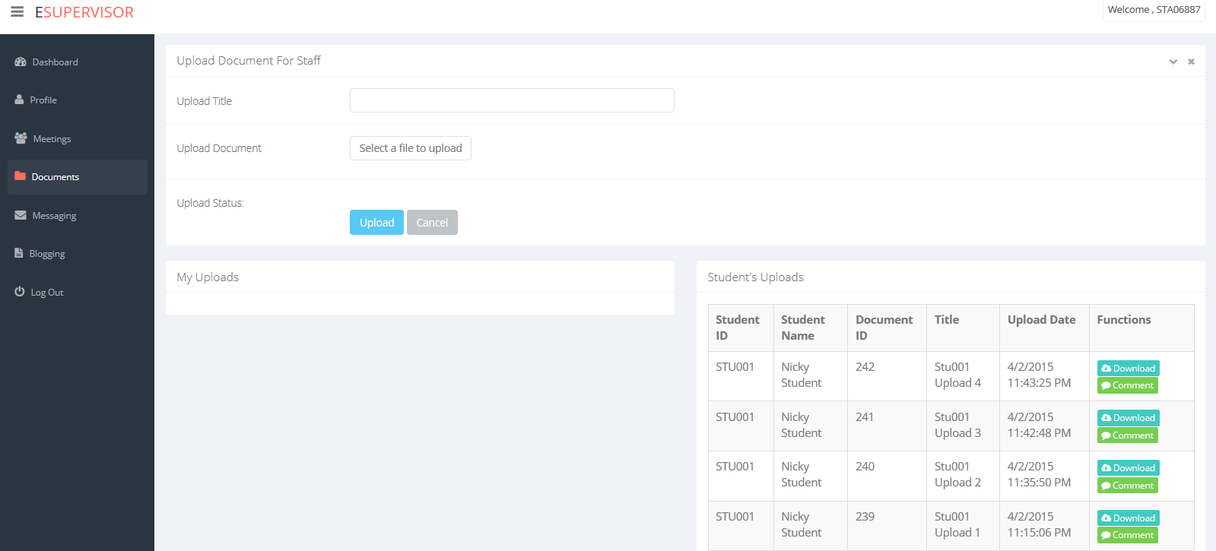

##### “Staff Messaging” page

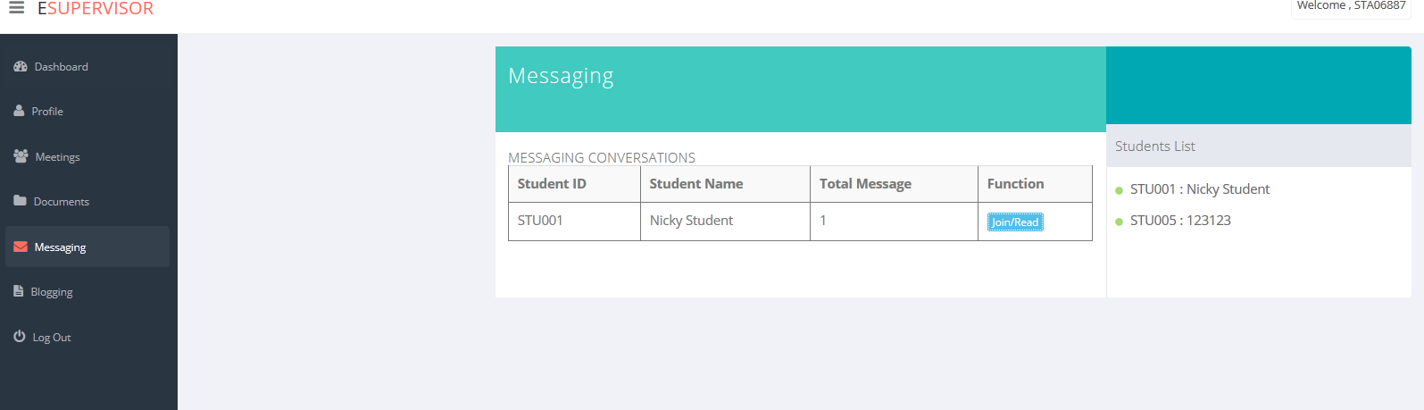

##### “Staff My Meeting” page

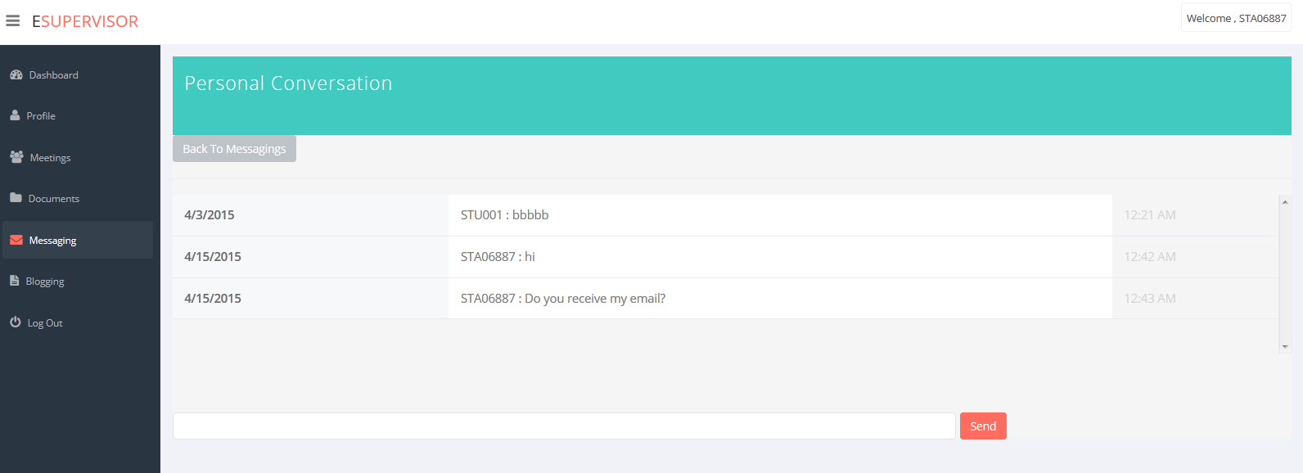

##### “Staff Blogging” page

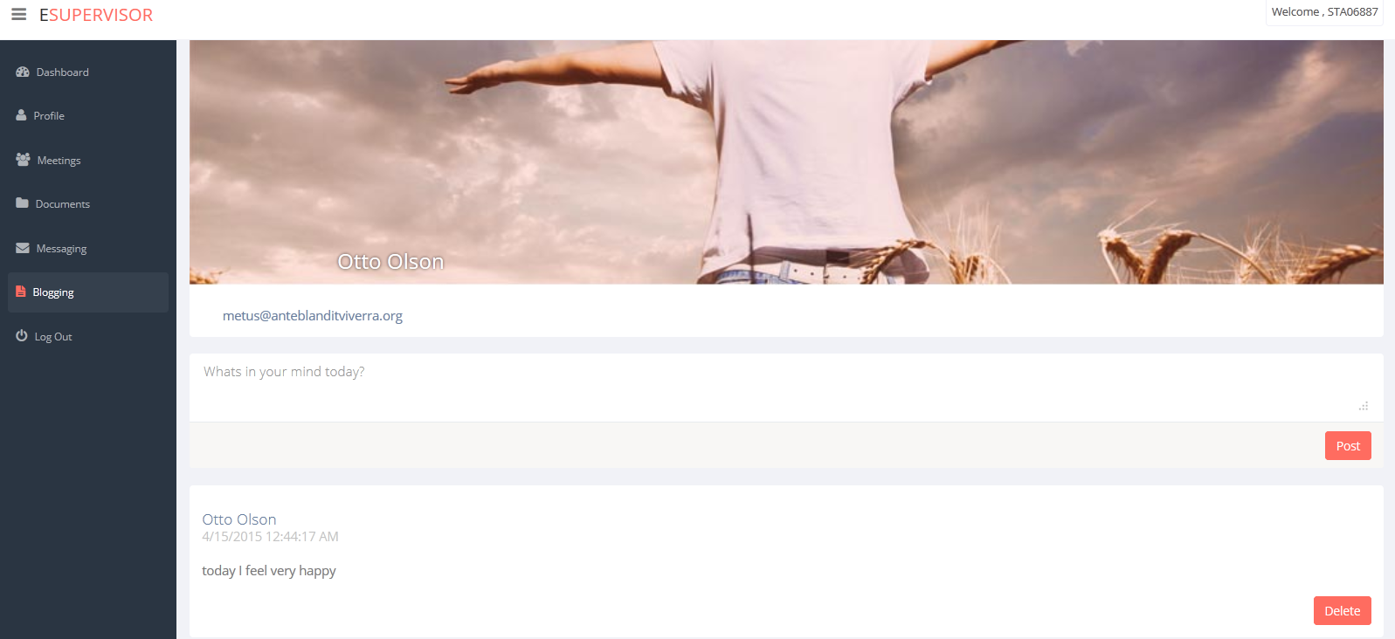

## Site map

-Site map shows the structure system of the website helps user find information or find page they need.

### Manager’s Site map

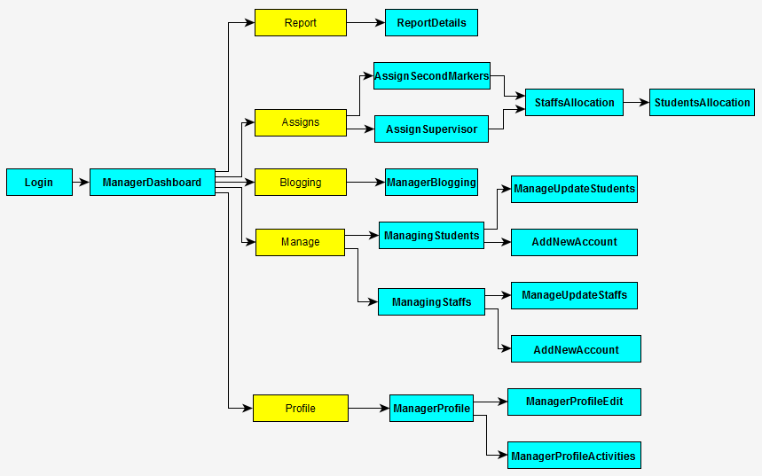

### Staff’s site map

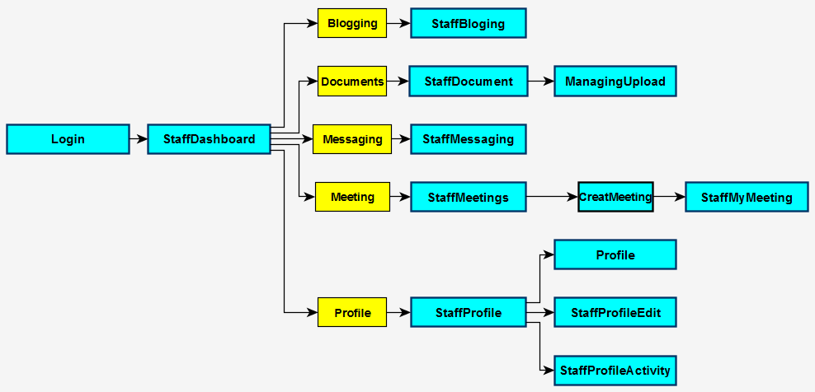

### Student’s site map

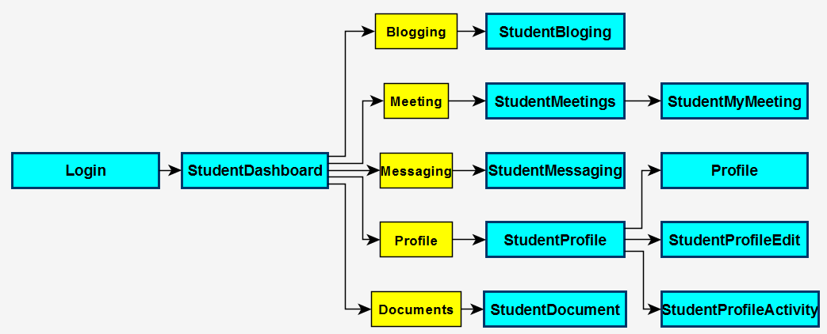

# Implementation

In order to make the system functional, we managed to implement and develop some codes as the following:

* Bootstrap (UI)
* LINQtoSQL
* JavaScript
* jQuery
* Inline Server Coding (Scriptlet)
* Server I/O Communication
  + Upload/Write to server
  + Download/Write to client
  + Delete file on server
* SMTP Mailing System
* Cookies/Session variables
* File I/O communication
  + - Create file on server (Meeting Logs)
    - Modify server’s file (Meeting Logs)

# Installation guide

* Step 1:

-Copy and unzip folder “**eSupervision_GC0763_Group4**” into computer.

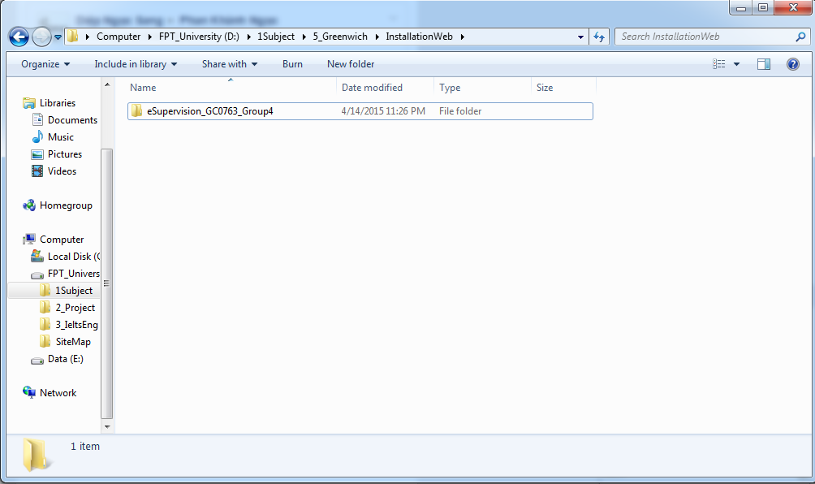

* Step 2:

-- Open SQL 2008 or later: (the best is SQL 2012).

- Open menu file/open/file choose file “dataEsupervision.sql” in folder “**eSupervision_GC0763_Group4”**.

- Click ‘’ button or press F5 to setup database for web and then you will see database “eSupervisor” in the left screen.

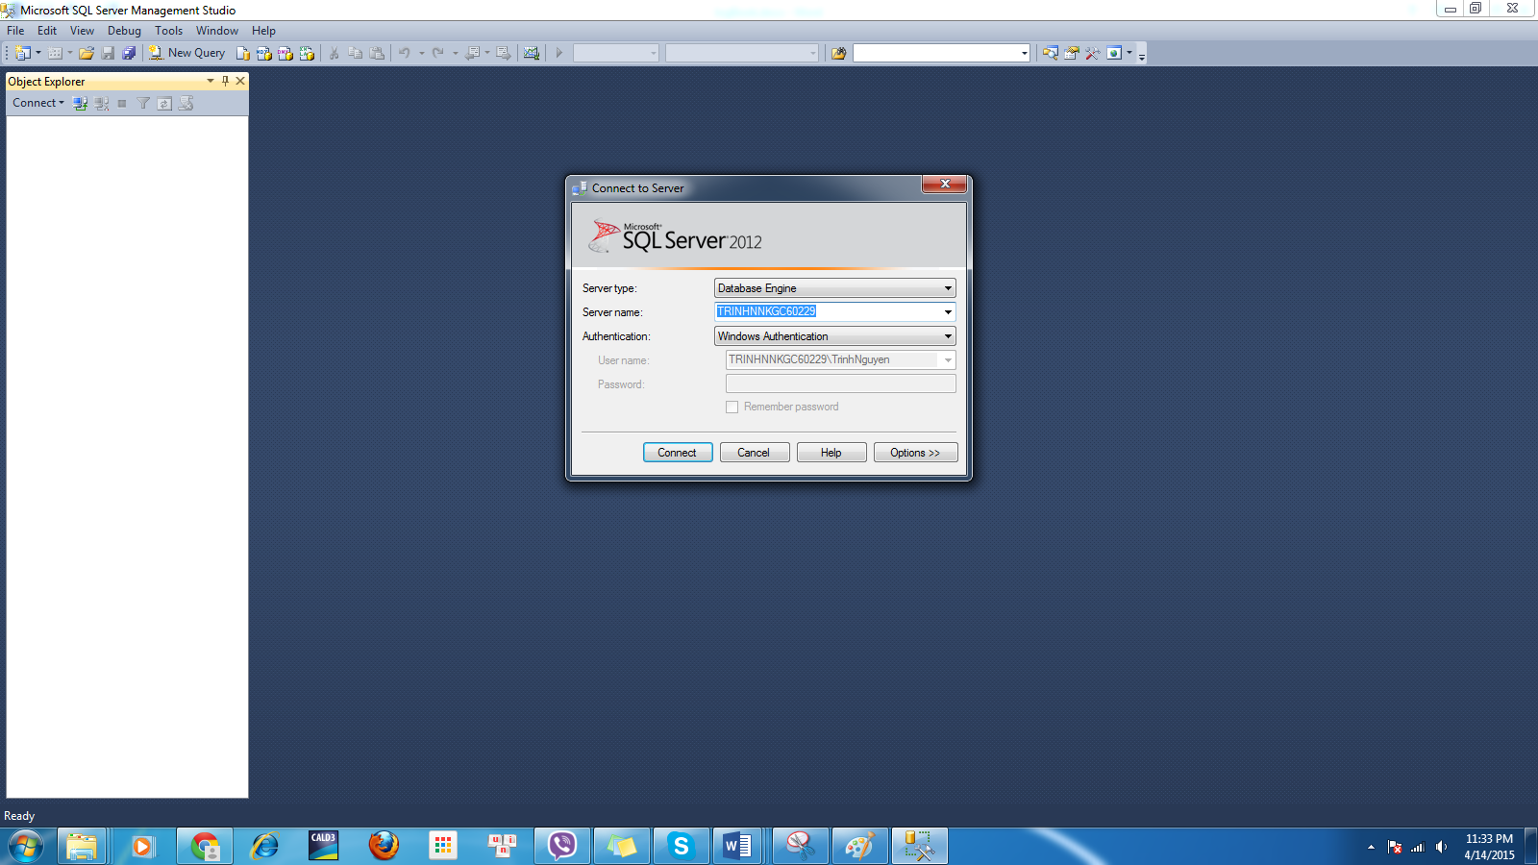

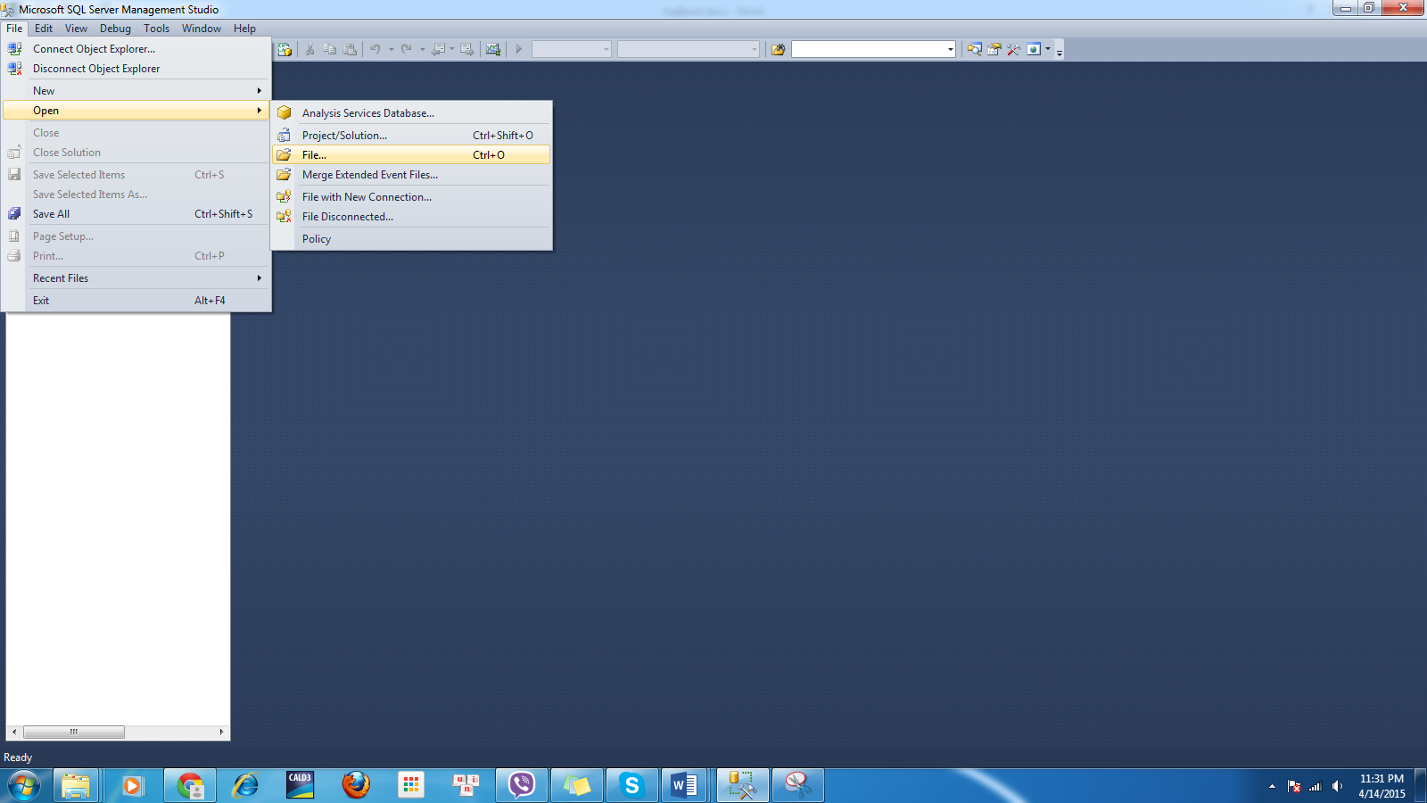

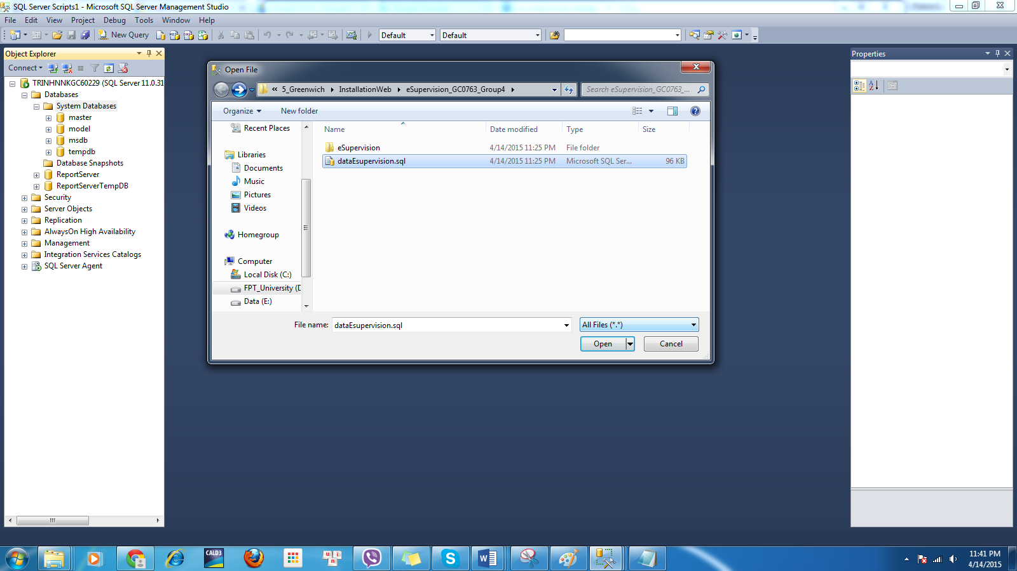

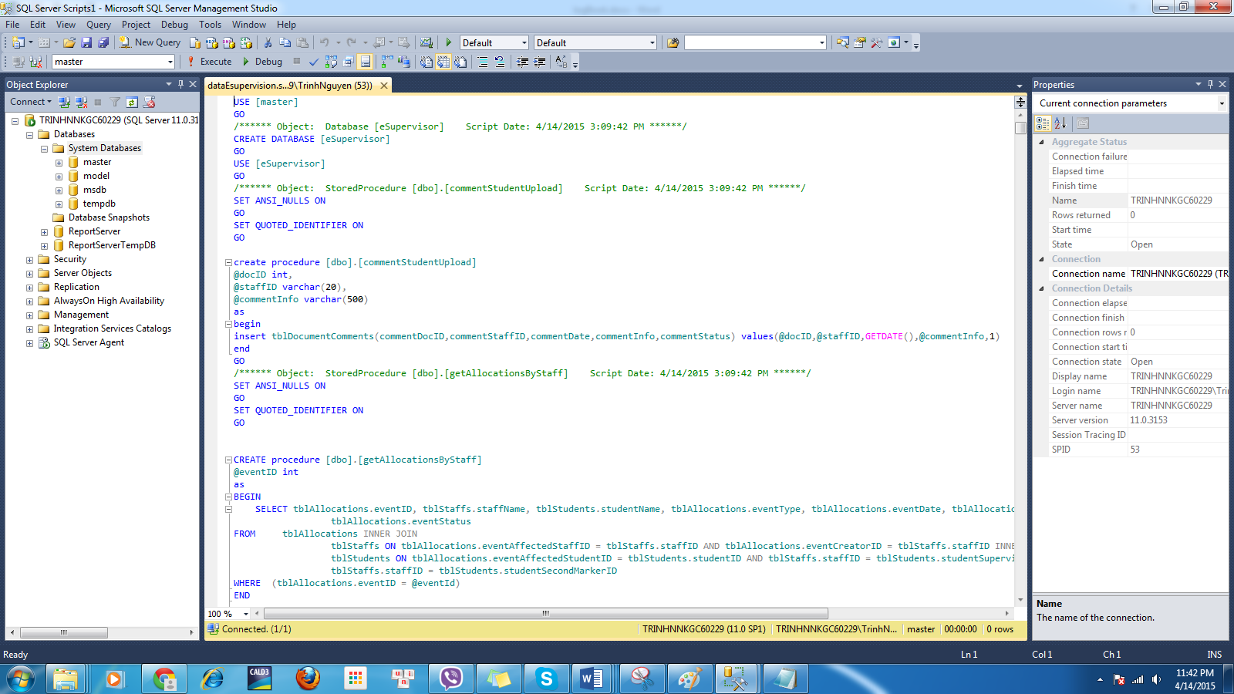

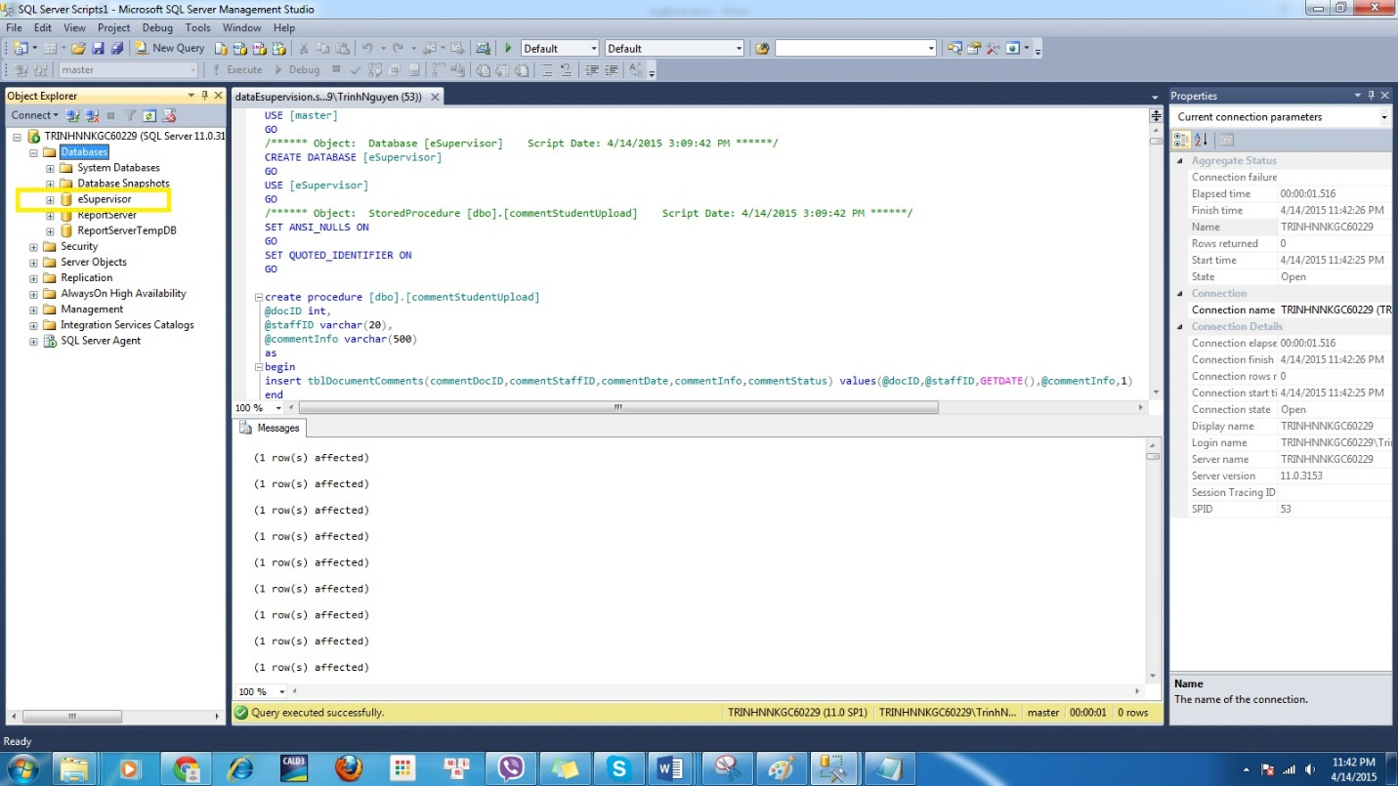

* Step 3:
* Open Web.config file into eSupervision folder.
* Alter the follow connection string:

<connectionStrings>

<add name="eSupervisorConnectionString" connectionString="Data Source=.;Initial Catalog=eSupervisor;User ID=sa;Password=12345678"

providerName="System.Data.SqlClient" />

</connectionStrings>

Include:

+ Data Source: Server name

+Initial Catalog: Database name, which is “eSupervisor” name.

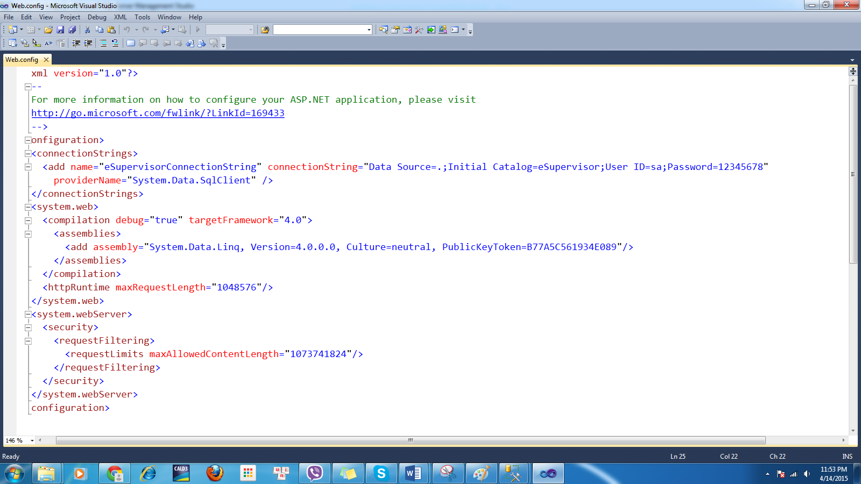

* Step 4:IIS Config
* Open IIS.
* In default website, right click and choose Add Application.

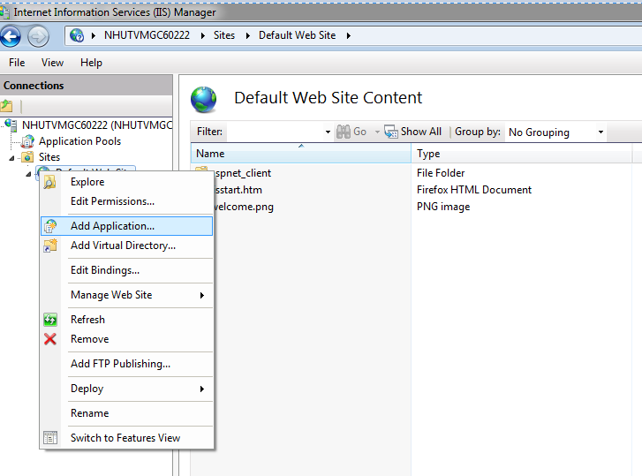

* In the Add Application Window

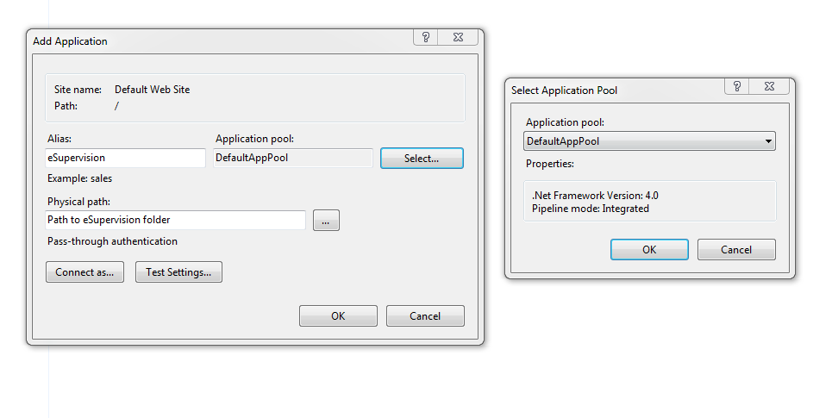

* Please make sure that the .Net Framework of DefaultAppPool is at least 4.0(Access by click “Select…”
* Open the browser and type <http://localhost/eSupervision/login.aspx> into the navigation bar.
* After the browser runs successful you see the image.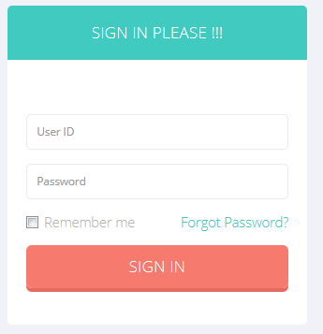
* Sign in Information And Result
  + Manager(Authorized Staff) Login
    - ID : STA001
    - Pass : 12345
    - Login Successes Page:

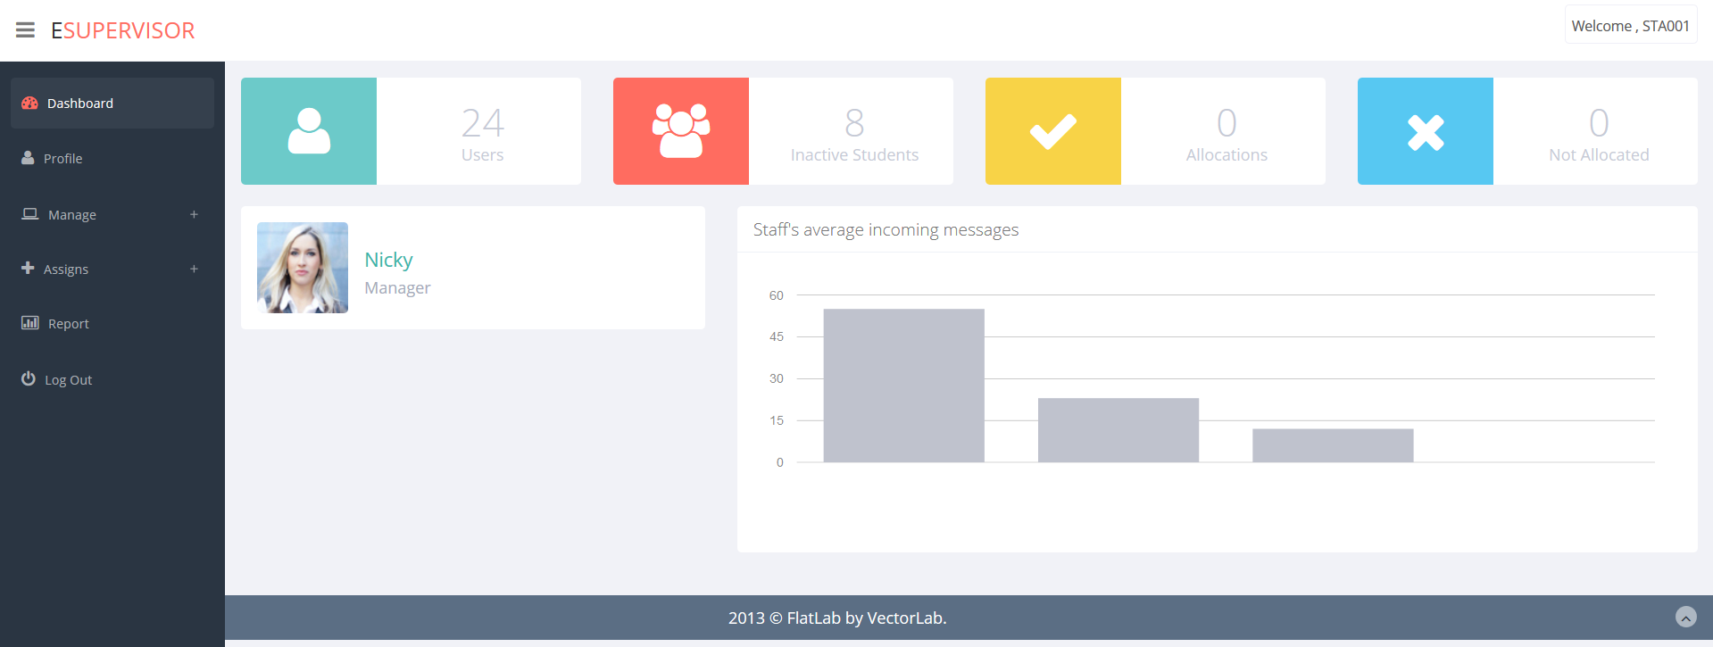

* + Staff Login
    - ID : STA002
    - Password : 12345
    - Login Successes Page: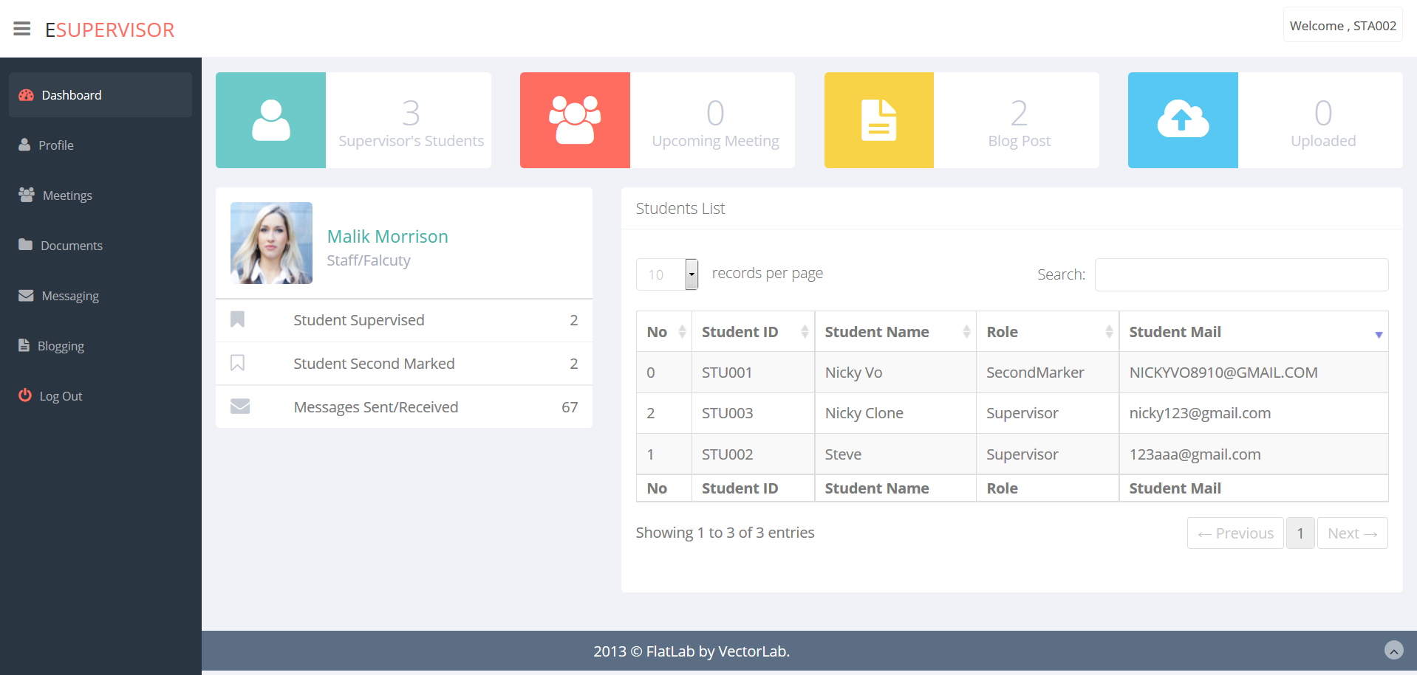
  + Student Login
    - ID : STU001
    - Password : 12345
    - Login Successes Page:

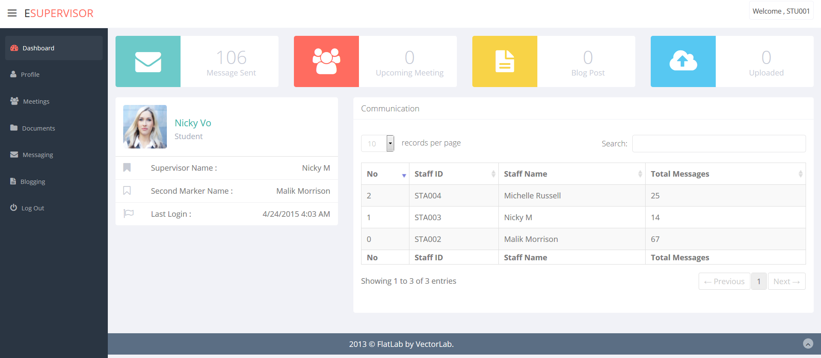

* Thanks for reading.
* Contact: If you set up errors you can contact us by:

|  |  |  |  |
| --- | --- | --- | --- |
| Name | Phone | Email | Skype |
| Vo Minh Nhut | (+84)908446993 | Nhutvmgc60222@fpt.edu.vn | Nickyvo8910 |
| Tran Nguyen Cong Nguyen | (+84)927547220 | Nguyentncgc60257@fpt.edu.vn |  |
| Nguyen Ngoc Kieu Trinh | (+84)982412628 | Trinhnnkgc60229@fpt.edu.vn | Kieutrinh2505 |

# Testing

## Test plan

### Features to be tested

The following is a list of areas to be focus on during testing of website

|  |  |  |  |  |
| --- | --- | --- | --- | --- |
| **Test** | **What is being tested** | **How** | **Test data used** | **Expected Results** |
| **1** | Test identify when fail | User leaves empty id or password and click “Login” or fill incorrect id and password | id:123  Pass:123 | System will display message “Log in failed! Try again” |
| **2** | Test log out when success | User click “Log out” tab menu |  | System will redirect to Login Page |
| **3** | Test forgot password when success | User fill email and click “Submit” | Email:”nicky123@gmail.com” | System will check DB if checking successfully, system will send new password to this user email |
| **4** | Test forgot password when fail | User fill email and click “Submit” or empty the email and click “Submit” | Email:”lucky1@gmail.com” | System will check DB if checking fails, system will display message:” This email doesn’t belong any account in the system!!! Try Again?” |
| **5** | Test Search message in Student Dashboard | Click “Search” button or fill information and click “Search” button |  | System will display information :Staff ID, Staff name, Message sent, message received |
| **6** | Test Edit Profile Manager when success | Edit information in any textbox or do nothing and click “Save” button | Phone: ”123456789” | System will update user profile and redirect to ManageProfile Page |
| **7** | Test blank validation in Edit Profile Manager | User leaves empty Full name, Email and click “Save” button |  | System will display the message below the field: ”Can’t be blank” |
| **8** | Test validation of Email in Edit Profile Manager | User fill incorrect email format | Email:”mr1@yahoo” | System will display the message below the field: ”Wrong email format” |
| **9** | Test validation of Phone in Edit Profile Manager | User fill incorrect phone format | Phone:”123” | System will display the message below the field :”Phone must be 8 or 11 digit numbers” |
| **10** | Test Change Password & Avatar Manager when success | Fill correct Current Password, fill new password then click “Save” button | Current password: “RIK56DMB0CH”  New password:”123” | System will check DB if checking successfully, system will update user password and avatar and redirect to ManageProfile Page |
| **11** | Test blank validation in Change Password & Avatar Manager | User leaves empty Current Password, New Password and Re-type New Password then click “Save” button |  | System will display the message below the field: ”Can’t be blank” |
| **12** | Test matching password validation in Change Password & Avatar Manager | User fill New Password and fill Re-type New Password then click “Save” button | New Password:”123”  Re-type New Password:”1234” | System will display the message below the field: ”Password doesn’t match ” |
| **13** | Test Change Password & Avatar Manager when fail | Fill incorrect information in Current Password field, fill new password and click “Save” button | Current password:”123” | System will check DB if checking fail, system will display message on Pass Update Status label: “Retype Password Do Not Match” |
| **14** | Test Add New Account when success | From Managing Staff, user click Add New Staff the system will redirect to ManagerAddAccount page then user fill information and click “Create” button | Fullname: “Robinson”  Birthday: 04-09-2015  Email:”robin1@yahoo.com” | System will add new account information to database and redirect to ManagerDashboard Page |
| **15** | Test blank validation in Add New Account | User leaves empty Fullname, Email and click “Create” button |  | System will display the message below the field: ”Can’t be blank” |
| **16** | Test Email validation in Add New Account | User fill incorrect email format | Email:”mr1@yahoo” | System will display the message below the field: ”Wrong email format” |
| **17** | Test Phone validation in Add New Account | User fill incorrect phone format | Phone:”123” | System will display the message below the field :”Phone must be 8 or 11 digit numbers” |
| **18** | Test Allocation success | From StaffAllocation Page then click the “Assign” Button on each table’s record, it will redirect to Student Allocation Page. User can select one or more row and click “Assign” |  | System will update database |
| **19** | Test Search Staff when success | From Managing Staff Page or Staff Allocation Page, click “Search” button or fill information and click “Search” button |  | System will display information :Staff ID, Staff name, Staff Type, Staff Birthday, Staff Phone, Authority |
| **20** | Test Search Student when success | From Managing Student Page, click “Search” button or fill information and click “Search” button |  | System will display information :Student ID, Student Name, Student Email, Academic Year, Student Phone |
| **21** | Test Search assigned Student List when success | From StaffDashboard Page, click “Search” button or fill information and click “Search” button |  | System will display information: Student ID, Student Name, Role, Student Mail |
| **22** | Test Edit Profile Staff when success | Edit information in any textbox or do nothing and click “Save” button | Phone: ”123456789” | System will update user profile and redirect to StaffProfile Page |
| **23** | Test blank validation in Edit Profile Staff | User leaves empty Fullname, Email and click “Save” button |  | System will display the message below the field: ”Can’t be blank” |
| **24** | Test validation of Email in Edit Profile Staff | User fill incorrect email format | Email:”mr1@yahoo” | System will display the message below the field: ”Wrong email format” |
| **25** | Test validation of Phone in Edit Profile Staff | User fill incorrect phone format | Phone:”123” | System will display the message below the field :”Phone must be 8 or 11 digit numbers” |
| **26** | Test Change Password & Avatar Staff when success | Fill correct Current Password, fill new password then click “Save” button | Current password: “1234567”  New password:”123” | System will check DB if checking successfully, system will update user password and avatar and redirect to StaffProfile Page |
| **27** | Test blank validation in Change Password & Avatar Staff | User leaves empty Current Password, New Password and Re-type New Password then click “Save” button |  | System will display the message below the field: ”Can’t be blank” |
| **28** | Test matching password validation in Change Password & Avatar Staff | User fill New Password and fill Re-type New Password then click “Save” button | New Password:”123”  Re-type New Password:”1234” | System will display the message below the field: ”Password doesn’t match ” |
| **29** | Test Change Password & Avatar Staff when fail | Fill incorrect information in Current Password field, fill new password and click “Save” button | Current password:”123” | System will check DB if checking fail, system will display message on Pass Update Status label: “Retype Password Do Not Match” |
| **30** | Test Search Document Staff’s Upload when success | Click “Search” button or fill information and click “Search” button |  | System will display information : Document ID ,Title, Date |
| **31** | Test Search Document Upload when success | Click “Search” button or fill information and click “Search” button |  | System will display information: Document ID ,Title, Date |
| **32** | Test Search Student’s Upload success | Click “Search” button or fill information and click “Search” button |  | System will display information :”Student ID, Student Name, Document ID, Title, Upload Date |
| **33** | Test Upload Document when success | Fill the Title and choose the file to upload then click “Upload” button | Title: ”Greenwich” | System will add user Document to database and will display in Staff/StudentDocuments Page |
| **34** | Test Download Document success | Click the “Download” button on each table’s record |  | System will display the download system |
| **35** | Test Delete Document when success | Click the “Delete” button on each table’s record. |  | The record want to remove is disappear |
| **36** | Test Delete Document comment when success | Click the “Delete” button on each table’s record. |  | The record want to remove is disappear |
| **37** | Test Create new message when success | From Student/Staff Messaging page user click “Join/Read” button on its record. Then user fill information and click “Send” button |  | User new message will appear in this page |
| **38** | Test Update Staff when success | Edit information in some fields : or do nothing and click “Save” button | Phone: ”123456789” | System will update this staff profile and redirect to ManagingStaff Page |
| **39** | Test Update Student when success | Edit information in some fields : or do nothing and click “Save” button | Phone: ”123456789” | System will update this student profile and redirect to ManagingStudent Page |
| **40** | Test Remove Student when success | Click “Delete” Button on each table’s record. System will display messages : “Are you sure to delete this record” then click “OK” button |  | The record want to remove is disappear |
| **41** | Test Edit Profile Manager when success | Edit information in some fields : or do nothing and click “Save” button | Phone: ”123456789” | System will update user profile and redirect to ManageProfile Page |
| **42** | Test blank validation in Edit Profile Manager | User leaves empty Fullname, Email and click “Save” button |  | System will display the message below the field: ”Can’t be blank” |
| **43** | Test validation of Email in Edit Profile Manager | User fill incorrect email format | Email:”mr1@yahoo” | System will display the message below the field: ”Wrong email format” |
| **44** | Test validation of Phone in Edit Profile Manager | User fill incorrect phone format | Phone:”123” | System will display the message below the field :”Phone must be 8 or 11 digit numbers” |
| **45** | Test Change Password & Avatar Manager when success | Fill correct Current Password, fill new password then click “Save” button | Current password: “RIK56DMB0CH”  New password:”123” | System will check DB if checking successfully, system will update user password and avatar and redirect to ManageProfile Page |
| **46** | Test blank validation in Change Password & Avatar Manager | User leaves empty Current Password, New Password and Re-type New Password then click “Save” button |  | System will display the message below the field: ”Can’t be blank” |
| **47** | Test matching password validation in Change Password & Avatar Manager | User fill New Password and fill Re-type New Password then click “Save” button | New Password:”123”  Re-type New Password:”1234” | System will display the message below the field: ”Password doesn’t match ” |
| **48** | Test Change Password & Avatar Manager when fail | Fill incorrect information in Current Password field, fill new password and click “Save” button | Current password:”123” | System will check DB if checking fail, system will display message on Pass Update Status label: “Retype Password Do Not Match” |
| **49** | Create new Blog Post | From StaffBloging/StudentBloging Page, user fill information and click ”Send” button | Data input:”123” | System will add new post to database and the new post will displayed in this page |
|  | Delete Blog Post | From StaffBloging/StudentBloging Page, user click ”Delete” button on its post. |  | This post will disappear |

## Test Log

|  |  |  |  |  |  |  |  |
| --- | --- | --- | --- | --- | --- | --- | --- |
| **Test** | **What is being tested** | **How** | **Test data used** | **Expected Results** | **Date** | **Actual results** | **Action taken** |
| **1** | Test identify when fail | User leaves empty id or password and click “Login” or fill incorrect id and password | id:123  Pass:123 | System will display message “Log in failed! Try again” | 04/13/2015 | Ok | None |
| **2** | Test log out when success | User click “Log out” tab menu |  | System will redirect to Login Page | 04/13/2015 | Ok | None |
| **3** | Test forgot password when success | User fill email and click “Submit” | Email:”nicky123@gmail.com” | System will check DB if checking successfully, system will send new password to this user email | 04/13/2015 | Ok | None |
| **4** | Test forgot password when fail | User fill email and click “Submit” or empty the email and click “Submit” | Email:”lucky1@gmail.com” | System will check DB if checking fails, system will display message:” This email doesn’t belong any account in the system!!! Try Again?” | 04/13/2015 | OK | None |
| **5** | Test Search message in Student Dashboard | Click “Search” button or fill information and click “Search” button |  | System will display information :Staff ID, Staff name, Message sent, message received | 04/13/2015 | OK | None |
| **6** | Test Edit Profile Manager when success | Edit information in any textbox or do nothing and click “Save” button | Phone: ”123456789” | System will update user profile and redirect to ManageProfile Page | 04/13/2015 | OK | None |
| **7** | Test blank validation in Edit Profile Manager | User leaves empty Fullname, Email and click “Save” button |  | System will display the message below the field: ”Can’t be blank” | 04/13/2015 | OK | None |
| **8** | Test validation of Email in Edit Profile Manager | User fill incorrect email format | Email:”mr1@yahoo” | System will display the message below the field: ”Wrong email format” | 04/13/2015 | OK | None |
| **9** | Test validation of Phone in Edit Profile Manager | User fill incorrect phone format | Phone:”123” | System will display the message below the field :”Phone must be 8 or 11 digit numbers” | 04/13/2015 | OK | None |
| **10** | Test Change Password & Avatar Manager when success | Fill correct Current Password, fill new password then click “Save” button | Current password: “RIK56DMB0CH”  New password:”123” | System will check DB if checking successfully, system will update user password and avatar and redirect to ManageProfile Page | 04/13/2015 | OK | None |
| **11** | Test blank validation in Change Password & Avatar Manager | User leaves empty Current Password, New Password and Re-type New Password then click “Save” button |  | System will display the message below the field: ”Can’t be blank” | 04/13/2015 | OK | None |
| **12** | Test matching password validation in Change Password & Avatar Manager | User fill New Password and fill Re-type New Password then click “Save” button | New Password:”123”  Re-type New Password:”1234” | System will display the message below the field: ”Password doesn’t match ” | 04/13/2015 | OK | None |
| **13** | Test Change Password & Avatar Manager when fail | Fill incorrect information in Current Password field, fill new password and click “Save” button | Current password:”123” | System will check DB if checking fail, system will display message on Pass Update Status label: “Retype Password Do Not Match” | 04/13/2015 | OK | None |
| **14** | Test Add New Account when success | From Managing Staff, user click Add New Staff the system will redirect to ManagerAddAccount page then user fill information and click “Create” button | Fullname: “Robinson”  Birthday: 04-09-2015  Email:”robin1@yahoo.com” | System will add new account information to database and redirect to ManagerDashboard Page | 04/13/2015 | OK | None |
| **15** | Test blank validation in Add New Account | User leaves empty Fullname, Email and click “Create” button |  | System will display the message below the field: ”Can’t be blank” | 04/13/2015 | OK | None |
| **16** | Test Email validation in Add New Account | User fill incorrect email format | Email:”mr1@yahoo” | System will display the message below the field: ”Wrong email format” | 04/13/2015 | OK | None |
| **17** | Test Phone validation in Add New Account | User fill incorrect phone format | Phone:”123” | System will display the message below the field :”Phone must be 8 or 11 digit numbers” | 04/13/2015 | OK | None |
| **18** | Test Allocation success | From StaffAllocation Page then click the “Assign” Button on each table’s record, it will redirect to Student Allocation Page. User can select one or more row and click “Assign” |  | System will update database | 04/13/2015 | OK | None |
| **19** | Test Search Staff when success | From Managing Staff Page or Staff Allocation Page, click “Search” button or fill information and click “Search” button |  | System will display information :Staff ID, Staff name, Staff Type, Staff Birthday, Staff Phone, Authority | 04/13/2015 | OK | None |
| **20** | Test Search Student when success | From Managing Student Page, click “Search” button or fill information and click “Search” button |  | System will display information :Student ID, Student Name, Student Email, Academic Year, Student Phone | 04/13/2015 | OK | None |
| **21** | Test Search assigned Student List when success | From StaffDashboard Page, click “Search” button or fill information and click “Search” button |  | System will display information: Student ID, Student Name, Role, Student Mail | 04/13/2015 | OK | None |
| **22** | Test Edit Profile Staff when success | Edit information in any textbox or do nothing and click “Save” button | Phone: ”123456789” | System will update user profile and redirect to StaffProfile Page | 04/13/2015 | OK | None |
| **23** | Test blank validation in Edit Profile Staff | User leaves empty Fullname, Email and click “Save” button |  | System will display the message below the field: ”Can’t be blank” | 04/13/2015 | OK | None |
| **24** | Test validation of Email in Edit Profile Staff | User fill incorrect email format | Email:”mr1@yahoo” | System will display the message below the field: ”Wrong email format” | 04/13/2015 | OK | None |
| **25** | Test validation of Phone in Edit Profile Staff | User fill incorrect phone format | Phone:”123” | System will display the message below the field :”Phone must be 8 or 11 digit numbers” | 04/13/2015 | OK | None |
| **26** | Test Change Password & Avatar Staff when success | Fill correct Current Password, fill new password then click “Save” button | Current password: “1234567”  New password:”123” | System will check DB if checking successfully, system will update user password and avatar and redirect to StaffProfile Page | 04/13/2015 | OK | None |
| **27** | Test blank validation in Change Password & Avatar Staff | User leaves empty Current Password, New Password and Re-type New Password then click “Save” button |  | System will display the message below the field: ”Can’t be blank” | 04/13/2015 | OK | None |
| **28** | Test matching password validation in Change Password & Avatar Staff | User fill New Password and fill Re-type New Password then click “Save” button | New Password:”123”  Re-type New Password:”1234” | System will display the message below the field: ”Password doesn’t match ” | 04/13/2015 | OK | None |
| **29** | Test Change Password & Avatar Staff when fail | Fill incorrect information in Current Password field, fill new password and click “Save” button | Current password:”123” | System will check DB if checking fail, system will display message on Pass Update Status label: “Retype Password Do Not Match” | 04/13/2015 | OK | None |
| **30** | Test Search Document Staff’s Upload when success | Click “Search” button or fill information and click “Search” button |  | System will display information : Document ID ,Title, Date | 04/13/2015 | OK | None |
| **31** | Test Search Document Upload when success | Click “Search” button or fill information and click “Search” button |  | System will display information: Document ID ,Title, Date | 04/13/2015 | OK | None |
| **32** | Test Search Student’s Upload success | Click “Search” button or fill information and click “Search” button |  | System will display information :”Student ID, Student Name, Document ID, Title, Upload Date | 04/13/2015 | OK | None |
| **33** | Test Upload Document when success | Fill the Title and choose the file to upload then click “Upload” button | Title: ”Greenwich” | System will add user Document to database and will display in Staff/StudentDocuments Page | 04/13/2015 | OK | None |
| **34** | Test Download Document success | Click the “Download” button on each table’s record |  | System will display the download system | 04/13/2015 | OK | None |
| **35** | Test Delete Document when success | Click the “Delete” button on each table’s record. |  | The record want to remove is disappear | 04/13/2015 | OK | None |
| **36** | Test Delete Document comment when success | Click the “Delete” button on each table’s record. |  | The record want to remove is disappear | 04/13/2015 | OK | None |
| **37** | Test Create new message when success | From Student/Staff Messaging page user click “Join/Read” button on its record. Then user fill information and click “Send” button |  | User new message will appear in this page | 04/13/2015 | OK | None |
| **38** | Test Update Staff when success | Edit information in some fields : or do nothing and click “Save” button | Phone: ”123456789” | System will update this staff profile and redirect to ManagingStaff Page | 04/13/2015 | OK | None |
| **39** | Test Update Student when success | Edit information in some fields : or do nothing and click “Save” button | Phone: ”123456789” | System will update this student profile and redirect to ManagingStudent Page | 04/13/2015 | OK | None |
| **40** | Test Remove Student when success | Click “Delete” Button on each table’s record. System will display messages : “Are you sure to delete this record” then click “OK” button |  | The record want to remove is disappear | 04/13/2015 | OK | None |
| **41** | Test Edit Profile Manager when success | Edit information in some fields : or do nothing and click “Save” button | Phone: ”123456789” | System will update user profile and redirect to ManageProfile Page | 04/13/2015 | OK | None |
| **42** | Test blank validation in Edit Profile Manager | User leaves empty Fullname, Email and click “Save” button |  | System will display the message below the field: ”Can’t be blank” | 04/13/2015 | OK | None |
| **43** | Test validation of Email in Edit Profile Manager | User fill incorrect email format | Email:”mr1@yahoo” | System will display the message below the field: ”Wrong email format” | 04/13/2015 | OK | None |
| **44** | Test validation of Phone in Edit Profile Manager | User fill incorrect phone format | Phone:”123” | System will display the message below the field :”Phone must be 8 or 11 digit numbers” | 04/13/2015 | OK | None |
| **45** | Test Change Password & Avatar Manager when success | Fill correct Current Password, fill new password then click “Save” button | Current password: “RIK56DMB0CH”  New password:”123” | System will check DB if checking successfully, system will update user password and avatar and redirect to ManageProfile Page |  | OK | None |
| **46** | Test blank validation in Change Password & Avatar Manager | User leaves empty Current Password, New Password and Re-type New Password then click “Save” button |  | System will display the message below the field: ”Can’t be blank” | 04/13/2015 | OK | None |
| **47** | Test matching password validation in Change Password & Avatar Manager | User fill New Password and fill Re-type New Password then click “Save” button | New Password:”123”  Re-type New Password:”1234” | System will display the message below the field: ”Password doesn’t match ” | 04/13/2015 | OK | None |
| **48** | Test Change Password & Avatar Manager when fail | Fill incorrect information in Current Password field, fill new password and click “Save” button | Current password:”123” | System will check DB if checking fail, system will display message on Pass Update Status label: “Retype Password Do Not Match” | 04/13/2015 | OK | None |
| **49** | Create new Blog Post | From StaffBloging/StudentBloging Page, user fill information and click ”Send” button | Data input:”123” | System will add new post to database and the new post will displayed in this page | 04/13/2015 | OK | None |
|  | Delete Blog Post | From StaffBloging/StudentBloging Page, user click ”Delete” button on its post. |  | This post will disappear | 4/13/2015 | OK | None |
|  |  |  |  |  |  |  |  |

# Evaluation

## Advantages

* This website biggest advantage is that it can be run on multiple types of device from PC(s) to smartphones and even tablets. This possibility enable it to be used widely in university management. Despite some drawbacks, the system is especially good to be used as communicating system in a large scale because all of the meeting detail will go to the file not the database. This really helps the system to work stably as the time passing by. Another thing is the system documents/files reservation system is optimized so that whenever the user upload a document or a file to a system, it will be automatically renamed or processed to avoid file conflicts. One more thing is thanks to JQuery, the system can provides search functions that improve user experiences and last but not least, with the JS, the system also capable of providing eye-catching summarizing graphs.

## Disadvantages

* There are some drawbacks in this system, among those, the system will be able to bring the customer greatest experiences only if it is dedicated to a major in university because the major factor is not mentioned in this project. There is still a bug in the system that the commenting on documents has not yet implemented. Another thing is that the validation is only at the basic level.

# References

CodeProject, 2015. *Downloading .docx file in asp.net is being corrupted after download..* [Online]   
Available at: http://www.codeproject.com/Questions/265166/Downloading-docx-file-in-asp-net-is-being-corrupte  
[Accessed 20 4 2015].

stack exchange inc, 2015. *auto scroll to bottom gridview asp.net.* [Online]   
Available at: http://stackoverflow.com/questions/6613664/auto-scroll-to-bottom-gridview-asp-net  
[Accessed 20 4 2015].

CBS Interactive, 2015. *How do I... Use C# to upload and download files from an FTP server?.* [Online]   
Available at: http://www.techrepublic.com/blog/how-do-i/how-do-i-use-c-to-upload-and-download-files-from-an-ftp-server/  
[Accessed 20 4 2015].

Microsoft, 2015. *Code: Reading a Text File One Line at a Time (Visual C#).* [Online]   
Available at: https://msdn.microsoft.com/en-us/library/aa287535%28v=vs.71%29.aspx  
[Accessed 20 04 2015].

Microsoft, 2015. *MSDN : How to: Read From a Text File (C# Programming Guide).* [Online]   
Available at: https://msdn.microsoft.com/en-us/library/ezwyzy7b.aspx  
[Accessed 20 4 2015].

net-tutorials.com , 2015. *FileUpload control.* [Online]   
Available at: http://asp.net-tutorials.com/controls/file-upload-control/  
[Accessed 20 4 2015].

stack exchange inc, 2015. *How to call javascript function from code-behind.* [Online]   
Available at: http://stackoverflow.com/questions/4848678/how-to-call-javascript-function-from-code-behind  
[Accessed 20 4 2015].

stack exchange inc, 2015. *Response.redirect raises “Thread was being aborted”.* [Online]   
Available at: http://stackoverflow.com/questions/4874823/response-redirect-raises-thread-was-being-aborted  
[Accessed 20 4 2015].

stack exchange inc, 2015. *SMTP Email from ASP.NET.* [Online]   
Available at: http://stackoverflow.com/questions/3824837/smtp-email-from-asp-net  
[Accessed 20 4 2015].

stack exchange inc, 2015. *What's the fastest way to read a text file line-by-line?.* [Online]   
Available at: http://stackoverflow.com/questions/8037070/whats-the-fastest-way-to-read-a-text-file-line-by-line  
[Accessed 20 04 2015].

VectorLab, 2015. *FlatLab - Flat & Responsive Bootstrap Admin Template.* [Online]   
Available at: http://thevectorlab.net/flatlab/  
[Accessed 20 4 2015].